Yianni Gavalas
Communication Senior Seminar
Professor Lupo
11/9/16
Analysis

Forty years after the release of the well-known 1976 Rocky film, Director Ryan Coogler produced a six-movie spinoff to re-engage with Rocky’s favorite fans. Creed (2015) maintains many of the same ideas and themes as Rocky, although remains unique in its own way because of its cast members, and the much later time period it was released.
The Rocky film (1976) was as popular as it was because of its empowering storyline. The plot is centered around a discouraged club fighter determined to catch his big break. Throughout the film Rocky works out at a local boxing gym, and is constantly reminded by one of the head trainers of what a waste of talent he is. Later in the film, Apollo Creed, the reigning heavyweight boxing champion of the world, learns that his next opponent has sustained an injury and is in need of someone to fight. While Apollo is looking through a boxer catalog list, he comes across the name “The Italian Stallion”, which is Rocky’s fighter nickname. This name entices Creed and as a result he tells his promoter to contact Rocky and challenge him to this upcoming fight. When Rocky is first approached, he declines the offer. However, he ultimately decides to get in the ring. The same trainer that said he was a waste of talent ironically trains Rocky to prepare him for the title match. As the much anticipated fight approaches, Rocky’s main purpose is to prove to those watching that he’s not just another “bum” from a Philly neighborhood. Even though in the end he loses the fight, he goes the distance with Creed leaving it all in the ring. This milestone proved to both him and everyone else that he truly is worth something.
Rocky’s inspirational journey also included time for romance. When he wasn’t punching the bag or his opponents, he frequently paid visit to the pet shop across the street from the gym where his friend Paulie’s sister, Adrian, worked. She was an extremely shy girl and Rocky persistently tried to tell her a new joke every time he passed by. Throughout the movie the love evolves between the two and climaxes at the end of the film when they profess their love for one another. The movie ends with both Rocky and Adrian embracing each other in the middle of the ring.
Creed (2015) has a similar underdog story about an average boxer trying to make a name for himself. Adonis Johnson is the son of the former Apollo Creed, who passed away while fighting earlier in the Rocky series. Adonis’ biological mother also died when he was a young boy, forcing him to bounce around foster homes and juvenile facilities. Adonis was constantly fighting and getting in trouble in such unfortunate settings. Before his death, Apollo Creed married a woman out of wedlock who one day came to visit Adonis and offered him the chance to live with her. She ended up raising him, providing him with financial stability and a good job from which he recently received a promotion. However, deep down Adonis still had a passion for fighting as he constantly watched YouTube videos of father’s old fights. Later in the film, he sneaks away to Tijuana to participate in small underground fights to prove to himself that he can compete in high-level boxing. After he posts an undefeated, 15-0 record he decides to quit his job and commit to fighting full time.
He moves to Philadelphia seeking out Rocky Balboa, the man his father fought two times, to properly train him. Rocky does not accept at first, but feels like he needs to help Adonis because of how much Apollo helped him. Pretty Ricky Conlan, the reigning light heavyweight champion, was set to fight one final match before he was forced to go to prison for gun possession charges. Prior to Conlan’s final public appearance, Adonis had his first legitimate fight with an undefeated opponent whom he ended up beating. However, the very next day following his victory it is revealed to Adonis that he is Apollo Creed’s illegitimate son. Pretty Ricky Conlan’s manager sees this as an advantageous opportunity to make a good amount of money and steal a victory from the emotionally unstable Adonis before his fighter goes to jail.
Soon after, Conlan’s manager contacts Rocky to ask him if Adonis would take the fight. Rocky was skeptical at first, but eventually supports Adonis because he knows how badly the young boy wants his nearly identical chance to fight. A turn for the worse happens when Rocky learns that he has cancer, however it gives Adonis even more drive and the two develop an even stronger bond together.Adonis’ biggest fear is taking on his father’s name and losing in the ring. He is terrified that a defeat will tarnish the family name and people will look at him like a false Creed. Despite all the hard work, in the final fight Adonis does come up short. Even though he ultimately loses, he still proves to himself and everyone else that he is a true fighter and has a future in the sport.
Similar to the Rocky love story, Creed (2015) also includes a female character who provides support to her boxing counterpart. Early in the film, Adonis meets an aspiring singer that is slowly losing her hearing named Bianca. They fall deeper into affection with one another as the movie goes on. She is constantly there for Adonis even though she is pursuing her own career.
Although these films were produced forty years apart several of the overarching messaging and plotline remain in the later version. For example, both Rocky (1976) and Creed (2015) feature young boxers given a once in a lifetime shot at the title. In both films fighters are given a chance because the reigning champion was in need of an opponent and were looking for a replacement. At the end, both fights result in a loss for the determined boxers but they both win in many other ways.
These films allow their viewers to experience the journey with both main characters, watching them evolve from discouraged individuals to self-empowering believers. When both Rocky and Adonis are given their time to shine, those watching are anticipating the ringing of the bell as much as those participating in it. Viewers also witness the mental and physical transformation as a direct result of Rocky and Adonis’ inspiring trainers and support they had every step of the way. The comparable love stories in both films also allow for a different emotion to fill the scenes as a contrast from the competitive nature of the plots.
Some of the training montages are also portrayed in a similar format, especially when both Rocky and Adonis run through the streets of Philadelphia followed by citizens on the street. This closely identical training scene was a perfect way for Creed to come full circle, reconnecting with Rocky’s followers, and reminding them of why they fell in love with this very similar story forty years previous.
Although the storylines certainly match and overlap in several ways, there are also as many, if not more, differences that are presented in Creed (2015) vs. Rocky (1976). These mainly are a reflection of both character personalities, as well as how times drastically changed within the long span between film releases.
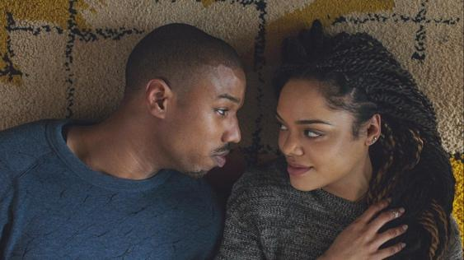
One of the main differences in both cinematic productions was the personalities and behaviors of cast members. The way the two male leads were portrayed were different when comparing each film. The viewer sees Rocky constantly trying to reaffirm his manhood. He is always striving to seem invincible, and live up to the strong persona of what it means to be a man. There are hardly any scenes, other than when he gets intimate with Adrian, where he is showing any sort of vulnerability or affection. However, there are various times in Creed (2015) where Adonis is blatantly documented “showing the love”. For example, when Adonis first moves into his new home he always hears Bianca working hard playing her music. In one scene we watch him go downstairs and ask if she wants to take a break and get food with him, which although seems to be a small gesture, it shows a humanistic side of the boxer knowing that he cares and wants to get to know this girl a little better.
Another example is how supportive and helpful Adonis was during Rocky’s cancer treatment. Originally Adonis was outraged when Rocky didn’t want to fight the disease, but he remained by his side to see it through. Adonis also shows his soft side when he helps Bianca with her hair and lies on the floor with her listening to music. Many men in film, including Rocky, are very often perceived as reserved and reluctant to show too much emotion. Whereas Adonis’s character challenges these stereotypes, opening up to Bianca on numerous occasions. When he is afraid to potentially tarnish the Creed name if he loses his fight he confides in her and asks for her opinion and support. All in all, the viewer can closely relate and sympathize with Adonis’ behaviors because he is much more loving and open than Rocky was as a character. One protagonist is very reserved and keeps to himself, while the other looks to others with words and acts of kindness.
Another crucial difference in comparing both films are the supporting actresses and how they influenced their boxing companions. The main female character in Rocky (1976) is Adrian, sister of Rocky’s friend Paulie. She frequently is responsible for taking care of her brother Paulie by cooking, cleaning and doing laundry for him. Similar to Rocky she is hesitant to letting others into her life. After Rocky gets denied time and time again telling Adrian his daily jokes at the pet store, he finally gets his chance. Paulie invites Rocky over for Thanksgiving and ensures Rocky that Adrian knows he will be in attendance. When he arrives on Thanksgiving, Adrian is unaware of his private invitation, sees him in disbelief and runs into her room. Rocky pleads outside her shut door to go on a date and she finally accepts. Adrian remains this shy, passive figure throughout their date and the majority of the movie. She fits the typical female supporting role commonly seen in the media: a girl taking the backseat to the superior male character.
Bianca in Creed (2015), similar to Adonis, also challenges the predictable behaviors we see in Rocky (1976). Bianca is a strong and independent young woman that is aspiring to become a professional singer. She is self-dependent and takes care of herself. The film does not make any reference to her family and the viewer can assume they are not a big influence. She is constantly performing small gigs and waiting on her chance to make it big time. Amelle Hastie writes, “Bianca isn’t a wallflower selling turtles; she’s a performer whose career is on the rise even as she faces her own debilitating physical condition, a plot detail which constructs her as a parallel to both men in the film at once.” Hastie is comparing the two different dynamics that the women from both movies bring to their films. She argues that Bianca is much more likeable than Adrian because she has aspirations and purpose striving to achieve something bigger.
One example of Bianca standing up for herself is one night when Adonis storms downstairs, knocks on her door and asks her to lower her music. She plays her music very loudly because she is slowly losing her hearing. When he confronts her she has no toleration for his request, gives him attitude and borderline mocks him in her response. She is never intimidated by Adonis and puts him in his place. Finally, she shuts the door and as Adonis goes back upstairs she turns the music back up to the same volume it was previously, once again showing her fearlessness in standing her ground.
Bianca also has a bolder, more challenging personality in her relationship with Adonis, whereas Adrian is more of a bystander. Viewers watch as Bianca teases Adonis when he first tells her that he wants to be a fighter, and in surprise she says “well you don’t look like the fighter type”. Later in the film, Adonis provokes a fight at the show that can potentially jumpstart Bianca’s career, she becomes furious and refuses to talk to him after he jeopardized her big moment. The final example of her influential role is moments before Adonis takes on the fight against Ricky Conlan. When Adonis confides in Bianca, professing his concern about how he is afraid to take on his father’s name and lose, she responds with a very compelling remark telling Adonis that the name is now his and he needs to use it to show how great he can be. In this moment, she is not just trying to console Adonis in his doubt, she is taking the role of the powerful character and motivating him to stop being afraid and go for it. Bianca’s main purpose in the film is certainly to be Adonis’ biggest fan, but simultaneously proves to be a very prominent, strong-willed female figure throughout.
The main characters definitely represent a noticeable difference when comparing both of these pieces, however the forty years between the making of Rocky in 1976 and Creed in 2015 inevitably resulted in a new style and representation due to both cultural evolution and technological advancements.
The cultural changes of the 20th century are certainly influenced and present throughout the film Creed. The language and diction used are vastly different from those in the Rocky script. For example, there are many instance of slang used such as “jaunt”, which is a word that can be referred to just about anything. Bianca uses this term in front of Adonis and he asks her what it means. She proceeds to define it by picking up a ketchup bottle and telling Adonis that it is a jaunt and that he is a jaunt. Another example is when Rocky is training Adonis and is worried about their first opponent, Adonis says, “he could catch my fade.” Rocky asks him to define what that phrase means and Adonis explains that it means he can take him in a fight. Lastly, after Bianca and Adonis get into an argument over a kept secret, Bianca states that she wants Adonis to “keep it one hundred” with her. This slang translates into her wanting him to remain honest and truthful with her. Again the presence of these terms and phrases are very relative to those of this generation, yet people that are older, especially those who watched the original Rocky film, may have never heard of them.
The representation of race in each film was also immensely different. While Rocky (1976) does not seem to have many African Americans present, the majority of the Creed (2015) cast is of color. The main character Adonis and his girlfriend Bianca are both African American. Those surrounding the main characters are also mostly African American. When Adonis travels to his friends boxing gym in California, everyone working out in there is African American. When he moves to Philadelphia the surrounding people shown are many times African American.
Some would argue that Creed (2015) can be considered a “black” film. Rashid Darden makes this claim in his article, “Creed: There are Black People in It”. He gives various examples defending his argument such as as how Creed is not another white savior film about a white man who comes to save the day. Hastie writes, “Philadelphia isn’t shown primarily as a haven for working-class white men; it’s revealed to be a city thriving with black culture, as it is offscreen.” She is saying here that this film is a more accurate representation of Philadelphia, and believes that because of this proper portrayal it makes the film feel more “real”.
The director of this movie is Ryan Coogler is also of African American descent. His first and only other movie was Fruitvale Station (2013) which also had Michael B. Jordan (Adonis) as the lead role. Darden also writes on the subject of Coogler’s directing, “To me, it’s not that he tried to make a black film, but he made a film that is authentic to the characters and their own voices, which are black.” This quote emphasizes that this film gave a true voice to those of color and it didn’t require a caucasian superhero to do any saving.
In one scene of the movie Adonis gets into a heated argument with another African American character and the word “nigga” is said by him. Darden states that when he heard this word used so naturally by Adonis, he knew that he was no longer watching only a Rocky movie, he was also watching a “black” movie. He later states that Hollywood will often times not allow black characters to speak or act as they normally would and instead are fed a filtered set of lines and actions. Darden feels Coogler challenged these racial restrictions, allowing the characters to show their true colors and react to situations as they would in real life.
The final example of this racial divide is when Bianca and Adonis cook Rocky dinner in his home. The meal includes collard greens and Rocky says, “I have not seen food in this house like this-ever.” The mention of this line certainly brings light to absence of diversity in the original Rocky films. Hastie agrees as she writes how this is a, “quick commentary on the absence of black culture in the previous Rocky franchise films, as well as a proclamation of an easy sense of gratitude for this younger generation’s care for him.”
The most impactful scene where you can easily compare racial representation is the classic running montage scene. Although the way the event of the scene is almost identical, the way the audiences interpret it is completely different. In Rocky (1976) all the Philadelphia kids are shown running behind Rocky in the older looking streets of Philadelphia. Darden argues that the Creed (2015) version is everything you could want in an update. In Creed (2015), Adonis is followed by black young men on dirt bikes and atvs, showing change in the childhood “norm”.
Bill Conti’s original track being played during the Rocky (1976) montage is also quickly replaced with blaring rap music in Creed. The song that Adonis is running to is called Lord Knows by Meek Mill, a well-known rapper from Philadelphia who would know first hand what it’s like to have rode around on such ATV vehicles. Earlier in the film Adonis asks Rocky what the deal is with all these dirt bikes in the street. Rocky blatantly replies, “It’s a Philly thing.” This just reaffirms how the exact same event, taken place on the exact same street, can be entirely different based on cultural change and social influence. Common language, racial diversity, musical influences, and atv riding are all a direct reflection of such influence.
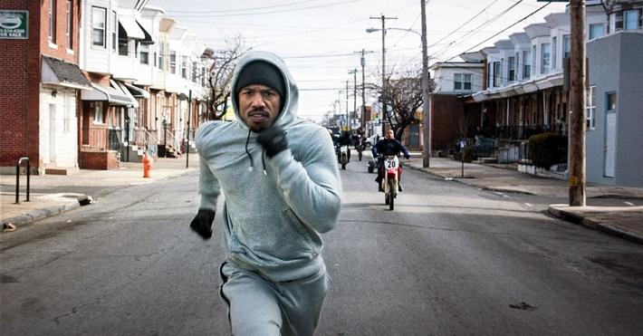
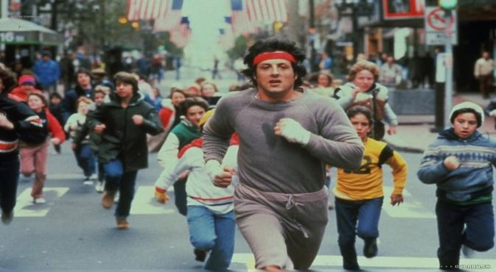

Aside from these examples of cultural change, access and advancements in technology also largely modernize Creed in comparison to Rocky. As a way to “introduce” Rocky to this new way of life in Creed, filmed 40 years later, there is a scene where Rocky gives Adonis a sheet of paper with some boxing drills on it. Adonis quickly takes a picture of the sheet of paper and hands it back to Rocky. Rocky looks at Adonis dumbfounded as he is walking away asking him if he still needed the sheet of paper. Adonis replies that it is in the cloud already and Rocky asks, “What cloud?” This was a great way to illustrate how the time period can have such a large effect on access to new technology and one-touch communication.
In Creed (2015) people use wireless devices to communicate with each other, while in Rocky (1976) Rocky didn’t even have a phone in his apartment. For example, when Adrian is in Rocky’s apartment she says that she needs to call her brother and let her brother know where she is. Rocky tells her that he’ll call her brother for her. He proceeds to open up the window and yell out Paulie’s name and tell him Adrian is with him. It is a bit of a comical act, but proves how much our modes of communication have dramatically changed over time.
The way mass media was portrayed in each film was also noticeably different, obviously coming from the fact that each film was released decades apart. In both films Rocky is seen looking at and reading the newspaper. Back in 1976 people got their information from reading words printed in black and white on a physical piece of paper. In Creed (2015) the majority of people communicate from the palm of their hand with their cell phone, being constantly up to speed on latest news. Adonis uses his smartphone and tablet to keep up on the status of Ricky Conlan’s recent fights before he was the one having to face him.
A concrete example is the morning after Adonis’ first fight: Rocky, Bianca and Adonis are cooking breakfast in Rocky’s kitchen. Bianca smiles at her phone and Adonis asks her what she is doing. She responds with, “I’m looking you up.” The news of his fight was instantly viral and available on the internet for people around the world to see what happened. Before this digital age, people received their news through the newspaper, radio or television. In contrast, when Adonis arrives backstage at Bianca’s big show he is stopped by a rapper. The rapper recognizes him and says, “Hey Creed let me get a pic for the gram.” The rapper wants to post a picture of Adonis and him onto his Instagram account. This form of media wasn’t even an imaginative thought when Rocky (1976) was produced. Now it is one of the most recognizable social media platforms, hence why it made an appearance in a film released in this time period.
Another example of communicative advancement was when in a matter of minutes Ricky Conlan’s manager calls Rocky on his cell phone to set up a meeting. In Rocky (1976) the fight promoter George Jergens had to physically go to Mickey’s gym to try and come into contact with Rocky. The accessibility of this new form of communication surely affected these storylines.
Another big difference in the way mass media was illustrated was the way the fights were promoted in each film. The build up of each fight was much more intense and widespread in Creed (2015), as were the press conferences of a much larger scale than they were in Rocky (1976). As technology has improved over the years, television sets have become much larger and a lot clearer. This is made evident in Creed (2015) when viewers see what kind of television sets are shown in the film in comparison to the miniscule sets in Rocky (1976).
Since nearly every American now has one of these large television screens in there home, we also see a substantial amount of product placement in Creed. The most noticeable brand being Jordan apparel, seeming as if every athlete were wearing it head-to-toe. Even though there was minor product placement in Rocky (1976), it seems that there is an incomparable amount in Creed (2015) due to the new ways of digital advertising to viewers.
The cinematic style and filming techniques were also heavily influenced by new technology. In Adonis’ first fight against Leo “The Lion” Sporino, the scene was shot in a way that had never been done in a boxing movie before. Michael B. Jordan stated, “When Ryan Coogler was first talking about it, we were trying to figure out ways to shoot the boxing scenes differently than any other fight film." The scene is framed as a long continuous shot that is filmed from the center of the ring. The camera continues to move wildly between Adonis, his opponent, Rocky and the crowd. This jerking movement allows its viewers to put themselves in the ring, feeling as if they are wearing the boxing gloves, trying to combat all the outside elements, including their opponent and the crowd. McNally writes, “Trust us you’ll probably flinch more than just once as you watch every punch land in startling close-up.” The viewer can truly appreciate this scene because it is unique and incomparable to anything they have seen in a boxing movie before.
The similarities of these two films allow viewers to emotionally reconnect to the same themes and messages that the beloved original Rocky movie portrayed. However, Creed remains unique and tailored to its own audience’s generation. The film differs in character personalities, while accurately representing cultural and technological changes that have occurred since the infamous Rocky release back in 1976.

Questions
I was not sure how many articles to use.
I was not sure what order to put my themes in.

Works Cited
Hastie, A. "The Vulnerable Spectator: Ryan Coogler's Creed: Showing the Love." Film Quarterly 69.4 (2016): 72-77. Web.
McNally, Victoria. "Michael B. Jordan On His First &#x27;Creed&#x27; Knockout: "We Worked On It For Months"." News. N.p., 25 Nov. 2015. Web. 09 Nov. 2016.
Rashid, Darden. "Creed: There Are Black People In It." Old Gold Soul. N.p., 26 Jan. 2016. Web.

08 Nov. 2016.

