Table 1 - Descriptions of Planned Districts
Planned District District Character Maximum Buildout Requirements
BH-CBH-R/RC  Brown's Hill - Residential / Commercial | The existing institutional/officebusiness/commercial part of the property has two multi-story structures, four buried water tanks, and substantial surface parking. Re-purposing existing structures or additions for commercial/life sciences or other new uses such as 55+ senior housing development may be options. | Existing OfficeBusiness/Commercial/Institutional Buildings:  Kerr Hall, Goddard Library, Academic Building & Chapel (164,612-Gross SF):Reuse of existing structures is permitted by-  right without Site Plan Review.  right.
New Uses and Additions:
By Special Permit Special Permit for additions exceding 10% of
each existing floor SF
N-R  North - Residential | High-intensity residential development area including two, existing three storythree-story Student HousingApartments Units E & F (109-Units) and new multi-plex housing units on surrounding land are options for building. | Existing Student HousingApartments Conversion:  Reuse of existing Student HousingApartments (102,387-Gross SF):  Permitted by-right without Site Plan Review.
Additions to Existing Student Apartments to provide accessibility and residential amenities: Permitted by right without Site Plan Review if XX% or less of the total square footage; Special Permit if more than XX% of the total square footage.

[Note to Draft: Awaiting feedback from potential developers on appropriate percentages]
Additions to Existing Student Apartments for reasons other than accessibility and residential amenities: Site Plan Approval for additions of XX% or less of total square footage; Special Permit for additions exceeding XX% of total square footage.
Additions to existing Student Housing:
Special Permit for additions exceding 10% of
each existing floor SF[Note to Draft: Awaiting feedback from potential developers on appropriate percentages]
New Residential Multiplex:
16-Dwelling Units;, 32,000-Gross SF by Special Permit.
C-R/C  Central - Residential / Commercial  [Note to Draft: GCTS believes the C-R/C and the S-R/C should be combined into one district] | Moderate-density multi-plex homes organized around a civic green in one concept or a limited alternative of senior-serviced use in proximity to residences. | New Residential Multiplex (C-R District): 34-Dwelling Units;, 68,000-Gross SF by Special Permit.
New Residential Multiplex & Senior Serviced
Housing (C-C District):
14-Dwelling Units;, 80-Beds; by Special Permit.
S-R/C  The Stables - Residential / Commercial | Moderate-density garden townhouses supplement two existing Student HousesApartments C & D (40-Units). The Stables (existing Pilgrim Hall, 15,351 Gross SF) an existing historic building may be developed with commercial/retail on the ground floor andand/or residential on the second flooruses. | 78,000-Gross StudentSF Housing Conversion: Existing  Existing Student Apartments Conversion: Reuse of existing Student Apartments (41,316-Gross SF):  Permitted by-right without Site Plan Review.
Additions to Existing Student Apartments to provide accessibility and residential amenities: Permitted by right without Site Plan Review if XX% or less of the total square footage; Special Permit if more than XX% of the total square footage.
[Note to Draft: Awaiting feedback from potential developers on appropriate percentages]
Additions to Existing Student Apartments for reasons other than accessibility and residential amenities: Site Plan Approval for additions of XX% or less of total square footage; Special Permit for additions exceeding XX% of total square footage.
Additions to existing Student Housing:
Special Permit for additions exceding 10% of
each existing floor SF[Note to Draft: Awaiting feedback from potential developers on appropriate percentages]
 |  | New Townhouses/1-Duplex Housing: 18-Dwelling Units;, 46,000-Gross SF by Special Permit.
 |  | Existing Pilgrim Hall Conversion: Permitted by-right without Site Plan Review.
 |  | Additions to Pilgrim Hall House: Permitted by-right without Site Plan Review for additions by religious or educational institutions; Permitted by Special Permit for additions for all other users.
S-D  South -  Development | High-density development with two-three storytwo three-story Student HousingApartment complexes A & B (60- Housing Units)being the sole structures occupying the site. | Existing Student HousingApartments Conversion: Reuse of existing Student Apartments (50,688-Gross SF): Permitted by-right without Site Plan Review.
Additions to Existing Student Apartments to provide accessibility and residential amenities: Permitted by right without Site Plan Review if XX% or less of the total square footage; Special Permit if more than XX% of the total square footage.
[Note to Draft: Awaiting feedback from potential developers on appropriate percentages]
Additions to Existing Student Apartments for reasons other than accessibility and residential amenities: Site Plan Approval for additions of XX% or less; Special Permit for additions exceeding XX% of each existing floor Special Permit.
Additions to existing Student Housing: In excess of 15% is by Special Permit.[Note to Draft: Awaiting feedback from potential developers on appropriate percentages]
HL  Heritage Landscape  [GCTS believes the boundaries of the Heritage Landscape should be adjusted to move the portion of this district immediately adjacent to the UE district into the BH-C/R district] | PreservedContains the Retreat House and open space with sloping lawn as a defining landscape surrounding a single historic residence with summit trail. No additional residential or other use is permitted. Other than potential modifications and/or expansions to the Retreat House, no additional development is currently anticipated. | Development of the district is limited to minor renovations to repurpose the historic building (per uses in Section ???) and to trails, educational signs, and similar improvementsExisting Retreat House Conversion: Permitted by-right without Site Plan Review.
 |  | Additions to Retreat House: Permitted by-right without Site Plan Review for additions by religious or educational institutions; Permitted by Special Permit for additions for all other users.
UE  Utility Expansion | Land set aside for utility use such as wastewater treatment expansion or existing underground water reservoirs. | Special Permit for ancillarySite Plan Review for structures for the use of the zoneand any necessary or prudent improvements or upgrades.
NA  Natural Area | Natural lands including wetlands, steep slopes with landscaping and hardscaping within designated areas as shown on the District Plan. The Gate House is also located within this District.  [Note to Draft: GCTS would like to see the Gate House and surrounding area for parking moved into a new district called the Gate House District]  Permanently protected and/or preserved natural lands including wetlands, steep slopes, and mature trees. | N/AOpen space, passive and active recreation, and trails are Permitted by-right without Site Plan Review.
 |  | Existing Gate House Conversion: Permitted by-right without Site Plan Review.
 |  | Additions to Gate House: Permitted by-right without Site Plan Review for additions by religious or educational institutions; Permitted by Special Permit for additions by all other users.

Draft: August 10, 2023

Table 2 - Allowable Uses in Districts

Land Use | Planned | BH- |  | C- | S-
Types | Districts | R/C | N-R | R/C | R/C | S-D | HL | UE | NA

RECREATION, EDUCATION & PUBLIC ASSEMBLY
Conference/Convention Facility | SPP¹
Library, Museum, Art Gallery | SPP
Studio: Art, Dance, Martial Arts, Music | SP
Active and Passive Recreation; Trail | P | P | P | P | P | P | P | P
Educational or religious uses | P | P | P | P | P | P | P | P
RESIDENTIAL
Two-Family Dwelling | SP | SP | SP | SP
Three-Family Dwelling | SP | SP | SP | SP
Four-Family Dwelling | SP | SP | SP | SP
Multi-Family Dwelling (5 or more DU) | SP | SP | SP | SP
Townhouse Dwelling | SP | SP | SP | SP
Student HousingApartments Conversion to Multi-Family Dwelling |  | P |  | SPP | P
Live/Work UnitBuilding |  |  | SP | SP
Mixed-Use with Residential Component | SP |  |  | SP
Senior Serviced Care, 7 or More Clients | SP |  | SP
Second Unit or Carriage House |  |  |  | SP
SERVICES – BUSINESS, FINANCIAL, PROFESSIONAL
Reuse: Existing Office/Business Space¹/Commercial/ Indusrtial² | P |  |  | P |  | P | P
Expansion: Existing Office/Business²Business/ Commercial/Industrial³ | P/SP |  |  | P/SP |  | P/SP | P/SP
Business Support Services | SPP |  | SP | SP
Medical Services: Clinic | SP |  | SP
Medical Services: Doctor office | SPP |  | SP
Medical Services: Extended care | SPP |  | SP
New Office: Business, Service | SPP |  | SP | SP
New Office: Professional, Administrative | SPP |  | SP | SP
Day Care Center: Child or Adult | P |  | SP | SP
Fitness/Health Facility | P |  | SP | SP
Restaurant, Café & Coffee Shop | P |  | SP | Sp
INDUSTRY & PROCESSING
Laboratory – Medical, Analytical | SPP |  | SP
ACCESSORY USES
Day Care Center: Child or Adult | SPP | SPP | SPP | SPP | SPP
Fitness/Health Facility | SPP | SPP | SPP | SPP | SPP
Meeting Facility | SPP | SPP | SPP | SPP | SPP
Home Occupation | SPP | SPP | SPP | SPP | SPP
Park, Playground | SPP | SPP | SPP | SPP | SPP | SPP | SPP | SPP
Active and Passive Recreation, Trails | P | P | P | P | P | P | P | P
Restaurant, Café & Coffee Shop | SP | SP | SP | SP | SP
Off-Street Parking | P | P | P | P | P | P | P | P

Key to Table of Allowable Uses
P = By-Right
SP = Special Permit
NOTE:
- Existing Conference/Conventions Facilities shall be P; new Conference/Convention Facilities or expansions to existing Conference/Convention Facilities shall be SP
- 1. Reuse of existing occupancies and uses in Kerr Hall, Library, Academic Center & Chapel, The Retreat, Pilgrim Hall, Gate House, Wastewater Treatment Facility & Dormitories: By RightBusiness/Commercial for Business or Professional Office, Multi-Family Dwelling, Mixed Use with a residential component, or Personal Services Establishment and related uses are P without the need for any Site Plan review.
- 2. Expansion of usable space in existing facilities as noted in Note 1 by Site Plan Review or Special Permit (SP)as noted herein.
Draft: August 10, 2023

TABLE 3A
AS OF RIGHT
Reuse of Existing Dormitories plus 10% additional square footage; Reuse of Existing Institutional/Office/ Residential Space plus 10% additional square footage; Reuse of the Retreat House; Reuse of Pilgrim Hall; Reuse of the Gate House.
TABLE 3B
ABBREVIATED SPECIAL PERMIT
Concept Plans using one or more Illustrative Plans 1-4.
TABLE 3C
SPECIAL PERMIT
Concept Plans (non-use of Illustrative Plans) for New Construction plus Reuse of Dormitories and Reuse of Existing Institutional/Office/Residential Space in excess of 10% additional square footage.

Table 4 - Building Type Standards
[Note to Draft: All dimensional standards under review by GCTS; building floor areas of existing buildings to take into account additions permitted as of right]

Building Floor
Permitted in
Building Types Area
Districts (min. / max.)
Lot Size Width / Depth
Lot Coverage
(max)
Height
Stories
(min. /
max.)
Attached House  (Duplex) | BH-R/C; C-R/C;  S-R/C; HL | 2600 / 2800 SF | 100' max./110' max. | 60% max. | 2
Attached House (Triplex, Fourplex) | N-R; C-R/C; HL | 1600 / 2200 SF | 75' max./150' max. | 60% max. | 23
Multi-Plex  (6 / 8 DU) | N-R; C-R/C;  S-R/C | 5400 / 6600 SF or  7200 / 8800 SF | 110' max./150' max. | 60% max. | 2 / 2-1/2
Multi-Family  (Townhouse) | S-R/C | 2800 / 3000 SF | 30' max./140' max. | 60% | 2
Live/Work | C-R/C | 1800 / 2200 SF | 75' max./150' max. | 60% | 2
Existing Student  Housing | N-R; S-R/C;  S-D | 110,000+/- SF | N/A | N/A | 3
New Student  Housing | N-R; S-R/C;  S-D | Match existing dormitoryapartment location and individual floor areas if being replaced. |  | by permitN/A | 3
Existing Business / Commercial | BH-CBH-R/C | 76,000+/- SF | N/A | N/A | 2 N/ 3A
Existing  Institutional | BH-CBH-R/C | 89,000+/- SF | N/A | N/A | 3N/A
New Commercial / Institutional | C-C | 50,000 SF max. | by permitSpecial Permit | 75% | 2-3No higher than existing rooflines without a Special permit
Utilities  Infrastructure | UE | by permitBy site plan approval to service allowed as of right uses; by Special Permit for expansions | by permitSpecial Permit | 10% max. | 12
Accessory | by permit | by permit | by permitSpecial Permit | 10% max. | 1
Civic Lot | BH-CBH-R/RC; N-R;  C-R/C; S-R/C | N/A | 50' min./no max. | 80% | 1

Standards for Specific Existing Historic Buildings
The Retreat | HL | 14,72325,000 gross SF; by Special Permit for expansions | N/A | N/A | 3
Pilgrim Hall &  Accessory Garage | S-R/C | 15,351 gross SF; by Specia Permit for expansions | N/A | N/A | 2
Gate House | NA | 2,2268,500 gross SF; by Special Permit for expansions | N/A | N/A | 23

Draft: August 10, 2023

Table 5 - Allowable Form Standards (Applies to New Construction Only; Does Not Apply to Existing Buildings or Additions to Existing Buildings)
[Note to Draft: All standards under review by GCTS]

Form Standards | Planned Districts | BH-C | BH-R | N-R | C-R | C-C  Residential

Allowable Density
New Dwelling Units(DU) - Density | N/A | 3-DU/Acre | 2-DU/Acre | 6.2-DU/Acre | 2.5-DU/Acre
No. DU-DU Area (max/min) | N/A | 46-DU -  2600/2800 SF | 10-DU -  1800/2200 SF | 34-DU - 1800/2200 SF | 14-DU - 1800/3000 SF
Total New Gross Square Footage | N/A | 120,000 SF | 20,000 SF | 68,000 | 28,000 SF
Existing Business/InstitionalInstitutional | 165,000+/- SF | N/A | N/A | N/A | N/A
Additions to Business/Institutional | See Table 1 | N/A | N/A | N/A | N/A
Senior Serviced Housing (Beds) | N/A | N/A | N/A | N/A | See Table 5-2 C-C  Commercial
Total Gross Square Footage | N/A | N/A N/A |  | N/A
Building Placement
BTL, or Setback (min./max.) | 15' min. | 20' /40' | 20'/48' | 6'/12' | 6'/12'
Front Street Frontage Buildout | N/A | 40% min. | 40% min. | 60% min. | 60% min.
Side Street frontage Buildout | 40% min. | N/A | N/A | 30% min. | 30% min.
Side Street BTL (min./max.) | 15' max. for 20% of lot width | 6'/40' | 12'/0' | 3'/10' | 3'/10'
Interior Side Property Line Setback | 10' abutting a  residential lot | 10' min. | 8' min. | 0' (Attached)  8' (Detached) | 0' (Attached) 8' (Detached)
Rear Setback (Lot or Alley) | 10' abutting a  residential lot | 15' min. | 12' min. | 5' min. | 5' min.
Lot and Block Standards
Lot Width | None Required | 100' min. | 50' min. | 20' min., 100'  max. | 20' min., 100' max.
Lot Depth | None Required | 150' min. | 110' min. | 80' min. | 150' min.
Lot Coverage |  | 60% max. | 60% | 70% max. | 70% max.
Building Heights
Principal Building (Stories/Height) | 3/45' max. | 2-1/2/35' max. | 2-1/2/35' max. | 2-1/2/35' max. | 2-1/2/35' max.
Ground Floor Elevation Above Sidewalk | 6" max. | 2' min. | 1'6" min. | 1'6" min. | 1'6" min.
Ground Floor Ceiling Height (min.) | 14' | 9' | 9' | 9' | 9'
Upper Floors Ceiling Height (min.) | 9' | 8' | 8' | 9' | 8'
Parking Locations
Front Setback (min.) | 30' | 30' | 30' | 30' | 30'
Side Street Setback (min.) | 5' | 12' | 5' | 6' | 5'
Interior Side Property Line Setback (min.) | 0' | 8' | 0' | 0' | 0'
Rear Setback (Lot or Alley) | 5' | 5' | 5' | 5' | 5'
Allowed Frontages and Encroachments
Allowed Frontage Types | Shopfront,  Gallery | Porch & Fence | Common Yard, Forecourt, Gallery, Porch
Other Allowed Frontages | Balconies, Bay Windows, Awnings & Other Frontage Elements
Front Setback | 12' max.
Side Street Setback | 8' max.
Rear Setback (Lot or Alley) | 0' max.

Draft: August 10, 2023

Table 5 - Allowable Form Standards
[Note to Draft: All standards under review by GCTS]
Form Standards | Planned Districts | C-C  Commercial | S-R/C | S-D | UE | HL/NA
Allowable Density
New Dwelling Units - Density |  | See Table 5-1  C-C Residential | 2-DU / Acre | N/A | N/A | N/A
No. Dwelling Units |  |  | 18-DU  2800 SF/3000 SF
DU Area - max./min.
Total New Gross Square Footage |  |  | 46,000 SF
Senior Serviced Housing (Beds) |  | 80 Beds | N/A | N/A | N/A | N/A
Total Gross Square Footage |  | 50,000 SF
Building Placement
Front Build-to-Line, or Setback |  | 15' min. | 15' | 20' min., 48'  max. | 20' min. | by permit
Front Street Frontage Buildout |  | N/A | 60% min. | 40% min. | n/a | by permit
Side Street frontage Buildout |  | N/A | 30% min. | n/a | n/a | by permit
Side Street Build-to-Line |  | 15' min. | 10' max. | 12' min. | 20' min. | by permit
Interior Side Property Line Setback |  | 10' abutting  Residential | 0' min. | 8' min. | 30' min. | by permit
Rear Setback (Lot or Alley) |  | 10' abutting  Residential | 5' min. | 12' min. | 30' min. | by permit
Lot and Block Standards
Lot Width |  | None Required | 100' max. | 50' min. | by permit | n/a
Lot Depth |  | None Required | 150' max. | 110' min. | by permit | n/a
Lot Coverage |  |  | 60% | 60% | by permit | by permit
Building Heights
Principal Building |  | 2-1/2 stories; 35'  max. | 2-1/2 stories, 35' max. | 2-1/2 stories,  35' max. | 1 Story max. | by permit
Ground Floor Elevation Above Sidewalk |  | 6" min. | 1'6" Min. | 1'6" min. (Res.) 6" min. (Non-  Res.) | 0' min. | by permit
Ground Floor Ceiling Height |  | 14' max. | 9' min. (Res.) | 9' min. (Res.) | 9' min. | by permit
Upper Floors Ceiling Height |  | 10' max. | 8' min. (Res.) | 8' min. clear | 9' min. | by permit
Parking Locations
Front Setback |  | 30' | 20' min. | 30' min. | 12' min. | by permit
Side Street Setback |  | 5' | 0' min. | 5' min. | 12' min. | by permit
Interior Side Property Line Setback |  | 0' | 0' min. | 0' min. | 5' min. | by permit
Rear Setback (Lot or Alley) |  | 5' | 5' min. | 5' min. | 5' min. | by permit
Allowed Frontages and Encroachments
Allowed Frontage Types |  | Gallery Forecourt, Gallery, Porch, Stoop |  |  | N/A | N/A
Other Allowed Frontages |  | Balconies, Bay Windows, Awnings, and Other  Elements |  |  | N/A | N/A
Front Setback |  | 12' max. | 3' max. | 12' max. | N/A | N/A
Side Street Setback |  | 3' max. | 3' max. | 8' max. | N/A | N/A
Rear Setback (Lot or Alley) |  | 0' max. | 3' max. | 0' max. | N/A | N/A

Draft: August 10, 2023

Table 5 - Allowable Form Standards

District Specific Parking Requirements
a. Parking shall be as established in Section ???
b. Parking locations applies to location of garage or parking lot
c. Parking shall be located behind the Front Façade of buildings and accessed from the Rear Alleys or Side Streets
d. Garden Walls, Fences, or Hedges are required along unbuilt Street Rights-of-Ways adjacent to to parking
e. Parking / Driveway Curb Cut Width 12' max.

Miscellaneous
1. All buildings must have a Principal Entrance along the Front Façade

Draft: August 10, 2023

Table 5B - Building Form Standards
Brown's Hill - Residential District
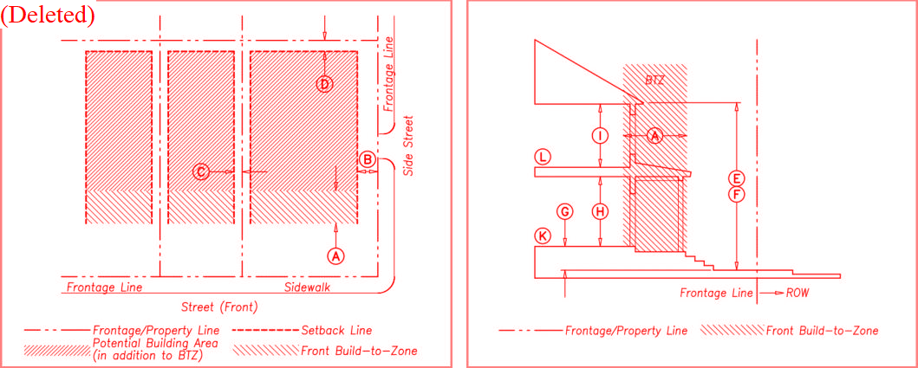

A. Building Placement
Setbacks
A | Front Build-to-Zone (min./max.) | 20'/40'
B | Side Street, BTL (min./max.) | 6'/40'
C | Interior Side Property Line Setback | 10' min.
D | Rear Setback | 15' min.

Frontage Type Buildout (e.g. Porch)

C. Building Forms
Height
F | Main Building Minimum | 2-1/2 Stories
F | Main Building Maximum | 2-1/2 Stories/35'
G | Ground Floor Elevation Above Sidewalk | 2' min.
H | Ground Floor Ceiling Height | 9'
I | Upper Floor(s) Ceiling Height | 8'
D. Allowed Frontage Types

Building Façade within Build-to-Zone Common Yard
Front Street Frontage 40% min. Porch
Side Street Frontage N/A Forecourt
Street facades must be built to BTL within 30' of every
corner
B. Lot and Block Standards
E. Allowed Use Types
Lot Width 100'
Lot Depth 150' max.
K Ground Floor
All Permitted Uses Allowed
L All Floors Otherwise All Permitted Uses Allowed
Lot Coverage 60% max.
Draft: August 10, 2023

Table 5B - Building Form Standards
A minimum 24' Front Setback shall apply when no Rear Alley or Side Street access are present and garage doors are perpendicular to the Primary Street Frontage Line
G. District Specific Parking Requirements
Parking shall be provided as established in Section ???
Parking shall be located behind the Front Façade of buildings and accessed from Rear Alleys or Side Streets whenever possible
Streetscreens, Garden Walls, fences, or hedges are required along unbuilt Street Right-of-Ways adjacent to parking
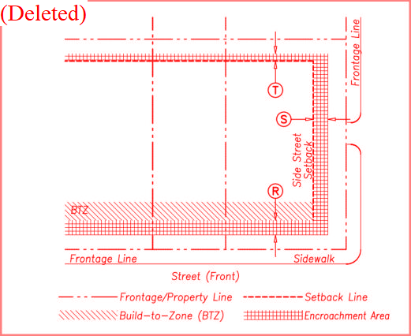
H. Allowed Encroachments
Balconies, Bay Windows, Awnings, Galleries, and Other Frontage Elements

R | Front | 12' max.
S | Side Street | 5' max.
T | Rear | 3' max.

Stairs may encroach beyond this maximum an additional 4 feet. Frontage Elements shall not Encroach into the right-of-way
I. Miscellaneous
All buildings must have a Principal Entrance along the Front Facade
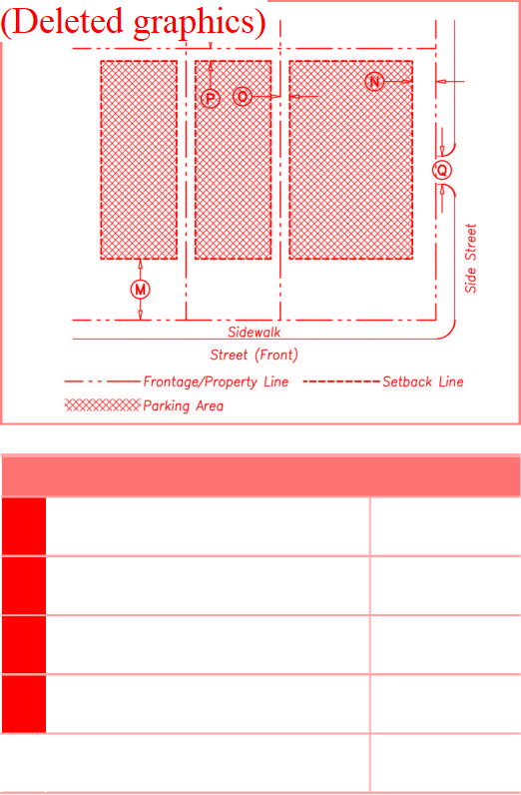
M
30' (min.)
Front Setback
P
5' (min.)
Rear Setback
F. Parking
Side Street Setback
N
Side Setback
O
Parking/Driveway Curb Cut Width 12' max.
12' (min.)
0' (min.)
Draft: August 10, 2023

Table 6-1 Streets and Sidewalks
Thoroughfares
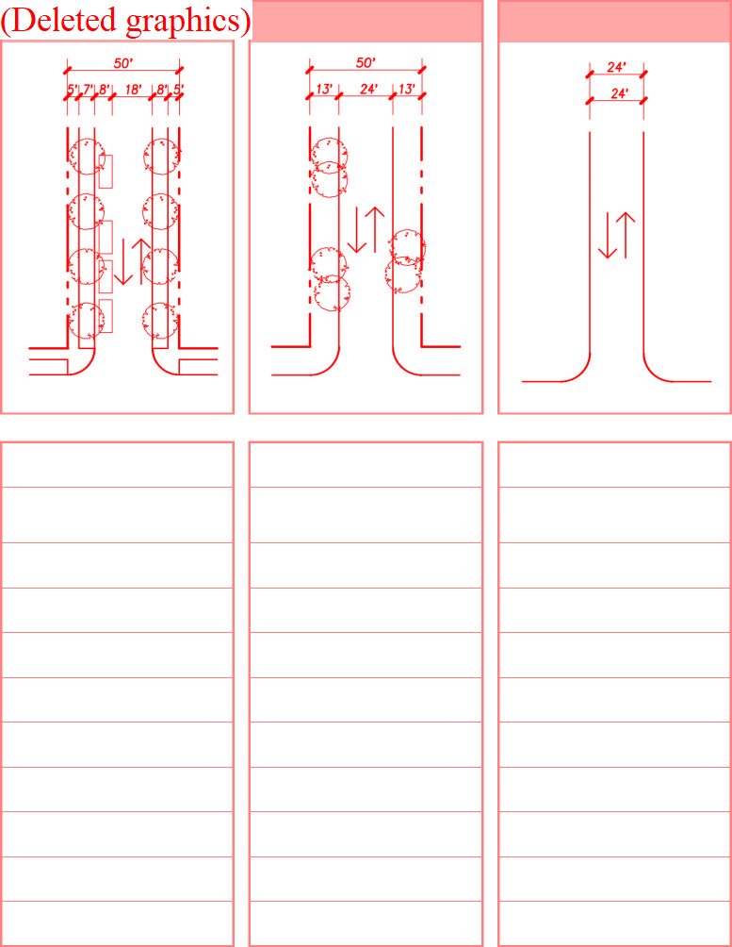
Street
BH-C/R; N-R; C-R/C;
S-R/C
50 ft.
26 ft.
25 mph
2 lanes
One side @ 8' marked
30'
5' sidewalk
7' continuous planter
Curb

RA-24-24
Rear Alley
BH-C/R; N-R; C-R/C; S-R/C; S-D; NA
24 ft.
24 ft.
10 mph
2 lanes
None
Taper
None
None
Inverted crown
ST-50-26
RD-50-24
Road
BH-C/R; NA; N-R; HL; S-D
50 ft.
24 ft.
30 mph
2 lanes
None
30'
Path optional
Continuous swale
Swale
Roadway Type
Planned Districts
Right-of-Way width
Pavement Width
Min. Design Speed
Traffic Lanes
Parking Lanes
Curb Radius
Walkway Type
Planter Type
Curb Type
Draft: August 10, 2023

TABLE 6-2 REQUIRED VEHICLE PARKNG SPACE AMOUNTS¹
[Note to Draft: Vehicle Parking Space amounts under review by GCTS]

USE | NUMBER OF PARKING SPACES
Residential - Studio/one bedroom/Second Unit or Carriage House | 1.0 per dwelling unit
Residential – Two + bedrooms | 2.0 per dwelling unit
Residential – Visiting Guests | 0.2 per dwelling unit
Senior Serviced Housing/ Medical Services Extended Care | 1.0 per 4 beds
Lodging (Small hotel, Bed and Breakfast) | 1.0 per guest room
Conference/Convention Facility | 5.0 units per 1,000 gross floor area²
Library, Museum, Art Gallery | 2 per 1,000 gross floor area
Studio, Art, Dance, Martial Arts, Music | 1.0 per 500 gross floor area
Live/Work | 1.0 per live/work unit
Mixed Use with Residential Component | 2.0 per unit
Business/Professional Offices, Business Support Services, Medical Services/Clinics, | 2.0 per 1,000 gross floor area
Laboratory – Medical Analytical | 2.0 per 1,000 gross floor area
All Accessory uses listed in Table 2 | 2.0 per each accessory use

¹ Parking space amounts are derived from the Smart Parking Model Bylaw, part of the Smart Growth Energy Toolkit Bylaw produced by the Commonwealth of Massachusetts.
² Gross Floor Area refers to the total space a building takes up and includes all the space inside a building including unusable space between walls.

Table 7 - Table of Dimensional Standards
[Note to Draft: All dimensional standards under review by GCTS;

Planned Districts | BH-C | BH-R | N-R | C-R | C-C
Minimum Parcel Size (sq. ft.)
Minimum Frontage (sq. ft.)
Front Setback (ft. min.) | 15 ft. | 20 ft. | 20 ft. | 6 ft. | 30 ft.
Side / Rear Setback (ft.) | 15 ft. / 10 ft. | 10 ft. / 15 ft. | 10 ft. / 15 ft. | 10 ft. / 15 ft. | 10 ft. / 15 ft.
Minimum Open Space per Total Acreage (%) | 15% | 15% | 15% | 15% | 15%
Maximum Building Gross Square Footage per Acre (SF/Acre)
Building Height (stories/feet) | 3 / 45 ft. max. | 2-1/2 / 35 ft.  max. | 2-1/2 / 35 ft.  max. | 2-1/2 / 35 ft.  max. | 2-1/2 / 35 ft.  max.

Planned Districts |  | S-R/C |  | S-D |  | HL |  | UE |  | NA

Minimum Parcel Size (sq. ft.)
Minimum Frontage (sq. ft.)
Front Setback (ft.) | 20 ft. | 30 ft. | by permit | 12 ft. | by permit
Side / Rear Setback (ft.) | 12 ft. / 12 ft. | 12 ft. / 12 ft. | by permit | 20 ft. / 30 ft. | by permit
Minimum Open Space per Total Acreage (%) | 15% | 15% | 15% | 15% | 15%
Maximum Building Gross Square Footage per Acre (sq. ft./Acre)
Building Height (stories/feet) | 2-1/2 / 35 ft.  max. | 2-1/2 / 35 ft.  max. | by permit | 1 / 20 ft. max. | N/A

Draft: August 10, 2023

Table - Lower Campus Buildout Options
[Standards under review by GCTS]

 |  | ILLUSTRATIVE PLAN 1
District | SOUTH  2.6 Acres |  | STABLES  8.8 Acres |  | CENTRAL  6.1 Acres |  | NORTH  7.6 Acres |  | TOTALS  25.1 Acres
New Construction | DU | Sq Ft | DU | Sq Ft | DU | Sq Ft | DU | Sq Ft | DU | Sq Ft
Residential | 0 | 0 | 18 | 46,000 | 34 | 68,000 | 16 | 32,000 | 68 | 146,000
Subtotals: | 0 | 0 | 18 | 46,000 | 34 | 68,000 | 16 | 32,000 | 68 | 146,000
Dwelling Units/Acre Square Footage/Acre | 0 | 0 | 2.0 | 5,230 | 5.6 | 11,150 | 2.1 | 4,200 | 2.7 | 5,820

 |  | ILLUSTRATIVE PLAN 2
District | SOUTH  2.6 Acres |  | STABLES  8.8 Acres |  | CENTRAL  6.1 Acres |  | NORTH  7.6 Acres |  | TOTALS  25.1 Acres
New Construction | DU | Sq Ft | DU | Sq Ft | DU | Sq Ft | DU | Sq Ft | DU | Sq Ft
Residential | 0 | 0 | 18 | 46,000 | 14 | 28,000 | 10 | 20,000 | 42 | 94,000
Senior Serviced Hs'g | 0 | 0 |  |  | 80 | 50,000 |  |  | 80 | 50,000
Subtotals: | 0 | 0 | 18 | 46,000 | 94 | 78,000 | 10 | 20,000 | 122 | 144,000
Dwelling Units/Acre Square Footage/Acre | 0 | 0 | 2.0 | 5,230 | 15.4 | 12,800 | 1.3 | 2,632 | 4.9 | 5,740

 |  | ILLUSTRATIVE PLAN 3
District | SOUTH  2.6 Acres |  | STABLES  8.8 Acres |  | CENTRAL  6.1 Acres |  | NORTH  7.6 Acres |  | TOTALS  25.1 Acres
New Construction | DU | Sq Ft | DU | Sq Ft | DU | Sq Ft | DU | Sq Ft | DU | Sq Ft
Residential | 0 | 0 | 18 | 46,000 | 34 | 68,000 | 16 | 32,000 | 68 | 146,000
Subtotals: | 0 | 0 | 18 | 46,000 | 34 | 68,000 | 16 | 32,000 | 68 | 146,000
Dwelling Units/Acre Square Footage/Acre | 0 | 0 | 2.0 | 5,230 | 5.6 | 11,150 | 2.1 | 4,200 | 2.7 | 5,820

 |  | ILLUSTRATIVE PLAN 4
District | SOUTH  2.6 Acres |  | STABLES  8.8 Acres |  | CENTRAL  6.1 Acres |  | NORTH  7.6 Acres |  | TOTALS  25.1 Acres
New Construction | DU | Sq Ft | DU | Sq Ft | DU | Sq Ft | DU | Sq Ft | DU | Sq Ft
Residential Senior Serviced Hs'g | 0  0 | 0  0 | 18  0 | 46,000  0 | 14  80 | 28,000  50,000 | 10 | 20,000 | 42  80 | 94,000  50,000
Subtotals: | 0 | 0 | 18 | 46,000 | 94 | 78,000 | 10 | 20,000 | 122 | 144,000
Dwelling Units/Acre Square Footage/Acre | 0 | 0.00 | 2.0 | 5,230 | 15.4 | 12,800 | 1.3 | 2,630 | 4.9 | 5,740

Draft: August 8, 2023

6230859.16230859.4
Table - Lower Campus Buildout Options

SUMMARY
 | SOUTH  District 2.6 Acres | STABLES  8.8 Acres | CENTRAL  6.1 Acres | NORTH  7.6 Acres | TOTALS  25.1 Acres
Scenarios | DU Sq Ft | DU Sq Ft | DU Sq Ft | DU Sq Ft | DU Sq Ft

0 | 0 | 18 | 46,000 | 34 | 68,000 | 16 | 32,000
0 | 0 | 18 | 46,000 | 94 | 78,000 | 10 | 20,000
0 | 0 | 18 | 46,000 | 34 | 68,000 | 16 | 32,000
0 | 0 | 18 | 46,000 | 94 | 78,000 | 10 | 20,000

Illustrative Plan 1 Illustrative Plan 2 Illustrative Plan 3 Illustrative Plan 4
68 146,000
122 144,000
68 146,000
122 144,000
NOTE: Brown's Hill District and existing Dormitories are not included in the calculations noted in this table.

Dorms | No. of Units | Gross Sq. Ft.
A & B | 60 Units | 50,688 SF
C & D | 40 Units | 41,316 SF
E & F | 109 Units | 102,387 SF
Total: | 209 Units | 194,391 SF

Draft: August 8, 2023

Summary report:
Litera Compare for Word 11.5.0.74 Document comparison done on 11/16/2023 9:25:51 AM
Style name: Default Style
Intelligent Table Comparison: Active
Original DMS: iw://imanagework.nutter.com/IMANAGE/6230859/1
Modified DMS: iw://imanagework.nutter.com/IMANAGE/6230859/4
Changes:
Add | 142
Delete | 250
Move From | 0
Move To | 0
Table Insert | 14
Table Delete | 2
Table moves to | 0
Table moves from | 0
Embedded Graphics (Visio, ChemDraw, Images etc.) | 0
Embedded Excel | 0
Format changes | 0
Total Changes: | 408

