Open burn permit application instructions

(Please review all screen shots below before starting)

These instructions are for smart phone, Lap top and PC directions.

the (link below) and should not be used exclusively.

https://www.hamiltonma.gov/wp-content/uploads/2019/01/Directions-for-Online-Open-Burning-Permits-.pdf

1. Go to the Town Webpage (<https://www.hamiltonma.gov/> ).
2. Click on “**GOVERNMENT**”

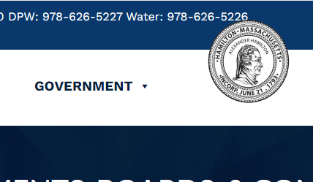

1. Scroll down to All Boards & Departments,

then look for the bullet point that has the “**Fire Departments**” link and then put your mouse over it to click on our page.

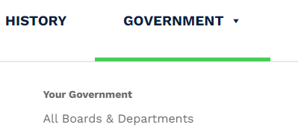 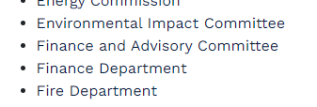

1. Scroll down to the ***middle***  of the Fire Department page where you will find the **Related Links section**, then click oneither“**Open Burning Permit Application**” (to pay the initial $20 permit fee), or “**Renewing Your Burning Permit Daily”** (to activate your permit on the day of burning). This will bring you to **City Hall Systems Mobile Bill Payment page**.

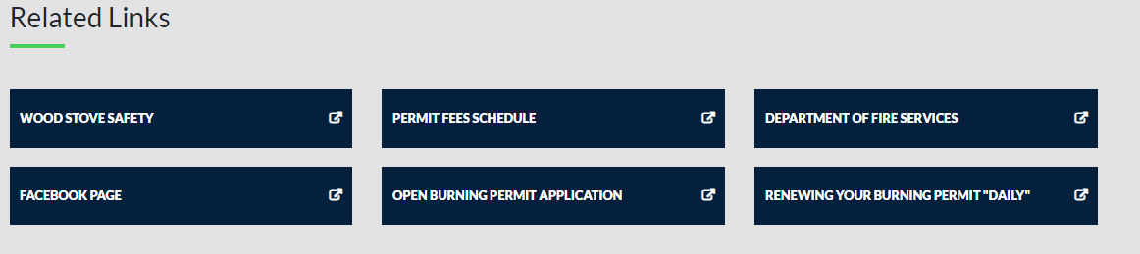

1. Enter Hamilton in the open box that says, Enter your Municipality.

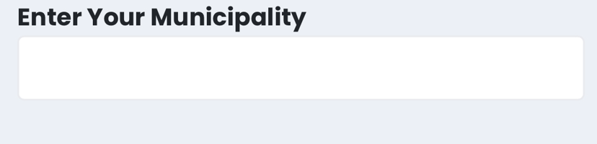

1. Select the drop down screen next to “**fire**”, and then select “**Activate Burning Permit**”, or “**Buy Burning Permit**”.

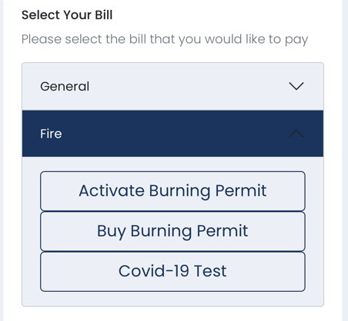

1. Once you’re at the City Hall System’s site follow the prompts to finish the transaction and/or activate your permit. A permit must be activated every time you plan on burning **“on a daily basis”.**

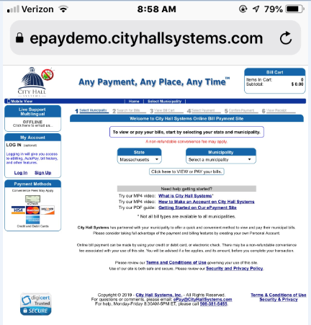

After you buy your permit for the season you must activate it, **BUYING YOUR PERMIT FOR THE FIRST TIME, WILL NOT AUTOMATICALLY ACTIVATE IT!**

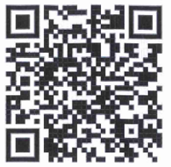

**Use QR code for direct link**

**To City Hall Systems**

**where you purchase/ activate your Permit**