Proposed Amendments to Existing Code

**SECOND DRAFT for Planning Board Review**

2025-04-24

The following sections of the existing code will be re-written as follows. Additions are underlined, deletions are ~~struck through~~, and additional instructions are *italicized.*

## *HAMILTON ZONING BYLAW TABLE OF CONTENTS*

*Insert the following to the Table of Contents under Section 9.0 Special District Regulations after 9.5:*

**9.6 3A Multifamily Overlay District (3A-MFOD)**

9.6.1 Purpose

9.6.2 Applicability

9.6.3 Permitted Uses

9.6.4 Dimensional Standards

9.6.5 Severability

9.6.7 Sunset Clause

**9.7 Hamilton Town Center Base Zoning**

9.7.1 Purpose and Intent

9.7.2 Interpretation

9.7.3 Town Center Districts

9.7.4 Dimensional Standards

9.7.5 Use Provisions

9.7.6 Site Standards

9.7.7 Administration

**2.1 CLASSES OF DISTRICTS.**

The Town of Hamilton is hereby divided into the following districts:

Residence District R-1A

Residence District R-1B

Residence-Agricultural District RA

~~Business District B~~

Depot Square

Bay Road Mixed-Use

Willow Street Mixed-Use

Downtown Residential

Bay Road Civic

**2.2 ZONING MAP.**

The Zoning Map dated December 28, 1964, filed with the Town Clerk, as amended by the Zoning Map, dated February 1, 1971, and further amended May 7, 1974, May 14, 1979, May 13, 1985, November 14, 1999, ~~and~~ May 5, 2009, and June XXX, 2025 (“Zoning Map”) is hereby made a part of this Bylaw.

*In the Downtown, add the following districts to the Town Zoning Map to replace the underlying existing portions of the B and R-1A districts in the current map. Remove key references to the Business District which is removed entirely. Extend the R-1A district southeast along Linden Street to include any parcels currently within the Business District and not included in the proposed Depot Square Mixed-Use District.*

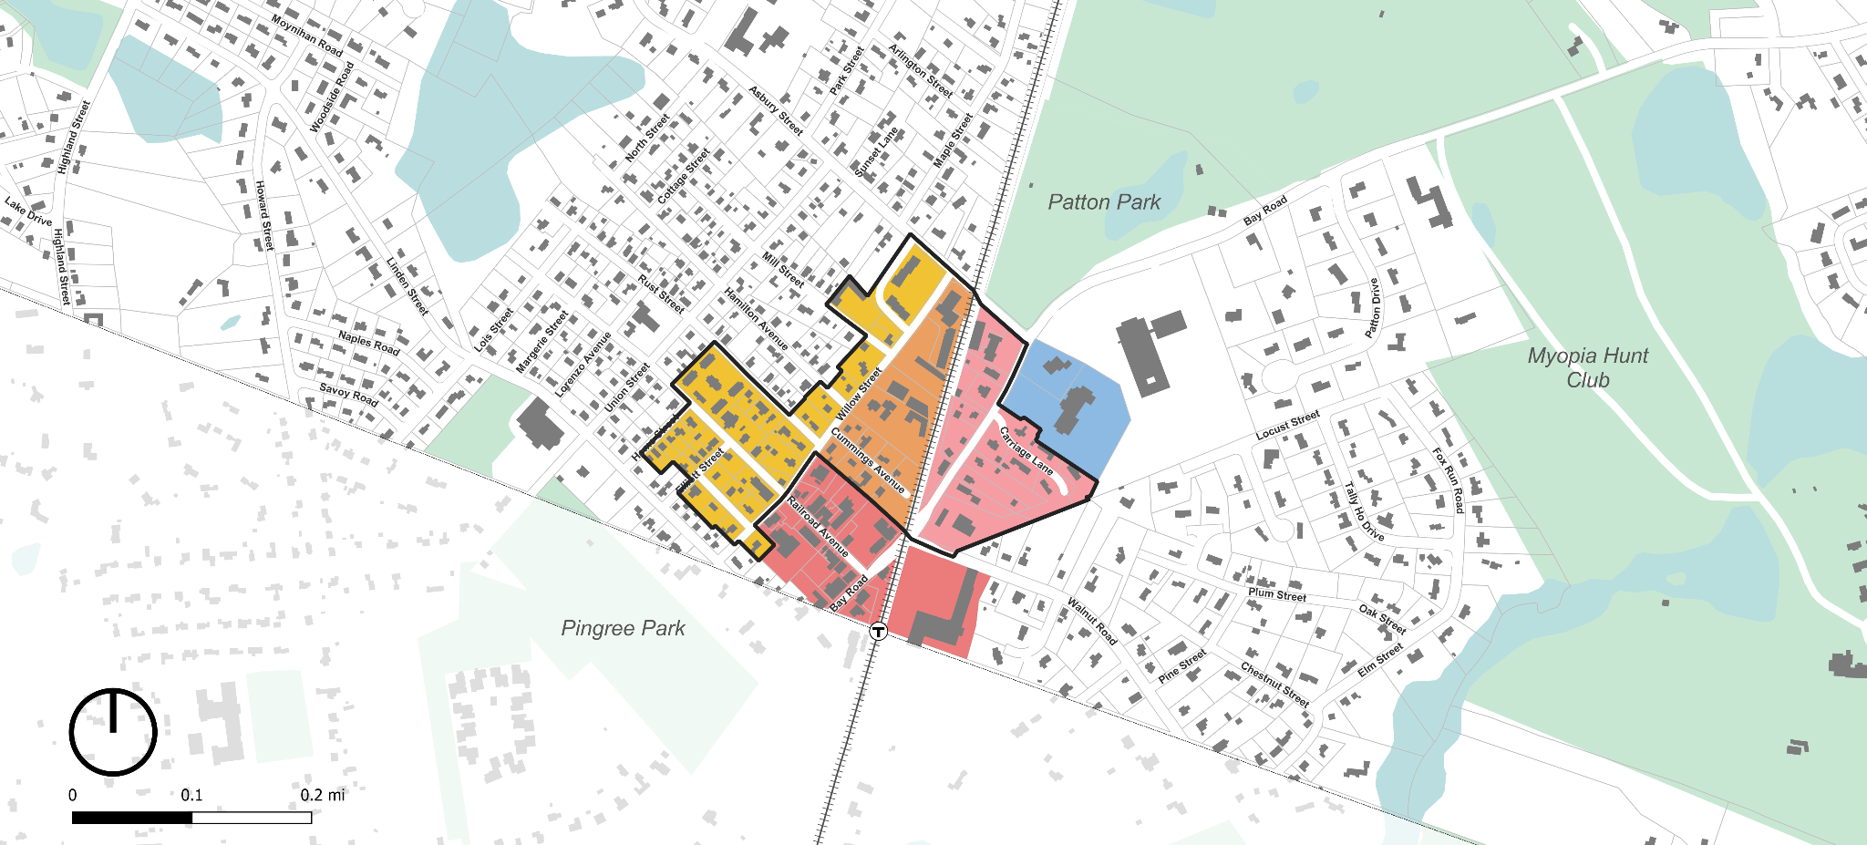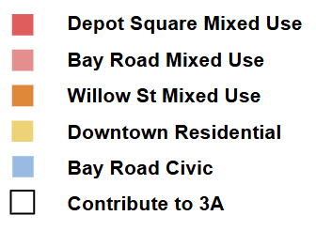

**TOWN CENTER DISTRICTS**

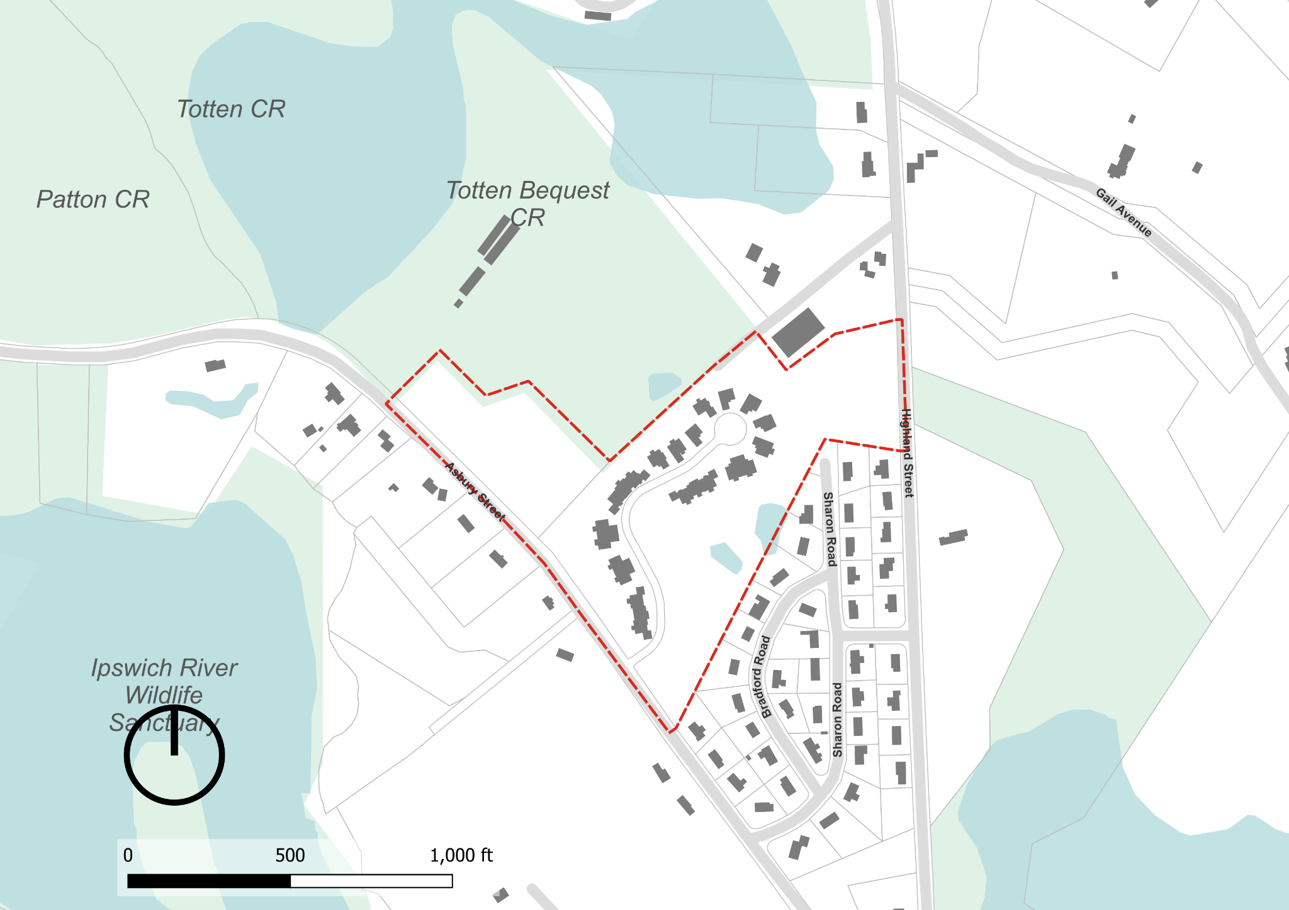

3A-MFOD

## **2.3 OVERLAY DISTRICTS.**

The following Overlay Districts are also established, as set forth in Section 8.0, herein.

Groundwater Protection Overlay District GPOD

Flood Plain Overlay District FPOD

Estate Overlay District EOD

~~Willow Street Overlay District WSOD~~

Commercial Overlay District COD

3A Multifamily Overlay District 3A-MFOD

**2.5 SPLIT LOTS.**

**2.5.2 By District Boundary.** Where a district boundary line between ~~a residential and a business district~~ an R District and a Town Center District divides any Lot existing at the time such line is adopted, the regulations for the less restricted portions of such lots shall extend no more than thirty (30) feet into the more restricted portion, provided the lot has lot frontage on a public way in the less restricted district.

## **3.1 PRINCIPAL USES.**

**TABLE OF USE REGULATIONS**

*Delete the last Column “B” Business District from the Table*

*Add the following uses under residential: A8 - Two Family Dwelling, A9 - Multi Family Dwelling,*

*Indicate in the table that A8 and A9 uses are not allowed (“N”) in the R-1A, R-1B and RA districts*

*Add 5 additional columns to include Depot Square, Bay Road Scenic, Willow Street Mixed Use and Downtown Residential Districts as follows:*

|  |  |  |  |  |  |
| --- | --- | --- | --- | --- | --- |
| 1. **Residential** | Depot Square | Bay Road Mixed-Use | Willow Street Mixed-Use | Downtown Residential | Bay Road Civic |
| **A1.** One Single Family Dwelling | N | Y | Y | Y | N |
| **A2.** Conversion of a Single Family Dwelling existing at the time of the adoption of the ordinance (1954) into a Two Family Dwelling (see Section 3.5) | Y | Y | Y | Y | N |
| **A3.** Open Space and Farmland Preservation Development (see Section 8.1) | N | N | N | N | N |
| **A4.** Senior Housing (see Section 8.2) | N | N | N | N | N |
| **A5.** Long Term Care Facility | ZBA | ZBA | ZBA | ZBA | ZBA |
| **A6.** Garage with more than 4 motor vehicle spaces | ZBA | Y | Y | ZBA | ZBA |
| **A7.** Two or more dwelling units, second floor and above when part of a mixed-use building or development | Y | Y | Y | N | Y |
| **A8**. Two-Family Dwelling | N | Y | Y | Y | N |
| **A9**. Multi Family Dwelling | N | Y | Y | Y | N |
| 1. **Community Facilities** | Depot Square | Bay Road Mixed-Use | Willow Street Mixed-Use | Downtown Residential | Bay Road Civic |
| **B1.** Use of land or  Structures for religious  purposes | Y | Y | Y | Y | N |
| **B2.** Museums, libraries and parks, playgrounds, conservation areas, water supply areas and other land owned and operated for the public enjoyment or service by a public or semi-public agency | Y | Y | Y | Y | Y |
| **B3.** Use of land or Structures for educational purposes on land owned or leased by the Commonwealth of Massachusetts or any of its agencies, subdivisions or bodies politic or by a religious sect or denomination, or by a nonprofit educational corporation | Y | Y | Y | Y | Y |
| **B4.** Hospital, Medical Clinic, cemetery, and camps of educational and charitable institutions | ZBA | ZBA | ZBA | N | ZBA |
| **B5.** Community or private club, not conducted for profit | ZBA | ZBA | ZBA | N | ZBA |
| **B6.** Nonprofit civic or fraternal building | N | N | N | N | N |
| **B7.** Child Care Center or School Aged Child Care Program | Y | Y | Y | Y | Y |
| **B8.** Commercial Recreation, Outdoors | N | N | N | N | SB |
| **B9.** Temporary use for amusements and recreation | SB | SB | SB | N | SB |
| **B10.** Municipal Buildings or facilities | Y | ZBA | ZBA | ZBA | Y |
| **B11.** Essential Services | Y | N | N | N | Y |
| 1. **Agricultural** | Depot Square | Bay Road Mixed-Use | Willow Street Mixed-Use | Downtown Residential | Bay Road Civic |
| **C1.** On parcels five (5) acres or more, or two (2) Qualified Acres or more: agriculture, horticulture and floriculture | N | N | N | N | N |
| **C2.** Gardens; riding stables; growing and storing of fruits, berries, vegetables, hay, fodder and ensilage; woodlots; forestry; and greenhouses | ZBA | ZBA | ZBA | ZBA | ZBA |
| **C3.** The raising or keeping of poultry, horses, or cows for other than the use of the occupants of the residence | ZBA | ZBA | ZBA | ZBA | ZBA |
| 1. **Commercial** | Depot Square | Bay Road Mixed-Use | Willow Street Mixed-Use | Downtown Residential | Bay Road Civic |
| **D1.** Adult Entertainment Uses | ZBA | N | N | N | N |
| **D2.** Motor Vehicle and/or Boat Sales and/or Leasing Shop | ZBA | N | N | N | N |
| **D3.** Business or Professional Office; bank; financial institution | Y | Y | Y | N | Y |
| **D4.** Communication Towers and Telecommunication Antenna Facilities (see Section 7.2) | PB | PB | PB | PB | PB |
| **D5.** Kennel | ZBA | ZBA | ZBA | ZBA | ZBA |
| **D6.** Funeral homes | ZBA | N | N | N | N |
| **D7.** Garage with more than four automobile/truck spaces | ZBA | ZBA | ZBA | N | ZBA |
| **D8.** Motor Vehicle Light Service Station | ZBA | N | N | N | N |
| **D9.** Manufacturing of products sold on the premises at retail, where no more than five operators are employed in such manufacture | ZBA | N | N | N | N |
| **D10.** Rail or bus station or terminal | ZBA | N | N | N | N |
| **D11.** Motor Vehicle Repair Shop | ZBA | N | N | N | N |
| **D12.** General Service Establishment | Y | N | N | N | N |
| **D13.** Personal Service Establishment | Y | Y | Y | N | Y |
| **D14.** Restaurant | Y | Y | Y | N | Y |
| **D15.** Restaurant, Fast Food | ZBA | N | N | N | N |
| **D16.** Retail Store | Y | Y | Y | N | Y |
| **D17.** Veterinary Facility or Clinic | ZBA | ZBA | ZBA | N | ZBA |
| **D18.** Wind Energy Facility in COD, subject to site plan approval (see Section 7.3) | N | N | N | N | N |
| **D19.** Wind Energy Facility (not in COD) (see Section 7.3) | ZBA | ZBA | ZBA | ZBA | ZBA |
| **D20.** Communications Tower and Telecommunication Antenna Facilities (see Section 7.2) | Y | Y | Y | Y | Y |
| **D21.** Mixed Use, subject to site plan approval | Y | Y | Y | N | Y |
| **D22.** Drive-In or Drive-Through Establishment | ZBA | N | N | N | N |
| **D23.** For Profit Educational Facility | ZBA | ZBA | ZBA | N | ZBA |
| **D24.** Marijuana Establishment | N | N | N | N | N |
| 1. **Accessory** | Depot Square | Bay Road Mixed-Use | Willow Street Mixed-Use | Downtown Residential | Bay Road Civic |
| **E1.** Up to three boarders in a Single Family Dwelling | N | Y | Y | Y | N |
| **E2.** Conversion for Temporary Living (see Section 3.4) | ZBA | Y | Y | Y | N |
| **E3.** Accessory Apartment (see Section 3.6) | ZBA | Y | Y | Y | N |
| **~~E4.~~** ~~Accessory Apartment on Large Lot (see Section 3.7)~~ |  |  |  |  |  |
| **E5.** Customary home occupation conducted in a Dwelling or Building accessory thereto by a person residing on the premises (see Section 3.3) | Y | Y | Y | Y | Y |
| **E6.** Accessory Uses or Building on the same Lot with and customarily incidental to a permitted main use on the same premises | Y | Y | Y | Y | Y |
| **E7.** Uses, whether or not on the same parcel as activities permitted as a matter of right, which are both: (a) accessory to activities permitted as a matter of right, and (b) necessary in connection with scientific research or scientific development or related production (see Section 3.2.1.2) | ZBA | ZBA | ZBA | ZBA | ZBA |
| **E8.** Parking area or garage for use of employees, customers or visitors | Y | Y | Y | N | Y |
| **E9.** Level Two Electric Charging Station | Y | Y | Y | Y | Y |
| **E10.** Large Family Child Care Home | ZBA | ZBA | ZBA | ZBA | ZBA |
| **E11.** Small Family Child Care Home | Y | Y | Y | Y | Y |
| **E12.** Adult Social Day Care | ZBA | ZBA | ZBA | ZBA | ZBA |
| **E13.** Marijuana Establishment | N | N | N | N | N |

**3.2 ACCESSORY USES.**

**3.2.2 Accessory Uses and Structures in the ~~Residence Districts~~ R1-A, R1-B, RA, Bay Road Mixed-Use, Willow Street Mixed-Use and Downtown Residential Districts.**

**3.2.3 Accessory Uses in the ~~Business~~ Depot Square District.**

In the ~~Business~~ Depot Square District any use permitted as a Principal Use is also permitted as an Accessory Use provided such use is customarily incidental to the main or principal building or use of the land.

## **6.1 OFF-STREET PARKING AND LOADING AREAS.**

**6.1.9 Site Plan.** Parking areas and loading areas in the ~~Business~~ Depot Square District shall be shown on a site plan, as provided in Section 10.6.

## **6.3 SIGNS.**

**6.3.2 ~~Residence~~ R-1A, R1-B, RA, and Downtown Residential Districts**

**6.3.3 ~~Business~~ Depot Square, Bay Road Mixed Use and Willow Street Mixed Use Districts**

**6.3.4 Standards**

8. A sign in the ~~business~~ Depot Square, Bay Road Mixed Use and Willow Street Mixed Use Districts shall not exceed a total area of (6) square feet.

## **8.2 SENIOR HOUSING.**

**8.2.2 Eligible Locations.** A Special Permit may be granted for Senior Housing on any lot(s) in the R- lA, R-1B, or R- A., ~~or B~~,

**8.2.7 Permitted Uses.** A Senior Housing development may include the following uses:

~~12. In the Business District a mixture of residential and business uses.~~

**8.2.9 Base Senior Housing Density.** The Base Density per Developable Acre for a Senior Housing Special Permit shall be: ~~four (4) Dwelling units in the Business District;~~ three (3) Dwelling units in the RI-A District, two (2) Dwelling units in the Rl-B District, and one (1) Dwelling unit in the RA District.

**NOTES ON HOW TO READ THE MATRIX:**

*Delete entire row for B District*

Column I: Encourages other initiatives which provide a public benefit to the Town such as, but not limited to, preservation and enhancement of trails; creation of playing fields; environmental, energy, water conservation, green building design, and other public benefits. For one (1) or a combination of these initiatives, an applicant may earn one (1) additional Dwelling Unit per Developable Acre in the ~~Business,~~ R1-A, and Rl-B Districts, and up to two (2) additional Dwelling Units per Developable Acre in the RA District.

**8.2.11 Minimum Distance between Projects.**

~~4. Senior Housing proposals in the Business District shall be exempt from the provisions of this Section and developments wholly within the Business District shall not be considered as existing or approved projects for purposes of establishing required project separation in any other district.~~

**8.2.13 General Requirements.** The following requirements shall apply.

3. Location of Wastewater Treatment. All wastewater shall be treated and discharged on-site. Off-site wastewater treatment is not allowed. ~~An exception to this is for parcels located in the Business District, where wastewater treatment may be located off-site.~~

## **8.3 INCLUSIONARY HOUSING**

**8.3.3 Mandatory Provision of Affordable Housing Units.** In any development subject to this Section, the tenth dwelling unit and every seventh unit thereafter shall be an Affordable Housing Unit, except in the 3A-MFOD, Bay Road Mixed-Use, Willow Street Mixed-Use, and Downtown Residential districts, where the tenth dwelling unit and every tenth unit thereafter shall be an Affordable Housing Unit. Nothing in this Section shall preclude a developer from providing more Affordable Housing Units than are required hereunder.

## **9.1 GROUNDWATER PROTECTION OVERLAY DISTRICT (GPOD)**

**9.1.4 Dimensional Requirements.** Regardless of the minimum Lot size of the underlying zone, there shall be a minimum lot area of eighty thousand (80,000) square feet per dwelling unit in the GPOD. Proposed development in the 3A-MFOD electing to seek a permit through the provisions of that overlay, and not through the provisions of the underlying district, are exempt from the minimum lot area per dwelling limitation.

**9.1.9 Uses and Activities Requiring a Special Permit.** The following uses and activities are permitted only upon the issuance of Special Permit by the Zoning Board of Appeals under such conditions as it may require. Proposed development in the 3A-MFOD electing to seek a permit through the provisions of that overlay, and not through the provisions of the underlying district, are exempt from the Special Permit Requirement.

## **9.4 WILLOW STREET OVERLAY**

*Remove this section entirely. Provisions no longer necessary due to replacement of underlying zoning.*

## **11.0 DEFINITIONS**

**Floor Area Ratio (FAR):** The ratio of the total Gross Floor Area of all buildings on a lot to the total lot area. For the purposes of calculating FAR, basements, cellars, attics, garages and interior parking spaces shall be excluded from the GFA. Half-stories that meet the criteria listed in 9.7.2.1.2 (j), Half Story, shall be counted as one half of the GFA of the floor below.

**~~Dwelling,~~** ~~Three-family: A building containing three dwelling units, each of which has direct access to the outside or to a common hall that leads to the outside.~~

**~~Dwelling,~~** ~~Four-family: A building containing four dwelling units, each of which has direct access to the outside or to a common hall that leads to the outside.~~

**Dwelling, Multi Family:** A building containing ~~five~~ three or more dwelling units, or two or more buildings on the same lot with more than one residential dwelling unit in each building, except as otherwise defined in this Bylaw.