Hamilton Town Center Base Zoning

**SECOND DRAFT for Planning Board Review**

2025-04-24

# 9.7 HAMILTON TOWN CENTER BASE ZONING.

The Hamilton Town Center Zoning consists of 4 Sections:

**Purpose and Intent**  
This section introduces the purpose and intent of the zoning generally, how and where it is to be applied, and how the regulations of this section relate to other sections of the bylaw.

**Interpretation**  
This section provides definitions and explanations of the terms and metrics that are used to regulate building scale, form and placement. Many of the terms are unique to this section.

**Town Center Districts**  
This section describes the purpose and intent of each subdistrict, as well as any relevant planning considerations. It also includes district-wide tables with dimensions for lots and buildings. A complete allowed use table is included as well which is specific to the Town Center sub-districts.

**Administration**

This section outlines the permitting path for proposed development, including whether Site Plan review or a Special permit are required.

# 9.7.1. PURPOSE AND INTENT.

**1. Purpose.** The purpose of this Article is to regulate the use of land, buildings, and structures in the Town in a way that preserves the historic village character of downtown Hamilton, and to provide standards for multifamily housing development that are both in accordance with G.L. c. 40A, § 3A and the Regulations issued by the Executive Office of Housing and Livable Communities (HLC) set forth at 760 CMR 72.00 and consistent with the Town’s existing character.

**2. Intent.** This Article is intended to ensure development in Hamilton’s downtown contributes to the realization of the [Hamilton Town Center Vision Plan](https://docs.google.com/presentation/d/1QyuEc1qKCFhwlbIDQigC12AALwFk7PO9_jCP7LiXnaA/edit?usp=sharing) developed over the course of a townwide visioning process conducted throughout 2024 and 2025. Specifically, this Article intends to:

1. Ensure that new development is compatible with the historic and village character of downtown Hamilton.
2. Preserve and enhance the historic commercial corridor along Railroad Ave and Depot Square.
3. Promote the activation of the Downtown, support the commercial uses and promote increased walkability.
4. Provide a variety of housing types that cater to the diverse and changing needs of Hamilton’s residents.
5. In conjunction with Section 9.6 3A-MFOD, comply with G.L. c. 40A, § 3A and the Section 3A Compliance Guidelines of the Executive Office of Housing and Livable Communities (HLC).

**3. Applicability.**

1. *Territorial Application.* This article is applicable to all real property, structures, and uses located in the Depot Square, Bay Road Mixed Use, Downtown Mixed Use, Downtown Residential District, and Bay Road Civic Districts as these districts are depicted on official Town of Hamilton Official Zoning Mapdated XXXXX.
2. *Required Conformance.* 
   1. All buildings, structures or land, in whole or in part, must be used or occupied in conformance with this Article. All buildings or structures, in whole or in part, must be erected, constructed, moved, enlarged or structurally altered in conformance with this Article.
   2. If any condition or requirement imposed by this Form-Based Code is more restrictive than a condition or requirement imposed by any other law, rule or regulation of any kind, the more restrictive condition or requirement from this Article governs.
3. *Conflicting Provisions.* 
   1. If any condition or requirement imposed by this Article contains an actual, implied or apparent conflict with another provision of this Article, the more restrictive condition or requirement controls.
   2. If any condition or requirement imposed by this Article contains an actual, implied or apparent conflict with any condition or requirement of any other provision of the Town of Hamilton's Bylaws, the provisions of this Article control.
4. *Text and Graphics.* Illustrations, photographs and graphics are included in this Article to illustrate the intent and requirement of the text. In the case of a conflict between the text of this Article and any illustrations, the text governs.
5. *Existing Applications and Permits.*
   1. Any project for which a valid and complete application for a permit was received prior to the effective date of this Article remains valid and, at the applicants option, may proceed to completion and permits may be issued under the regulations of the Town in place immediately prior to the effective date of this Article, provided that the permit is or can be issued within 90 calendar days of this Article effective date and all time frames associated with the permit are observed.
   2. Any project for which a permit cannot be issued within 90 calendar days from the effective date of this Article must proceed in accordance with these regulations.
6. *Severability.* If any provision of Section 9.7 is found to be invalid by a court of competent jurisdiction, the remainder of Section 9.7 shall not be affected but shall remain in full force. The invalidity of any provision of Section 9.7 shall not affect the validity of the remainder of Hamilton’s Zoning Bylaw.

# 9.7.2. INTERPRETATION.

**1. Site Dimensional Standards and Measurements.**

1. *Yards.* See Definitions Section 11. Each yard measurement is made perpendicular to the property line and begins at the property line. Measurements are made to the nearest portion of the building, excluding open porches less than 8ft. deep and bay windows less than 3 ft. deep.
2. *Frontage.* The side of a lot that faces a street or public way as defined in Section 11. For lots bounded by more than one street, all frontages shall conform to the dimensional standards applicable to Front.
3. *Lot Size.* The area of a lot measured as the land within the parcel lines.
4. *Open Space.* Land within a lot not covered by any structures or area dedicated to vehicular use including parking spaces and drive aisles.
5. *Parking Setbacks.*All parking spaces must be located behind the parking setback lines or as otherwise indicated. Each setback measurement is made perpendicular to the property line and begins at the property line.
6. *Number of Buildings.* Multiple buildings are permitted on each lot, subject to the dimensional requirements listed in Section 9.7.3. Where there are more than one building, FAR limitations shall apply to all buildings cumulatively, and Maximum Building Footprints limitations shall be applied on a per building basis.

**2. Building Dimensional Standards and Measurements.**

1. *Depth.* Measurement of a building, yard, or setback measured perpendicular to a Front lot line, excluding open porches less than 8ft. deep and bay windows less than 3 ft. deep.
2. *Facade Build Out.* The ratio of the façade width within the minimum and maximum Front Yard dimensions to the lot width, calculated by dividing the cumulative façade width by the lot width. Facade build out is intended to ensure that new development addresses the street in a pedestrian-friendly manner and that frontage conditions are compatible with existing patterns.

1. *Facade Length Without Offset.* The maximum allowable length of any building facade, front, side or rear, without a change in the plane of 5 ft. or greater, extending from the ground plane to the roof. The purpose of offset requirements is to limit long, undifferentiated facades and to ensure that larger building massings are broken down into smaller elements that are more reflective of the existing context.

1. *Building Footprint.* the area of land occupied by a building, defined by the outer edge of its foundation and exterior walls inclusive of covered parking and other enclosed spaces. Cantilevered elements that do not touch the ground, such as bay windows, do not contribute to the calculation of footprint area provided they do not protrude more than 3 ft. from the face of the building. Unenclosed porches less than 8ft deep do not contribute to the calculation of the building footprint.

1. *Building Separation.* The distance between buildings on a lot, measured from the nearest primary face of each building at its closest point, excluding bay windows less than 3 ft. deep and porches less than 8 ft. deep.

1. *Height.* See Definitions Section 11. In the Town Center Zoning, for buildings on lots fronting more than one public way, height shall be measured from all frontages.
2. *Roof.* Roof forms include gable, hip, gambrel, mansard, shed, and flat, and are permitted as detailed in Section 3.7 Building Standards. Gable, hipped and shed roofs shall have a minimum slope of 9:12.

|  |  |
| --- | --- |
| A drawing of a house  AI-generated content may be incorrect.  Gable Roof | A drawing of a roof pitch  AI-generated content may be incorrect.  Hipped Roof |
| A drawing of a house  AI-generated content may be incorrect.  Shed Roof | A white box with a roof  AI-generated content may be incorrect.  Gambrel Roof |
| A white box with a lid  AI-generated content may be incorrect.  Mansard Roof | A white box with a black outline  AI-generated content may be incorrect.  Flat Roof |

1. *Width.* Measurement of the length of a building parallel to a Front lot line.
2. *Fenestration.* The percentage area of glazing at the ground level, measured between 2 ft. and 10 ft. above the finished floor of the ground story. Where fenestration requirements apply, ground story windows should be display windows that may or may not have muntins and/or mullions, decorative stiles and or a combination of display windows and transoms supported by appropriate kickplates. The windows may be segmented with trim, piers or wall plane. Where required, minimum ground floor fenestration is intended to ensure that ground floor uses can activate the public realm.

1. *A diagram of a house

   AI-generated content may be incorrect.Half story.* The occupiable portion of a building between the uppermost floor and a pitched roof supported by a bottom plate no greater than 3 ft. above the floor level, and containing dormers whose aggregate length is less than 50% of the length of the roof measured horizontally. Where a story is being counted as a half story, dormers shall be located a minimum of 3 ft. from the edge of the primary roof. The uppermost level of gambrel, mansard and flat roofs may not be considered a half story and shall be considered a full story.

# 9.7.3. TOWN CENTER DISTRICTS.

## 1. Depot Square.

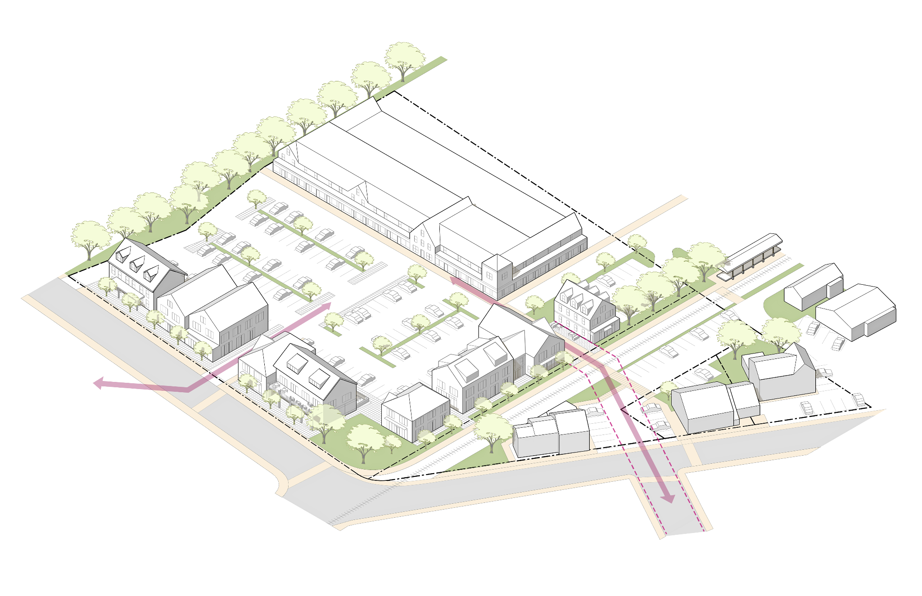

1. *Description.* The Depot Square district is characterized by two distinct conditions - on Railroad Ave by buildings with small footprints up to two and a half (2.5) stories in height, and east of the rail corridor, a large auto-centric shopping center. The area along Railroad Ave has the character of a small and historic town center; most buildings sit close together and near the sidewalk, while other buildings maintain some space between one another and include parking lots. The shopping center features large, one story buildings separated from its frontage by large parking areas. The district is primarily commercial, with some mixed-use residential near the edges. Most buildings west of the rail corridor were designed to accommodate commercial uses with form consistent with the historic residential buildings nearby.
2. *Purpose and Intent.* 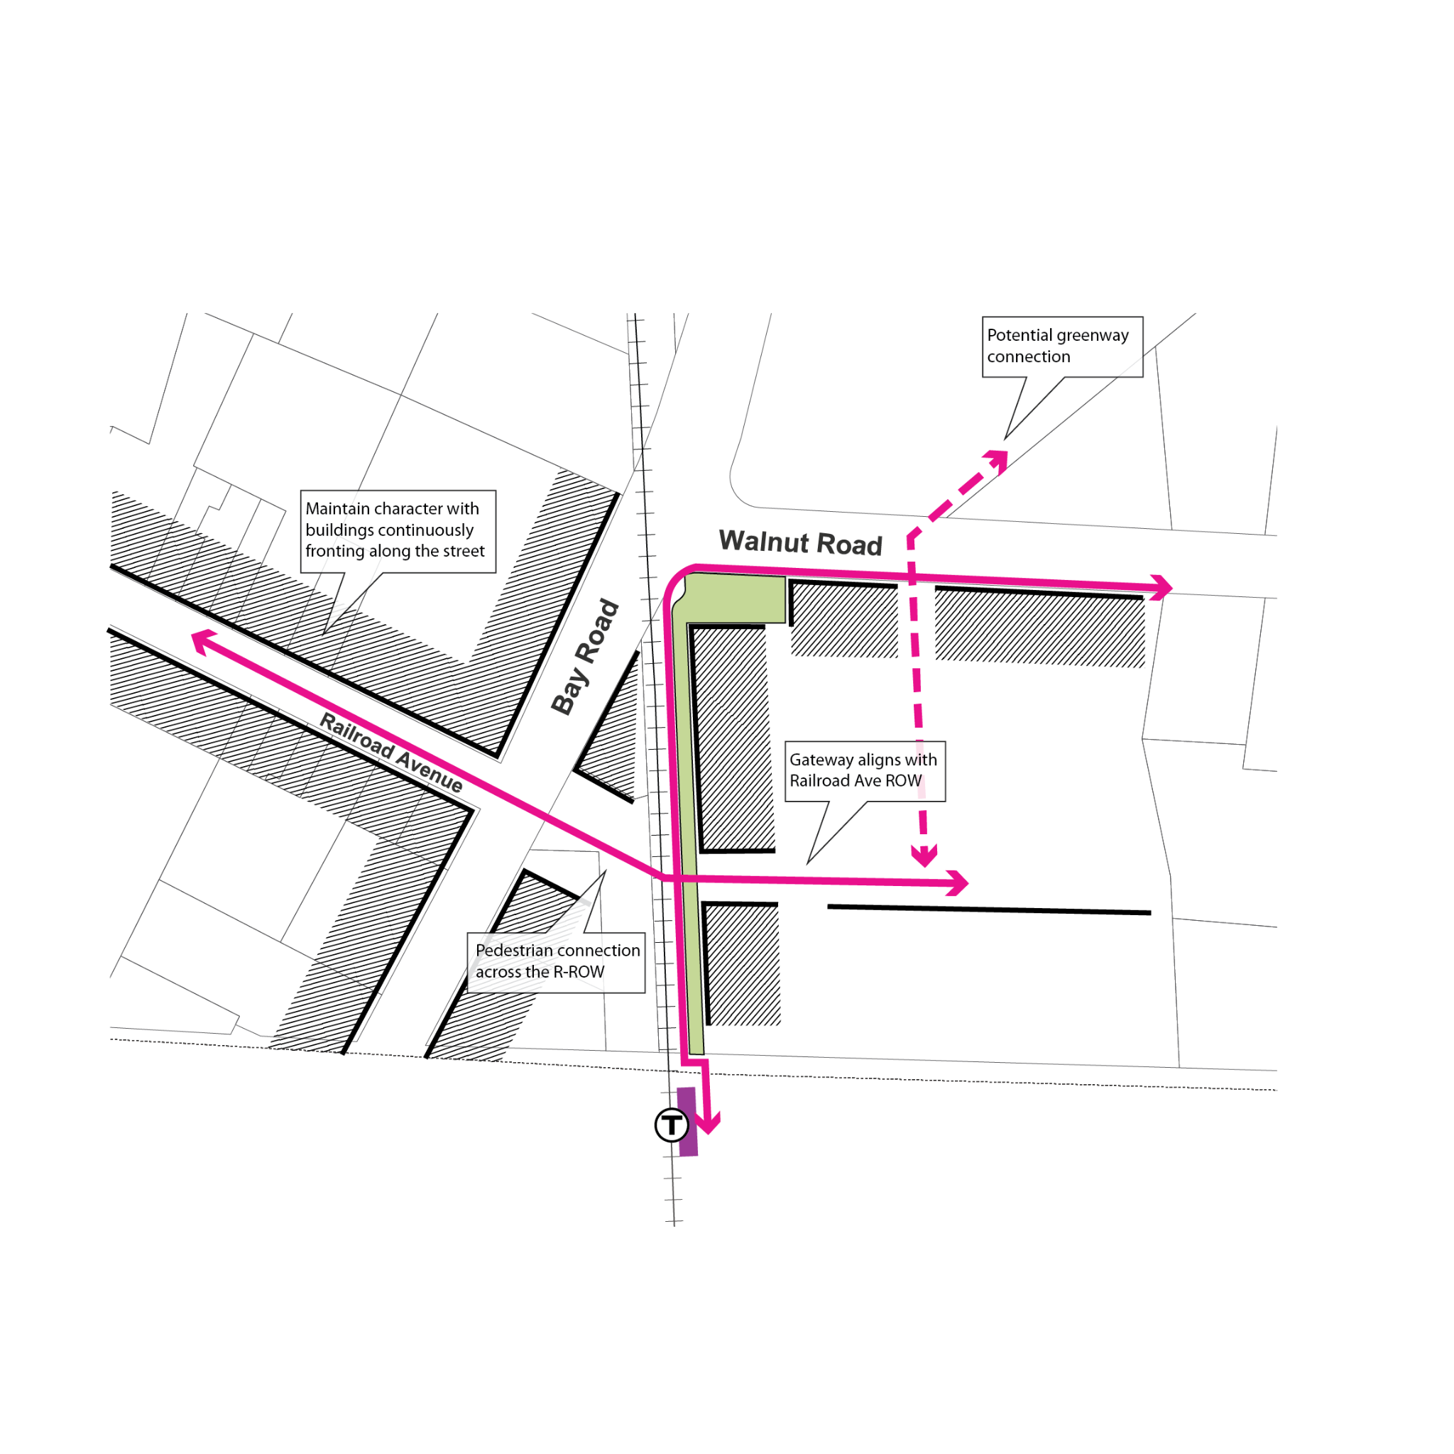
   1. To foster a mixed-use and vibrant town center and preserve the existing small-scale commercial character along Railroad Ave.
   2. To enhance a continuously built front along main public thoroughfare frontages in the district.
   3. To extend the small-scale commercial character pattern on Railroad Ave to future development in other larger parcels of the district.
   4. To preserve and extend the visual and pedestrian corridor along Railroad Ave across the MBTA tracks.
   5. To preserve existing open space/green space areas at critical intersections.
   6. To promote walkability and safety along all street frontages.

## 2. Bay Road Civic.

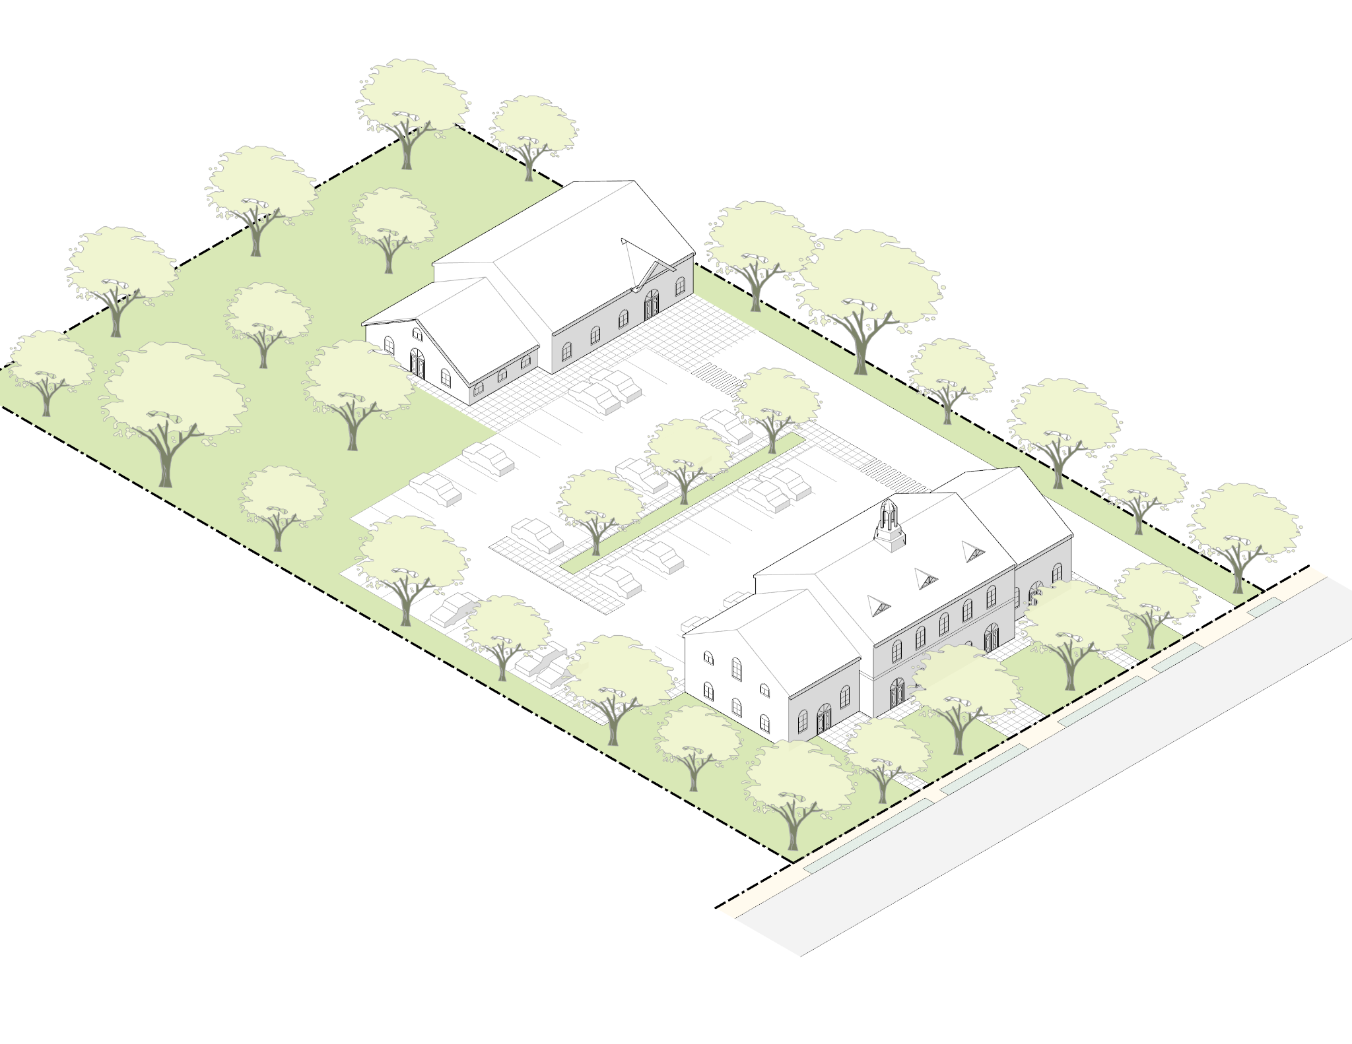

1. *Description.* The Bay Road Civic district is owned by the Town and hosts municipal functions, including the Public Safety Complex, the Council on Aging, and the Building and Health Departments. The current arrangement of buildings and parking do not align with the traditional frontages of the Bay Road corridor. The site occupies an important “gateway” moment for the Downtown, where the alignment of Bay Road straightens out and the historic pattern of large structures set back behind generous lawns begins.
2. *Purpose and Intent.* The purpose of this district is to guide the placement and scale of potential future buildings on this site that can improve and restore the consistency of Bay Road frontages. The regulations are crafted to ensure that the desirable patterns of Bay Road are enhanced while allowing the flexibility that may be required for additional municipal uses.

## 3. Bay Road Mixed-Use.

1. *Description.* Most of the Bay Road Mixed-Use district matches the form of nearby residential areas where buildings have small footprints and a maximum height of two and a half stories (2.5). The eastern half of the district contains a mix of residential, commercial, and civic uses, and is characterized by generous front yards and building types that are residential in form. The western side of Bay Road has a greater mix of building types and uses, and hence less consistent street edge and front yard conditions.
2. *Purpose and Intent.* The regulations for Bay Road are intended to preserve and restore the historically scenic character of Bay Road, when the thoroughfare was tree-lined and more pedestrian-oriented in nature, while allowing a variety of uses, including residential and commercial. Several parcels on the east side of Bay Road abut an unused rail corridor and potential future recreational pathway. Consideration should be given to these important future connections in the planning of these deep lots where multiple frontages and access points may be possible.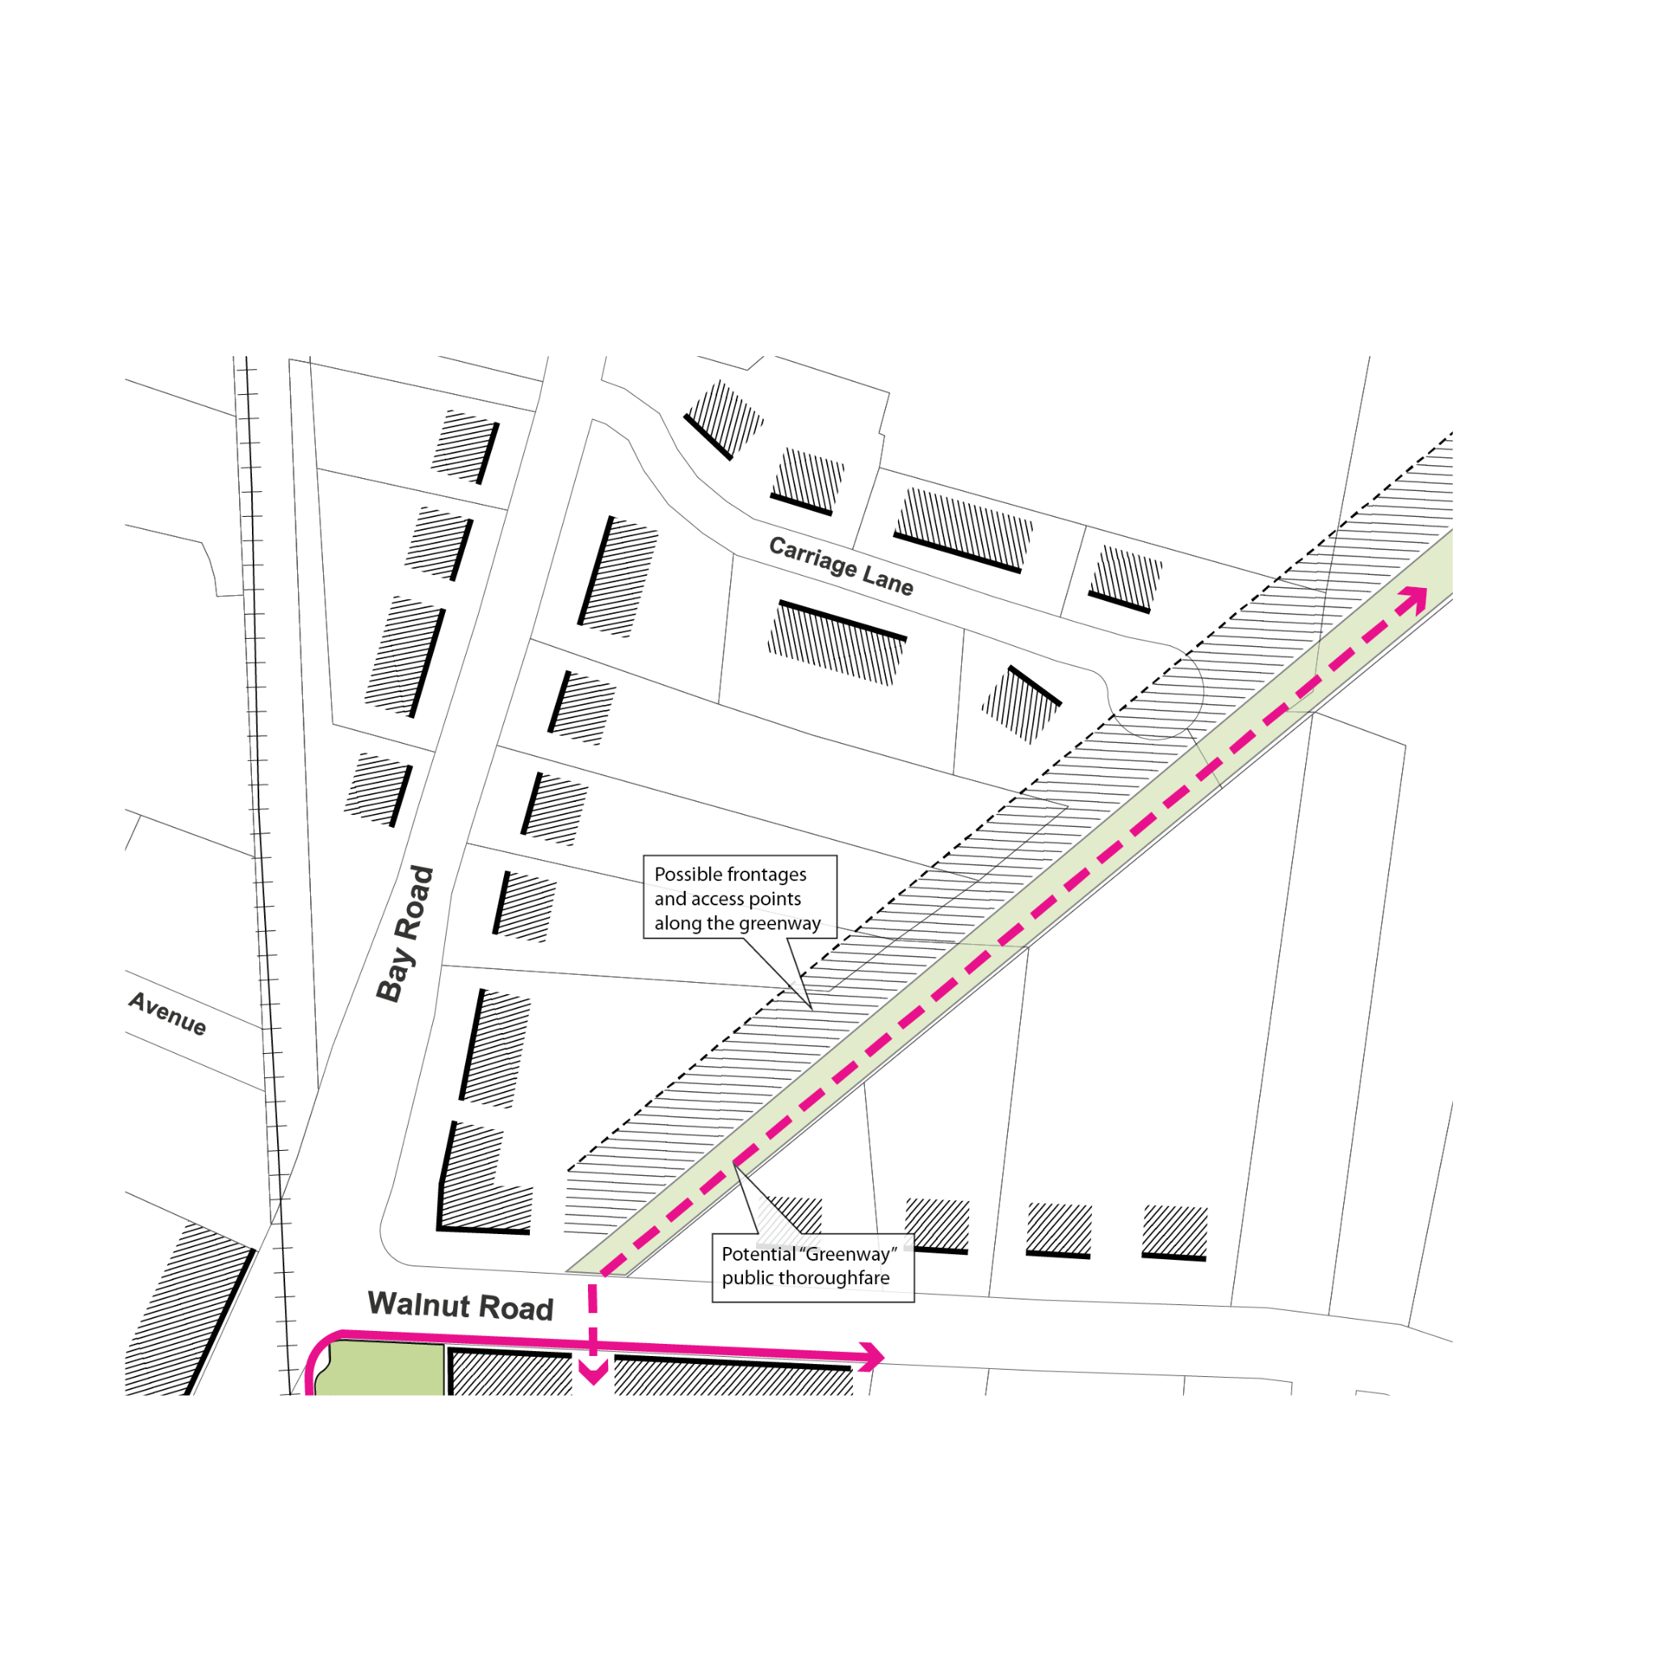

## 4. Willow Street Mixed-Use.

1. *Description.* The Willow Street Mixed Use district contains a variety of forms and uses. Portions of the district have commercial and/or light industrial-use buildings with relatively large floor plates, other portions have mixed-use buildings with moderately sized floor plates, while other portions of the site are primarily residential with smaller floor plates. The orientation of the rail corridor is such that rear yards are rarely consistent in depth.The objective of the code is to promote a more vibrant and walkable district through the activation of mixed use building frontages while respecting the scale and residential character of the adjacent Downtown Residential District.
2. *Purpose and Intent.* The objective of the code is to promote a more vibrant and walkable district by activating mixed-use building frontages while respecting the scale and residential character of the adjacent Downtown Residential District. Already mixed-use in character, the east side of Willow Street can accommodate more pedestrian-friendly ground floor uses and frontage conditions, supported by new residential uses. The code restricts the scale of buildings directly along Willow Street to match the abutting Downtown Residential district and allows for taller buildings toward the rear of the lot.

## 5. Downtown Residential.

1. *Description.* The Downtown Residential district is characterized by buildings that sit on small lots with small floor plates and with a height of about 2.5 stories. This district is almost entirely residential with a very small selection of parcels with commercial or institutional uses.
2. *Purpose and Intent.* The regulations seek to preserve the existing scale and character of the neighborhood while permitting incremental infill development and adaptation. The dimensional standards reflect the current single-family patterns while allowing for additional units within those envelopes.

# 9.7.4. DIMENSIONAL STANDARDS.

## 1. Site Dimensional Requirements.

|  |  |  |  |  |  |  |
| --- | --- | --- | --- | --- | --- | --- |
|  | Lot Dimensions | Depot Square | Bay Road Mixed-Use | Willow Street Mixed-Use | Downtown Residential | Bay Road Civic |
|  | Lot Size (min) | 1,000 ft | 5,000 ft | 3,000 ft | 3,000 ft | 5,000 |
| **A** | Lot Width (min) | 20 ft | 40 ft | 40 ft | 30 ft | 40 ft |
|  | Coverage | Depot Square | Bay Road Mixed-Use | Willow Street Mixed-Use | Downtown Residential | Bay Road Civic |
|  | Open Space (min) | 0% (note 1) | 40% | 40% | 40% | 40% |
|  | Building Yards Setbacks | Depot Square (note 3) | Bay Road Mixed-Use | Willow Street Mixed-Use | Downtown Residential | Bay Road Civic |
| **B** | Front Yard Setback on streets (min/max) (note 2) | 0 / 10ft. | 20 / 35 ft | 10 / 20 ft | 10 /20 ft | 20 / 35 ft |
| **C** | Side Yard Setback (min) | 0 ft | 5 ft | 5 ft | 10 ft | 10 ft |
| **D** | Rear Yard Setback (min) | 0 ft | 20 ft | 20 ft | 20 ft | 10 ft |
|  | Parking Setbacks | Depot Square | Bay Road Mixed-Use | Willow Street Mixed-Use | Downtown Residential | Bay Road Civic |
| **E** | Front Setback (min) | 10 ft | Aligned with, or set back further than, building frontage | | | |
| **F** | Side Setback (min) | 0 ft | 5 ft | 5 ft | 5 ft | 5 ft |
| **G** | Rear Setback (min) | 0 ft | 5 ft | 5 ft | 5 ft | 5 ft |
|  | Parking Requirements | Depot Square | Bay Road Mixed-Use | Willow Street Mixed-Use | Downtown Residential | Bay Road Civic |
|  | Parking spaces (min) | Per section 6.1 or by Special Permit | | | | |

Note 1: Corner lots in the Depot Square District must preserve existing contiguous patches of open space that are 3,000 sf or more.

Note 2: Includes frontage along the rail corridor within the Depot Square district. Porches less than 8ft in depth and bay windows less than three feet in depth may protrude into the Front Yard in all districts except Depot Square.

Note 3: Side and Rear Yards in the Depot Square District that directly abut a different zoning district shall conform to the minimums required in the abutting district.

.

## 2. Building Standards.

|  | Massing | Depot Square (note 1) | Bay Road Mixed-Use | Willow Street Mixed-Use | Downtown Residential | Bay Road Civic |
| --- | --- | --- | --- | --- | --- | --- |
| **A** | Building Footprint  (max per building) | 5,000 sf (note 2) | 3,000 sf | 5,000 sf | 3,000 sf | N/A |
| **B** | Facade Build Out (min) | 60% | 35% | 35% | 35% | 35% |
| **C** | Height (max) | 35 ft / 2.5 stories | 35 ft / 2.5 stories | 35 ft / 2.5 stories for the first 60 ft from the front lot line, 45 ft / 3.5 stories elsewhere | 35 ft / 2.5 stories | 35 ft / 2.5 stories |
|  | Number of Stories Minimum | N/A | 2 | 2 | 2 | 2 |
| **D** | Ground Floor Height (min/max) | 13 / 15 ft | 13 / 15 ft | 13 / 15 ft | N/A | N/A |
|  | Floor Area Ratio (max) | N/A | 0.39  0.45 by SP | 0.42  0.45 by SP | 0.40  0.45 by SP | N/A |
| **E** | Facade Length without Offset (max) | 70 ft | 70 ft | 70 ft | 70 ft | 70 ft |
| **F** | Building Separation (min) | 30 ft | 10 ft | 10 ft | 20 ft | 0 ft |
|  | Roof | Depot Square | Bay Road Mixed-Use | Willow Street Mixed-Use | Downtown Residential | Bay Road Civic |
|  | Allowed Roof Type (note 3) | Gable, hip, gambrel, mansard, shed, flat | Gable, hip, gambrel, mansard, shed | Gable, hip, gambrel, mansard, shed | Gable, hip, gambrel, mansard, shed | Gable, hip, gambrel, mansard, shed, flat |
|  |  |  |  |  |  |  |
|  | Windows | Depot Square | Bay Road Mixed-Use | Willow Street Mixed-Use | Downtown Residential | Bay Road Civic |
|  | Ground Story fenestration (min) | 50% | N/A | N/A | N/A | 20% |
|  | Doors | Depot Square | Bay Road Mixed-Use | Willow Street Mixed-Use | Downtown Residential | Bay Road Civic |
|  | Street Facing Entry Feature | Required | Required | Required | Required | Required |

Note 1: The Depot Square District requirements only apply to the first 80 ft as measured perpendicular from a property line bounded by the street. Additional development area requires a special permit.

Note 2:Larger building footprints allowed by special permit process as described in 10.6.

Note 3: Roof forms may be combined, so long as minimum roof steepness is maintained.

## 

# 9.7.5. USE PROVISIONS.

Note: the use table previously included here has been moved such that it would be an amendment to the existing use table housed in Section 3.1 of Hamilton’s existing code. All edits to the table are tracked in that location.

The allowable uses and accessory uses in the Town Center districts are contained in Section 3.0 Use Regulations. The following clarifications and exceptions are made with respect to the Town Center Districts:

Use A6, a Garage with more than 4 motor vehicle spaces, is permitted in the Bay Road Mixed Use, and Willow Street Mixed Use districts provided it is:

1. Accessory to a Multi Family Dwelling, and;
2. Located below grade or at grade beneath the primary building massing and not in a stand-alone structure.

Use A7**,** Two or more dwelling units, second floor and above when part of a mixed-use building or development, is allowed in the Depot Square District provided all of the following criteria are met:

1. the ground floor area associated with the dwelling units are limited to entry areas, lobbies and vertical circulation elements such as stairs and elevators
2. the residential ground floor uses occupy a minimum of 10% of the primary building frontage, or 10 ft., whichever is greater
3. the ground floor non-residential uses are a minimum of 20 ft. deep

# 9.7.6. SITE STANDARDS.

## 1. Site Access.

All development must provide vehicle, pedestrian, and bicycle access to and from a street.

1. *Pedestrian Access.*
   1. All development must provide pedestrian access connecting main entrances of buildings, establishments or uses on a site that allows for public access, with all other public entrances with available access points including adjacent rights of way, all parking lots, and sidewalks.
   2. Pedestrian access must consist of an accessible, easily discernible walkway with a minimum width of 5 feet.
   3. Pedestrian access routes between buildings must be physically separated from parking lots, except where required to cross a drive aisle; crossings must be perpendicular wherever practicable.
2. *Vehicle Access.*
   1. All parking spaces, parking lots, and driveways must have vehicle access from a street.
   2. No parking spaces or parking lots shall be located within the front yard for principal structures. Parking of vehicles shall be allowed within driveway areas providing access to a principal structure, as long as the driveway is designed at a proper width for parking.
   3. No parking areas, parking lots or access drives shall be located within the minimum separation area between structures.
   4. Parking garage entries that face a public way must be set back 60 ft. from the property line(s) abutting the public way.

## 2. Parking.

1. The quantity of off-street parking spaces shall be in accordance with the requirements of Section 6.1 of Hamilton’s Zoning By-Law.
2. All driveways must comply with Section 6.2.2 of Hamilton’s Zoning By-Law.
3. All parking spaces and structures must be located at or behind any required parking setback as specified for each Town Center District.
4. The maximum width of a curb cut and driveway for access to parking lots and structures is as follows:   
     
   One-lane: 12 ft   
   Two-lane: 24 ft
5. Each lot is limited to one curb cut per street frontage. Lots with more than 200 feet of frontage are allowed one additional curb cut every 200 feet.
6. The grade, cross slope, and clear width of the walkway of a sidewalk must be maintained between the driveway apron and the abutting driveway. The appearance of the walkway (i.e., scoring pattern or paving material) must indicate that, although a vehicle may cross, the area traversed by a vehicle remains part of the pedestrian sidewalk.
7. Shared driveways are encouraged where they reduce the interruption of curb cuts and allow for more landscape treatment. Permits shall be issued subject to the requirements of 6.2.6 Common Driveway.
8. Parking Lots with 10 or more parking spaces must have interior islands, median islands, and perimeter islands that conform with the following requirements:
   1. *Interior Islands.*
      1. An interior landscape island must be provided every 10 parking spaces and at the end of every parking row. Intervals may only be modified to preserve existing trees. Interior islands must be distributed evenly throughout the parking area.
      2. An interior landscape island abutting a single row of parking spaces must be a minimum of 8 feet in width and 150 square feet in area (measured inside the curb). The island must include 1 tree with a minimum caliper of 2½ inches.
      3. An interior landscape island abutting a double row of parking spaces must be a minimum of 8 feet in width and 300 square feet in area (measured inside the curb). This island must include 2 trees with a minimum caliper of 2½ inches.
   2. *Median Islands.*
      1. A median landscape island must be provided between every 4 rows of parking. Intervals may be modified to preserve existing trees.
      2. A median landscape island must include a tree with minimum caliper of 2½ inches spaced every 30 feet on average. Trees planted in an interior landscape island that overlap may be included in the count.
      3. A median landscape island must be a minimum of 6 feet wide. A landscape median island with a pedestrian walkway must be a minimum of 12 feet wide (measured inside the curb).
   3. *Perimeter Islands.*
      1. A perimeter landscape island is required on the outer edge of all parking lots when abutting the street or an internal access drive.
      2. A perimeter landscape island must be a minimum of 10 feet wide not including any curbing.
      3. Landscaping of perimeter islands must include evergreen shrubs planted 3 feet on center in a planting bed that is of a width suitable for the required plant spacing, but at least 36 inches wide.
      4. A perimeter landscape island must include a tree with minimum caliper of 2½ inches spaced every 30 feet on average.

## 3. Screening.

1. *Parking Lots.* Parking lots must be separated from the public right-of-way and abutting properties by a landscaped strip with a depth equal to the parking setback as specified in the Dimensional Requirements for each Town Center District. The landscaped strip must adhere to the following design standards:
   1. The landscape strip must run the full length of the parking lot perimeter along the right-of-way, excluding curb cuts and driveways.
   2. The landscape strip must be planted with shrubs, perennials, native grasses, and other planting types that provide screening from the public right-of-way.
   3. An optional low picket fence or pedestrian wall may be installed behind the landscape strip and set back up to 24” from the adjacent parking lot to accommodate for car overhang.
   4. The use of Low-Impact-Development (LID) stormwater management techniques such as rain gardens and bioswales is encouraged in landscape strips.
2. *Waste Receptacles.*
   1. Outdoor waste receptacles must be located to the side and rear of buildings.
   2. Outdoor waste receptacles must be screened on three sides by an opaque wall or fence a minimum height of 6 feet.
   3. Access gates must be provided on the fourth side and must also be a minimum height of 6 feet.
3. *Roof-Mounted Equipment.* All outdoor mechanical, electrical or utility equipment (except for solar panels, wind turbines and antennas) must be screened on the roof edge by an opaque parapet wall or other type of screen that is at least a height 6 inches higher than the topmost point of the equipment being screened.
4. *Ground-Mounted Equipment.* 
   1. Ground-mounted mechanical, electrical or utility equipment must be located to the side and rear of buildings.
   2. Ground-mounted mechanical, electrical or utility equipment visible from a public right-of-way must be fully screened by an opaque wall or fence or other type of screen that is at least a height 6 inches higher than the topmost point of the equipment being screened.
5. *Wall-Mounted Equipment.*
   1. Wall-mounted mechanical or electrical equipment must be located to the side and rear of buildings.
   2. Wall-mounted mechanical, electrical or utility equipment visible from a public right-of-way must be fully screened by an opaque wall or fence or other type of screen that is at least a height 6 inches higher than the topmost point of the equipment being screened.

## 4. Building Materials.

1. *Applicability.* The exterior visible surfaces of buildings and structures, including accessory structures, subject to Site Plan Review.
2. For All Structure Exteriors
   1. Existing structures undergoing regular maintenance or enlargement must use materials similar in color, size and texture to the original structure's materials as to blend patch or repair work seamlessly with existing materials.
   2. Replacement of existing materials that are no longer allowed must be completed by permitted materials. This standard does not apply to small patches, rather it is intended for whole replacement, i.e. whole roof replacement or whole facade reconstruction.
   3. Exterior building materials must be those typically used in historic construction or be a composite or synthetic material that bears a strong resemblance to traditional building materials, including but not limited to brick, wood siding, engineered wood, or fiber cement artificial wood siding, asphalt shingle, tile roof shingle, copper roofing, stone masonry, and stucco.
   4. Concrete masonry units, pre-cast concrete panels, cinder block, vinyl siding, ribbed metal siding or roofs, EIFS is not allowed unless required due to the expansion of an existing building to match the original structure.
   5. All windows and doorways shall be encased with wood or simulated wood trim; decorative trim is preferred. Aluminum windows shall be finished to match the proposed trim color of the building.
   6. Deviation from the standards above will require approval from the Planning Board deeming that the finishes are of a design and quality that will elevate rather than detract from the appearance of the corridor.

## 5. Landscape Standards.

1. *Native Trees.* Native deciduous shade trees must be spaced linearly and parallel to the public right-of-way, and planted at a minimum of 2.5 inches in tree caliper. The number of trees planted must be in accordance with the following:
   1. For lots with Frontage of 100 feet or more, one native deciduous shade tree must be planted every 30 ft in the Front Yard unless at least three trees already exist in the Front Yard.
   2. For lots with a lot frontage less than 100 feet and fronting Bay Road, a minimum of two trees must be planted in the Front Yard unless at least two trees already exist in the Front Yard.
2. *Permeable Surfaces.* Other than pathways to building entrances or driveways, only permeable pavers or landscape / plantings are permitted within the front yard between building frontage and the front lot line. Permeable pavers include brick, stone and/or cementitious materials, with joints that allow for the infiltration of water.

## 6. Exterior Lighting.

In order to ensure that impacts of exterior lighting on adjacent properties are controlled, exterior lighting shall adhere to the following requirements:

1. A lighting plan must be submitted in conjunction with a required site plan.
2. No glare onto adjacent properties is permitted.
3. Excessive illumination is prohibited.
4. Non-overhead light sources, such as bollards and path lights, are encouraged.
5. The following light sources and fixtures are prohibited:
   1. Any exterior uplighting. Lighting fixtures for all areas of vehicular and/or pedestrian access must be full cut-off type fixtures or Illuminating Engineering Society of North America (IESNA) cut-off fixtures, or must be fully shielded/recessed fixtures where the lens is recessed or flush with the bottom surface.
   2. Low-pressure sodium and mercury vapor light sources
   3. Searchlights, laser source lights, or any similar high-intensity narrow-beam fixtures
   4. Flickering or flashing lights

# ADMINISTRATION.

1. **Site Plan Review.** Proposed residential-only developments in the Bay Road Mixed Use, Willow Street Mixed Use and Downtown Residential districts that conform to the design and dimensional standards of this section are to be considered as-of-right in accordance with the requirements of G.L. c. 40A, § 3A and the Regulations set forth in 760 CMR 72.00, Multi-Family Zoning Requirement for MBTA Communities issued by the Executive Office of Housing and Livable Communities (HLC). As-of-right residential development may be subject to Site Plan Review as required by section 10.6. Applicants are encouraged to engage the Planning Board in a Pre-Application Conference.
2. **Special Permit.** Proposed developments in the Bay Road Mixed Use, Willow Street Mixed Use and Downtown Residential districts that contain non-residential uses that are not permitted as-of-right shall be subject to review by the appropriate SPGA as indicated in the allowed use table.   
     
   Any proposed development in the Depot Square district beyond a depth of 80’ from a lot line fronting a public way or the rail corridor shall be permitted only through a special permit, granted by the appropriate SPGA applicable to the proposed uses.