Proposed Amendments to Existing Hamilton Zoning By-law

**FIFTH DRAFT for Planning Board Review**

2025-06-11

The following sections of the existing Zoning By-law will be re-written as follows. Unless specifically indicated in the document, additions are underlined, deletions are ~~struck through~~, and explanatory and/or clarifying information for the reader that is not part of the proposed amendment itself and will not be included in the Zoning Bylaw is shown *italicized* and within borders.

## *HAMILTON ZONING BY-LAW TABLE OF CONTENTS*

*Insert the following to the Table of Contents under Section 9.0 Special District Regulations after 9.6:*

9.7 3A MULTI-FAMILY OVERLAY DISTRICT (3A-MFOD)

9.7.1 Purpose

9.7.2 Applicability

9.7.3 Permitted Uses

9.7.4 Dimensional Standards

9.7.5 Severability

9.8 TOWN CENTER DISTRICTS

9.8.1 Purpose and Intent

9.8.2 Interpretation

9.8.3 Town Center Sub-Districts

9.8.4 Dimensional Standards

9.8.5 Use Provisions

9.8.6 Site Standards

9.8.7 Administration

**2.1 CLASSES OF DISTRICTS.** The Town of Hamilton is hereby divided into the following districts:

Residence District R-1A

Residence District R-1B

Residence-Agricultural District RA

~~Business District B~~

Depot Square TC-DS

Bay Road Mixed-Use TC-BRMU

Willow Street Mixed-Use TC-WSMU

Downtown Residential TC-DR

Bay Road Civic TC-BRC

**2.2 ZONING MAP.** The Zoning Map dated December 28, 1964, filed with the Town Clerk, as amended by the Zoning Map - Conservancy District, dated February 1, 1971, and further amended May 7, 1974, May 14, 1979, May 13, 1985, November 14, 1999, ~~and~~ May 5, 2009, and June 26, 2025 (“Zoning Map”) is hereby made a part of this By-law.

*Maps depicting existing zoning and proposed zoning in the Town Center and the 3A-MFOD Overlay District presented under Articles I and II (note that the underlying zoning district for the 3A Multi-Family Overlay District, which is R-1B, is not proposed to change).*

*Map of Existing Town Center Zoning*

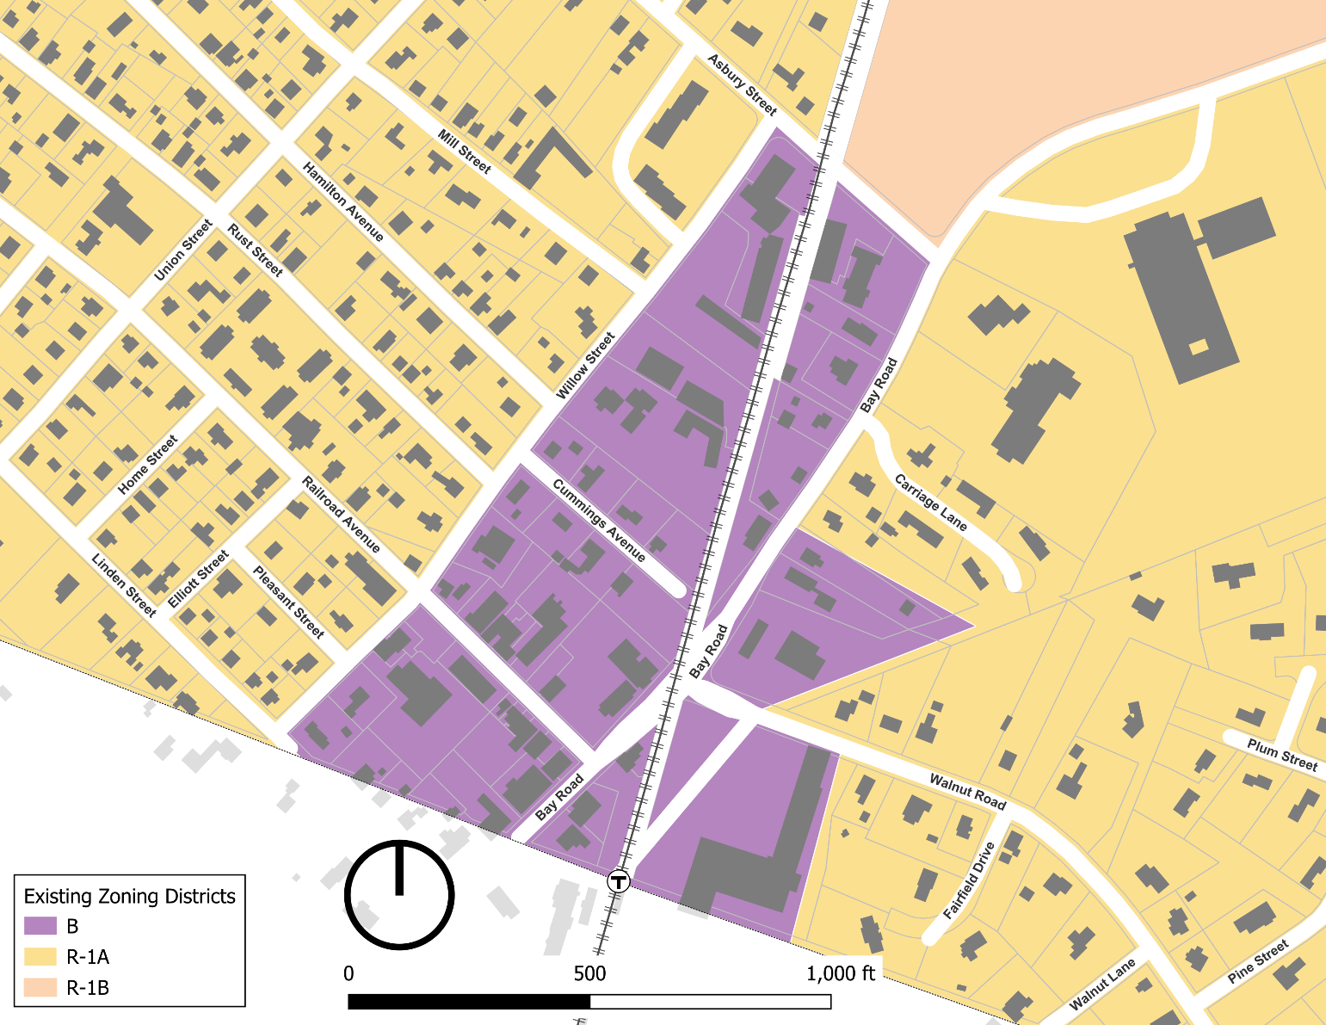

*Map of Proposed Town Center Zoning under Article I*

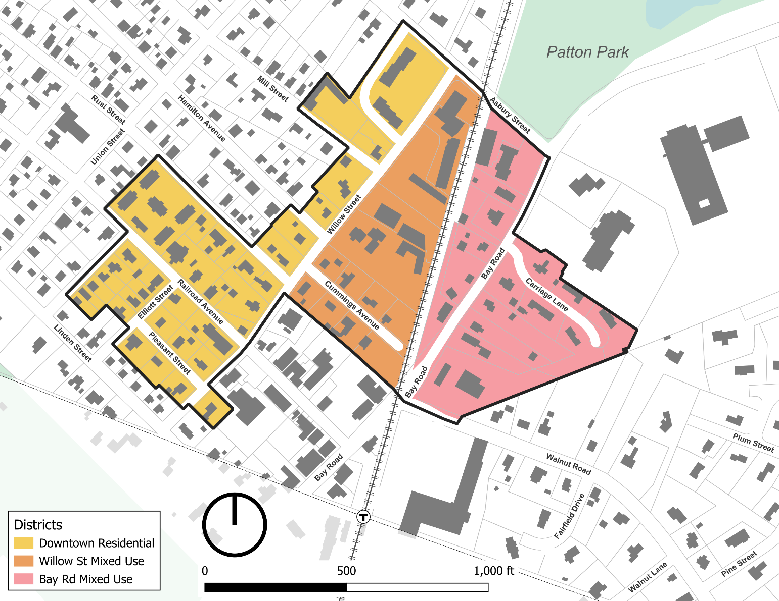

*Map of Proposed 3A-MFOD Overlay District (between Asbury Road and Highland Street) under Article I*

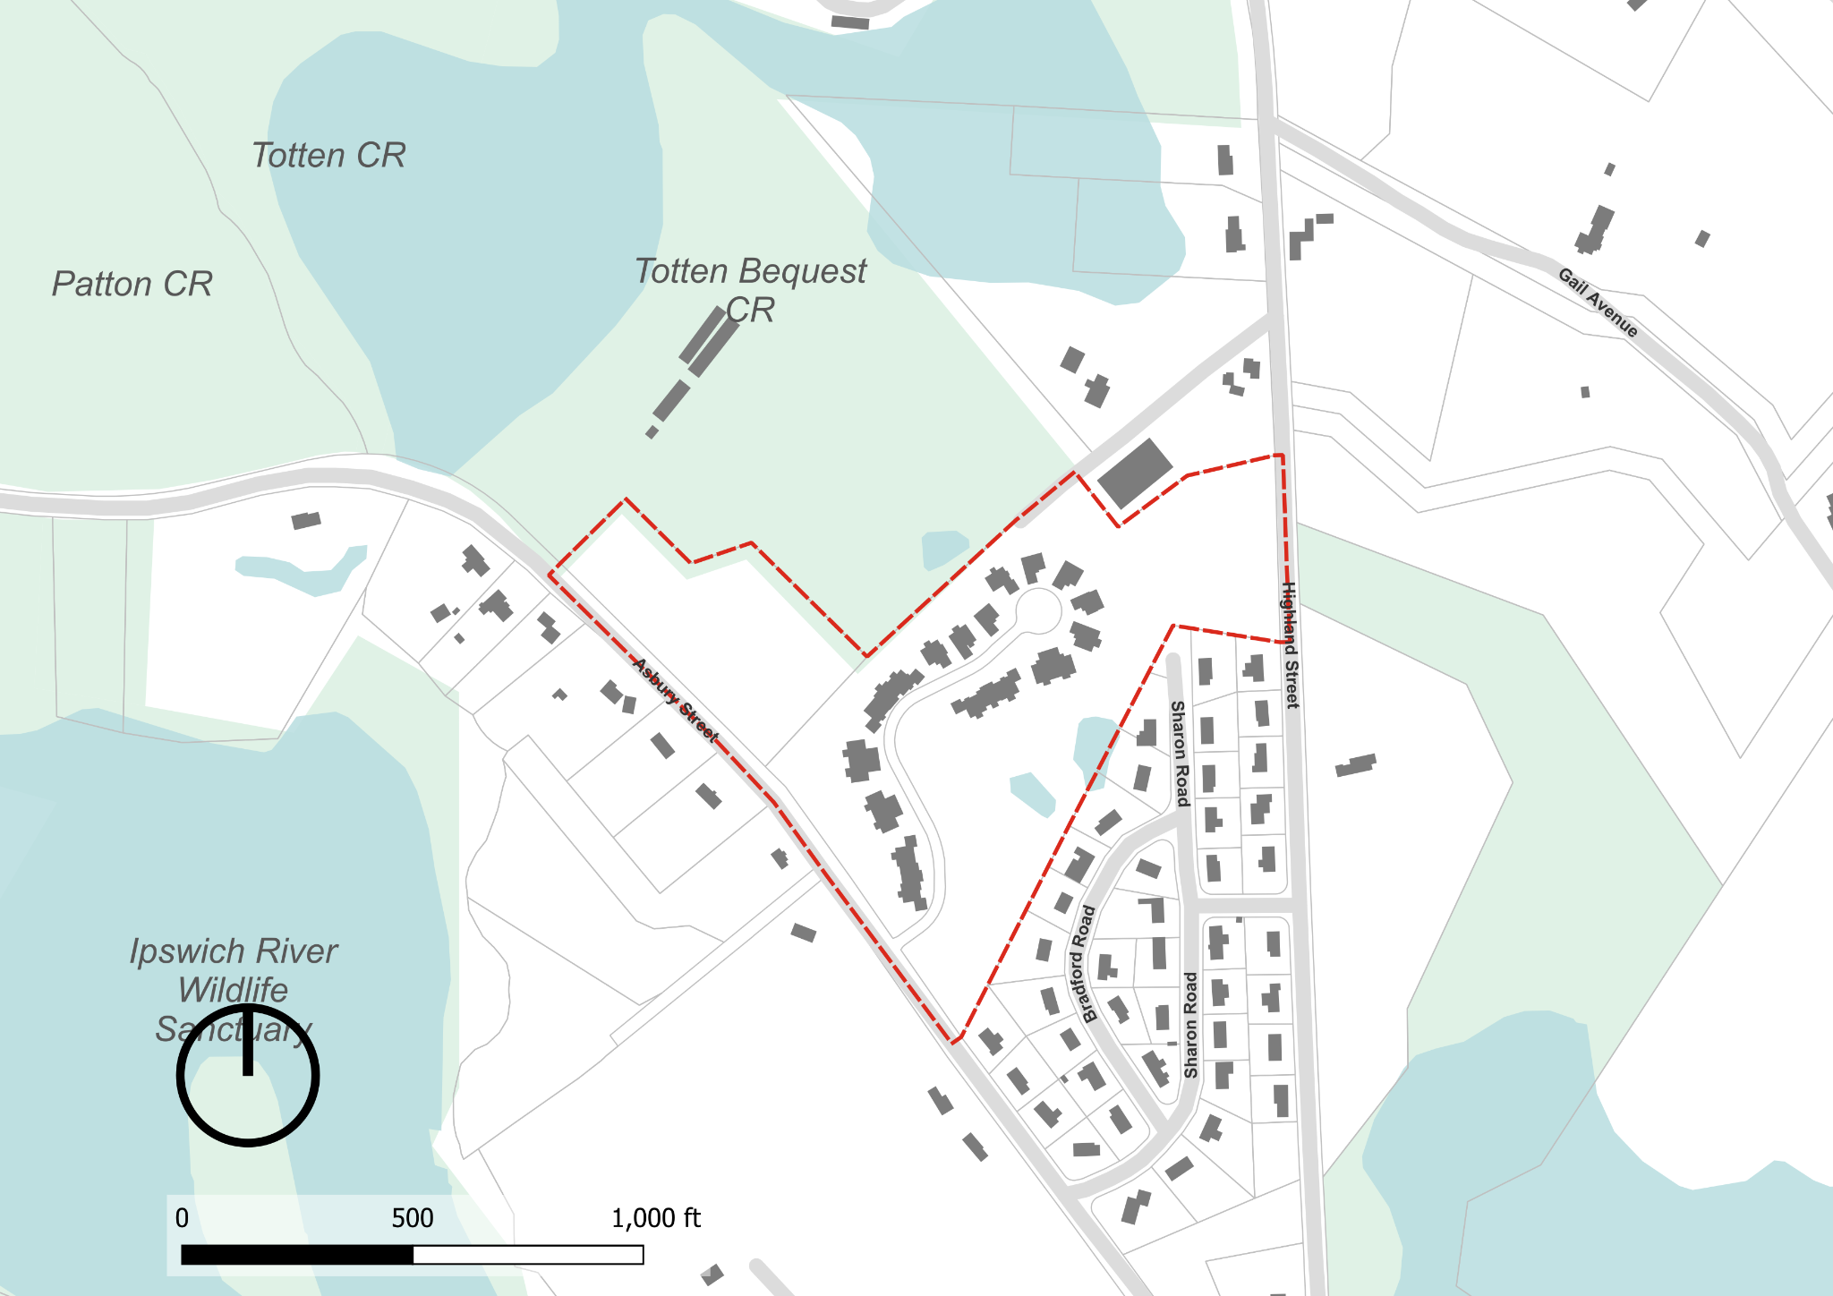

*Map of both Proposed Town Center Zoning and 3A-MFOD Overlay District under Article I*

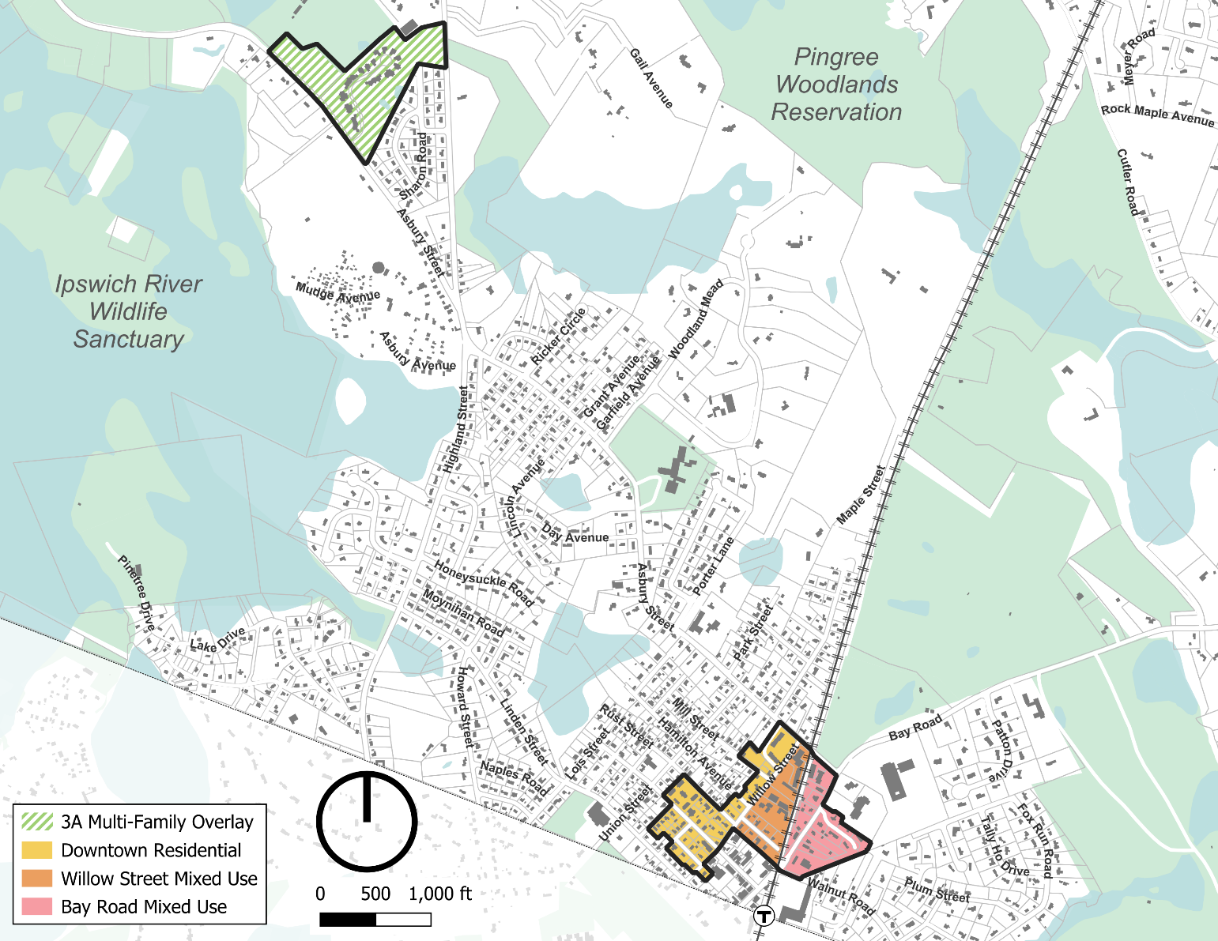

*Map of proposed Town Center zoning under Article II (Note that Depot Square and Bay Road Civic are proposed new Town Center Sub-districts, while the area shades in yellow on Linden Street spanning the Wenham town boundary is proposed to change from the Business District to the R-1A District).*

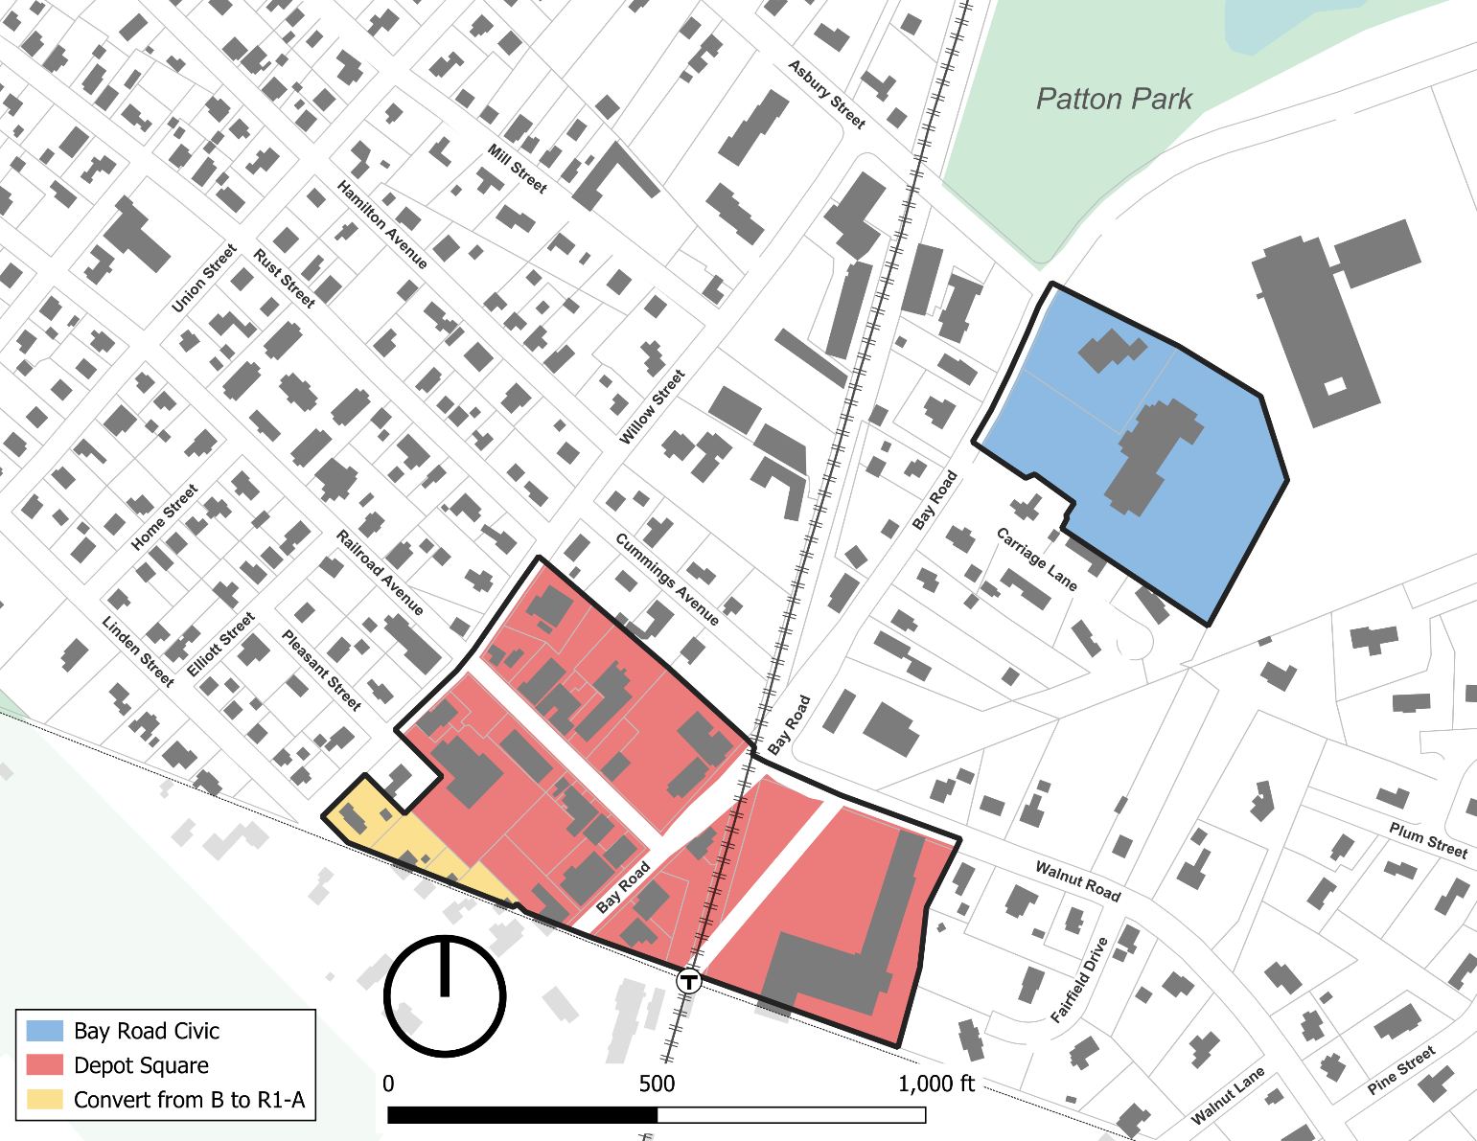

## **2.3 OVERLAY DISTRICTS.** The following Overlay Districts are also established, as set forth in Section 9.0, herein.

Groundwater Protection Overlay District GPOD

Flood Plain Overlay District FPOD

Estate Overlay District EOD

~~Willow Street Overlay District WSOD~~

Commercial Overlay District COD

3A Multi-Family Overlay District 3A-MFOD

**2.5 SPLIT LOTS.**

**2.5.2 By District Boundary.** Where a district boundary line between ~~a residential and a business district~~ an R-1A or R-1B District and a sub-district of the Town Center District divides any Lot existing at the time such line is adopted, the regulations for the less restricted portions of such lots shall extend no more than thirty (30) feet into the more restricted portion, provided the lot has lot frontage on a public way in the less restricted district or sub-district.

## **3.1 PRINCIPAL USES.**

**TABLE OF USE REGULATIONS**

*Given the extensive changes to the Table of Use Regulations, the following changes are described but not shown by underlined and strikethrough text, except for new uses added to the table which are shown in underline and additional language being added to A.6 and D.21 also shown in underline.*

*Delete the last Column “B” Business District from the existing Table*

*Indicate in the Table that uses A.8 and A.9 uses are not allowed (“N”) in the R-1A, R-1B and RA districts*

*Add 5 additional columns to include Depot Square, Bay Road Mixed-Use, Willow Street Mixed-Use, Downtown Residential, and Bay Road Civic sub-districts as follows:*

|  |  |  |  |  |  |
| --- | --- | --- | --- | --- | --- |
| 1. **Residential** | Depot Square | Bay Road Mixed-Use | Willow Street Mixed-Use | Downtown Residential | Bay Road Civic |
| **1.** One Single Family Dwelling | N | Y | Y | Y | N |
| **2.** Conversion of a Single Family Dwelling existing at the time of the adoption of the ordinance (1954) into a Two Family Dwelling (see Section 3.5) | Y | Y | Y | Y | N |
| **3.** Open Space and Farmland Preservation Development (see Section 8.1) | N | N | N | N | N |
| **4.** Senior Housing (see Section 8.2) | N | N | N | N | N |
| **5.** Long Term Care Facility | PB | PB | PB | PB | PB |
| **6.** Garage with more than 4 motor vehicle spaces subject to Section 9.8.5 in the Town Center District | PB | Y | Y | PB | PB |
| **7.** Two or more dwelling units, second floor and above when part of a mixed-use building or development | Y | Y | Y | N | N |
| **8**. Two-Family Dwelling | N | Y | Y | Y | N |
| **9**. Multi-Family Dwelling | N | Y | Y | Y | N |
| 1. **Community Facilities** | Depot Square | Bay Road Mixed-Use | Willow Street Mixed-Use | Downtown Residential | Bay Road Civic |
| **1.** Use of land or  Structures for religious  purposes | Y | Y | Y | Y | N |
| **2.** Museums, libraries and parks, playgrounds, conservation areas, water supply areas and other land owned and operated for the public enjoyment or service by a public or semi-public agency | Y | Y | Y | Y | Y |
| **3.** Use of land or Structures for educational purposes on land owned or leased by the Commonwealth of Massachusetts or any of its agencies, subdivisions or bodies politic or by a religious sect or denomination, or by a nonprofit educational corporation | Y | Y | Y | Y | Y |
| **4.** Hospital, Medical Clinic, cemetery, and camps of educational and charitable institutions | PB | PB | PB | N | N |
| **5.** Community or private club, not conducted for profit | PB | PB | PB | N | PB |
| **6.** Nonprofit civic or fraternal building | N | N | N | N | N |
| **7.** Child Care Center or School Aged Child Care Program | Y | Y | Y | Y | Y |
| **8.** Commercial Recreation, Outdoors | N | N | N | N | SB |
| **9.** Temporary use for amusements and recreation | SB | SB | SB | N | SB |
| **10.** Municipal Buildings or facilities | Y | PB | PB | PB | Y |
| **11.** Essential Services | Y | N | N | N | Y |
| 1. **Agricultural** | Depot Square | Bay Road Mixed-Use | Willow Street Mixed-Use | Downtown Residential | Bay Road Civic |
| **1.** On parcels five (5) acres or more, or two (2) Qualified Acres or more: agriculture, horticulture and floriculture | N | N | N | N | N |
| **2.** Gardens; riding stables; growing and storing of fruits, berries, vegetables, hay, fodder and ensilage; woodlots; forestry; and greenhouses | N | N | N | N | N |
| **3.** The raising or keeping of poultry, horses, or cows for other than the use of the occupants of the residence | N | N | N | N | N |
| 1. **Commercial** | Depot Square | Bay Road Mixed-Use | Willow Street Mixed-Use | Downtown Residential | Bay Road Civic |
| **1.** Adult Entertainment Uses | PB | N | N | N | N |
| **2.** Motor Vehicle and/or Boat Sales and/or Leasing Shop | PB | N | N | N | N |
| **3.** Business or Professional Office; bank; financial institution | Y | Y | Y | N | Y |
| **4.** Communication Towers and Telecommunication Antenna Facilities (see Section 7.2) | PB | PB | PB | PB | PB |
| **5.** Kennel | N | N | N | N | N |
| **6.** Funeral homes | PB | N | N | N | N |
| **7.** Garage with more than four automobile/truck spaces | N | N | N | N | N |
| **8.** Motor Vehicle Light Service Station | N | N | N | N | N |
| **9.** Manufacturing of products sold on the premises at retail, where no more than five operators are employed in such manufacture | PB | N | N | N | N |
| **10.** Rail or bus station or terminal | PB | N | N | N | N |
| **11.** Motor Vehicle Repair Shop | N | N | N | N | N |
| **12.** General Service Establishment | Y | N | N | N | N |
| **13.** Personal Service Establishment | Y | Y | Y | N | Y |
| **14.** Restaurant | Y | Y | Y | N | Y |
| **15.** Restaurant, Fast Food | PB | N | N | N | N |
| **16.** Retail Store | Y | Y | Y | N | Y |
| **17.** Veterinary Facility or Clinic | PB | PB | PB | N | PB |
| **18.** Wind Energy Facility in COD, subject to site plan approval (see Section 7.3) | N | N | N | N | N |
| **19.** Wind Energy Facility (not in COD) (see Section 7.3) | PB | PB | PB | PB | PB |
| **20.** Communications Tower and Telecommunication Antenna Facilities (see Section 7.2) | Y | Y | Y | Y | Y |
| **21.** Mixed-Use Development, subject to ~~Site Plan Review~~ Section 9.8.5 in the Town Center District | Y | Y | Y | N | Y |
| **22.** Drive-In or Drive-Through Establishment | N | N | N | N | N |
| **23.** For Profit Educational Facility | PB | PB | PB | N | PB |
| **24.** Marijuana Establishment | N | N | N | N | N |
| 1. **Accessory** | Depot Square | Bay Road Mixed-Use | Willow Street Mixed-Use | Downtown Residential | Bay Road Civic |
| **1.** Up to three boarders in a Single Family Dwelling | N | Y | Y | Y | N |
| **2.** Accessory Dwelling Unit (see Section 3.6 and definition) | Y | Y | Y | Y | N |
| **3.** Large Accessory Dwelling Unit (see Section 11.0) | PB | PB | PB | PB | PB |
| **4.** Customary home occupation conducted in a Dwelling or Building accessory thereto by a person residing on the premises (see Section 3.3) | Y | Y | Y | Y | N |
| **5.** Accessory Uses or Building on the same Lot with and customarily incidental to a permitted main use on the same premises | Y | Y | Y | Y | Y |
| **6.** Uses, whether or not on the same parcel as activities permitted as a matter of right, which are both: (a) accessory to activities permitted as a matter of right, and (b) necessary in connection with scientific research or scientific development or related production (see Section 3.2.1.2) | PB | PB | PB | PB | PB |
| **7.** Parking area or garage for use of employees, customers or visitors | Y | Y | Y | N | Y |
| **8.** Level Two Electric Charging Station | Y | Y | Y | Y | Y |
| **9.** Large Family Child Care Home | PB | PB | ZBA | PB | PB |
| **10.** Small Family Child Care Home | Y | Y | Y | Y | Y |
| **11.** Adult Social Day Care | PB | PB | PB | PB | PB |
| **12.** Marijuana Establishment | N | N | N | N | N |

**3.2 ACCESSORY USES.**

**3.2.2 Accessory Uses and Structures in the ~~Residence Districts~~ R-1A, R-1B, RA, and Downtown Residential Sub-district of the Town Center District.** The following provisions shall apply to Accessory Uses and Structures in the Residence R-1A, R-1B, RA, and Downtown Residential Districts:

**3.2.3 Accessory Uses in the ~~Business~~ Depot Square, Willow Street Mixed-Use, Bay Road Mixed-Use, and Bay Road Civic Sub-districts of the Town Center District.** In the ~~Business~~ Depot Square, Willow Street Mixed-Use, Bay Road Mixed-Use, and Bay Road Civic Sub-districts any use permitted as a Principal Use is also permitted as an Accessory Use provided such use is customarily incidental to the main or principal building or use of the land.

**4.1 GENERAL REGULATIONS.**

**4.1.2 Table of Dimensional Regulations.** The Table of Dimensional Regulations is hereby declared to be a part of this By-law.

**TABLE OF DIMENSIONAL REGULATIONS1**

|  |  |  |  |  |
| --- | --- | --- | --- | --- |
|  | R-1A | R-1B | RA | ~~B~~ |
| Minimum Lot Area per Dwelling Unit (sq. ft.) | 20,000 | 40,000 | 80,000 | ~~ZBA~~~~1~~ |
| Minimum Lot Frontage (ft.) | 125 | 175 | 175 | ~~ZBA~~~~2~~ |
| Minimum Lot width and depth (ft.) (for Dwellings, see also Sections 4.2.2, 4.2.6 and 4.3) | 100 at building | 100 at building | 100 at building | ~~ZBA~~~~3~~ |
| Maximum Building Height (ft.) | 35 | 35 | 35 | ~~35~~ |
| Maximum number of Stories | 3 | 3 | 3 | ~~3~~ |
| Maximum Building coverage of Lot (%) | 25 | 25 | 25 | ~~75~~~~4~~ |
| Minimum Front Yard (ft.)  (See also Section 4.2.4) | 25/50~~5~~2 | 25/50~~5~~2 | 25/50~~5~~2 | ~~25/50~~~~5~~ |
| Minimum Side Yard and Rear Yard (ft.) | 15 | 15 | 15 | ~~ZBA6~~ |

1. Dimensional Requirements for the Town Center Sub-District are found in Section 9.8 of the Zoning By-law.
2. Renumbered from #5 Twenty-five (25) feet from the Street line, or fifty (50) feet from the Street center line, whichever is greater.

~~1. For each Dwelling Unit, minimum lot area is twenty thousand (20,000) square feet or as determined by the SPGA. For other uses, to be determined during site plan review.~~

~~2. For a Building that contains a Dwelling Unit, 125 feet. For all other uses, to be determined during site plan review.~~

~~3. To be determined during site plan review.~~

~~4. Or as determined during site plan review.~~

~~5.~~ *Text moved to #2*.

~~6. For a Dwelling Unit, 15 feet. For all other uses, to be determined during site plan review.~~

## **SECTION 5.0 NONCONFORMING USES AND STRUCTURES**

5.1 APPLICABILITY. This By-law shall not apply to Structures or uses lawfully in existence or lawfully begun, or to a Building or special permit issued before the first publication of notice of the public hearing required by G.L. c. 40A, s. 5 at which this By-law, or any relevant part thereof, was adopted. Such prior, lawfully existing nonconforming uses and Structures may continue, provided that no modification of the use or Structure is accomplished, unless authorized herein~~under~~. This Section, with the exception of Subsection 5.1, shall not apply to Structures or uses in the Town Center Sub-Districts which are regulated under Section 9.8.1.4 of the By-law.

## **6.1 OFF-STREET PARKING AND LOADING AREAS.**

**6.1.3 No Reduction.** Required off-street parking and loading spaces shall not hereafter be reduced, unless approved by the Planning Board pursuant to Section 6.1.6, nor any loading space counted as or substituted for a parking space.

**6.1.6 Shared Parking**. ~~No part of an off-street parking or loading space required for any Building or use shall be included as a part of an off-street parking area required for another Building or use unless a determination is made by the Board of Appeals to the effect that the period of usage of such structure or uses will not be simultaneous.~~ In the Town Center District, shared parking may be permitted by the Planning Board for a mix of uses on a single site or between sites during the Site Plan Review process, if the applicant can demonstrate that shared spaces will adequately meet parking demands because uses have varying peak parking demands, will reduce excess parking, and if the Planning Board determines shared parking will serve as a benefit to the Town Center. The minimum number of parking spaces for a Mixed-Use Development or between sites where shared parking is proposed shall be determined by a study prepared by the applicant following the procedures of the Urban Land Institute Shared Parking Report, ITE Shared Parking Guidelines, or other professionally accepted procedures.

**6.1.9 Site Plan.** Parking areas and loading areas ~~in the Business District~~ shall be shown on a site plan, as provided in Section 10.6.

## **6.3 SIGNS.**

**6.3.2 ~~Residence Districts~~ R-1A, R-1B and RA Districts, and Downtown Residential Sub-District.**

**6.3.3 ~~Business District~~ Depot Square, Bay Road Civic, Bay Road Mixed-Use and Willow Street Mixed-Use sub-districts of the Town Center District.**

**6.3.4 Standards**

8. A sign in the ~~Business District~~ Depot Square, Bay Road Civic, Bay Road Mixed-Use and Willow Street Mixed-Use sub-districts of the Town Center District shall not exceed a total area of (6) square feet.

## **8.2 SENIOR HOUSING.**

**8.2.2 Eligible Locations.** A Special Permit may be granted for Senior Housing on any lot(s) in the R-1A, R-1B, or R-A.~~, or B~~,

**8.2.7 Permitted Uses.** A Senior Housing development may include the following uses:

~~13. In the Business District a mixture of residential and business uses.~~

**8.2.9 Base Senior Housing Density.** The Base Density per Developable Acre for a Senior Housing Special Permit shall be: ~~four (4) Dwelling units in the Business District;~~ three (3) Dwelling units in the R-1A~~R1-A~~ District, two (2) Dwelling units in the R-1B~~R1-B~~ District, and one (1) Dwelling unit in the RA District.

|  |  |  |  |  |  |  |  |  |  |  |
| --- | --- | --- | --- | --- | --- | --- | --- | --- | --- | --- |
|  | A | B | C | D | E | F | G | H | I | J |
|  | Zoning District | Base Senior Housing Density (BSHD) per Dev. Acre | Incentives to Increase Base Senior Housing Density for: | | | | | Subtotal of Base Senior Housing Density Incentives (C+D+E+F+G) | Incremental Density per Developable Acre Rewardable by PB for Trails, Fields, Environmental, energy, water conservation, building green, & other public benefits | Maximum Density per Dev. Acre |
| Mix of Smaller Units (50% units under 1300 sq. ft.) | On or Off Site Construction of Inclusionary Housing Obligation (Affordable Housing) | Smart Growth, per Comm. of Mass. Criteria (PB Rules & Regs) | Additional 25% of Property as Open Space | Voluntary Cap on Appreciation of Units |
| ~~1~~ | ~~B~~ | ~~4~~ | ~~25%~~ | ~~25%~~ | ~~25%~~ | ~~N/A~~ | ~~25%~~ | ~~100%~~ | ~~1.0~~ | ~~6.00~~ |
| 1 | R-1A | 3 | 25% | 25% | 25% | 25% | 25% | 125% | 1.0 | 4.00 |
| 2 | R-1B | 2 | 25% | 25% | 25% | 25% | 25% | 125% | 1.0 | 4.00 |
| 3 | RA | 1 | 25% | 25% | 25% | 50% | 25% | 150% | 2.0 | 4.00 |

**NOTES ON HOW TO READ THE MATRIX:**

Column I: Encourages other initiatives which provide a public benefit to the Town such as, but not limited to, preservation and enhancement of trails; creation of playing fields; environmental, energy, water conservation, green building design, and other public benefits. For one (1) or a combination of these initiatives, an applicant may earn one (1) additional Dwelling Unit per Developable Acre in the ~~Business,~~ R-1A ~~R1-A~~, and R-1B ~~R1-B~~ Districts, and up to two (2) additional Dwelling Units per Developable Acre in the RA District.

**8.2.11 Minimum Distance between Projects.**

In order to mitigate the impact of multiple developments on surrounding neighborhoods, a proposed project must be located at least the distance established in the Minimum Distance Between Projects Table below from any other existing or approved Senior Housing project, any existing or approved project including ~~multi‑unit~~ residential buildings permitted under G.L. c. 40B, or any existing or approved project including ~~multi-unit~~ Multi-Family Housing ~~under any other provision or By-law~~. Excluded from this calculation and this Section are any existing multi-unit Multi-Family projects approved prior to January 1, 2003, Multi-Family Dwellings or Mixed-Use Developments in the Town Center District, and ~~apartments under Sections~~ ~~3.4, 3.6, or 3.7~~ Accessory Dwelling Units or Large Accessory Dwelling Units.

~~4. Senior Housing proposals in the Business District shall be exempt from the provisions of this Section and developments wholly within the Business District shall not be considered as existing or approved projects for purposes of establishing required project separation in any other district.~~

**8.2.13 General Requirements.** The following requirements shall apply.

3. Location of Wastewater Treatment. All wastewater shall be treated and discharged on-site. Off-site wastewater treatment is not allowed.

**8.2.15 Dimensional Standards.** The following dimensional and other standards shall supersede all dimensional standards in the underlying zoning district and shall be applied to any Senior Housing development:

**TABLE OF DIMENSIONAL REQUIREMENTS**

|  |  |  |  |  |  |  |  |  |  |
| --- | --- | --- | --- | --- | --- | --- | --- | --- | --- |
|  | A | B | C | D | E | F | G | H | I |
|  | Zoning District | Under- lying Zoning District Require-ment (s.f.) | Minimum Parcel Size (sq.ft.) to be eligible for develop-ment | Minimum Parcel Frontage Required (feet) to be eligible for develop-ment | Front Setback (feet) from perimeter property line | Side & Rear Setbacks (feet) from perimeter property line | Vegetated Buffer (feet) around perimeter of parcel | Minimum Open Space Required of total acreage | Maximum Lot Coverage of entire parcel |
| ~~1~~ | ~~Bus. District~~ |  | ~~none~~ | ~~site specific~~ | ~~0~~ | ~~01~~ | ~~01~~ | ~~0~~ | ~~site specific~~ |
| 2 | R-1A | 20,000 | 80,000 | 125 | 25 | 252 | 20 | 0 | 25% |
| 3 | R-1B | 40,000 | 80,000 | 175 | 25 | 252 | 20 | 15% | 25% |
| 4 | RA | 80,000 | 80,000 | 175 | 50 | 252 | 20 | 25% | 25% |

## **8.3 INCLUSIONARY HOUSING**

**8.3.3 Mandatory Provision of Affordable Housing Units.** In any development subject to this Section, the tenth dwelling unit and every seventh unit thereafter shall be an Affordable Housing Unit, except in the 3A-MFOD, Bay Road Mixed-Use, Willow Street Mixed-Use, and Downtown Residential Sub-districts, where the tenth dwelling unit and every tenth unit thereafter shall be an Affordable Housing Unit. Nothing in this Section shall preclude a developer from providing more Affordable Housing Units than are required hereunder. In the 3A-MFOD, Bay Road Mixed-Use, Willow Street Mixed-Use, and Downtown Residential Sub-districts, Affordable Housing Units in Multi-Family Housing developments shall not be required to make up more than 10% of the total units and eligibility requirements for such units shall not be required to be less than 80% of Area Median Income (AMI) as determined by the US Department of Housing and Urban Development (HUD).

## **9.1 GROUNDWATER PROTECTION OVERLAY DISTRICT (GPOD)**

**9.1.4 Dimensional Requirements.** Regardless of the minimum Lot size of the underlying zone, there shall be a minimum lot area of eighty thousand (80,000) square feet per dwelling unit in the GPOD. Proposed development in the 3A-MFOD electing to seek a permit through the provisions of that overlay, and not through the provisions of the underlying district, are exempt from the minimum lot area per dwelling limitation.

**9.1.9 Uses and Activities Requiring a Special Permit.** The following uses and activities are permitted only upon the issuance of Special Permit by the Zoning Board of Appeals under such conditions as it may require. Proposed development in the 3A-MFOD electing to seek a permit through the provisions of that overlay, and not through the provisions of the underlying district, are exempt from the Special Permit Requirement.

## **9.5** **~~WILLOW STREET OVERLAY~~ Reserved *(Willow Street Overlay District deleted in June 2025)***

## **11.0 DEFINITIONS**

**Floor Area Ratio (FAR):** The ratio of the total Gross Floor Area of all buildings on a lot to the total lot area. For the purposes of calculating FAR, basements, cellars, attics, garages and interior parking spaces shall be excluded from the GFA. Half-stories that meet the criteria listed in 9.8.2.2.2 (j), Half Story, shall be counted as one half of the GFA of the floor below.

**~~Dwelling,~~** ~~Three-family: A building containing three dwelling units, each of which has direct access to the outside or to a common hall that leads to the outside.~~

**~~Dwelling,~~** ~~Four-family: A building containing four dwelling units, each of which has direct access to the outside or to a common hall that leads to the outside.~~

**Dwelling, Multi-Family or Multi-family housing:** A building with ~~containing~~ ~~five~~ three or more residential dwelling units, or two or more buildings on the same lot with more than one residential dwelling unit in each building.

**Mixed-Use Development:** ~~Two or more uses on a single parcel as a part of a single development plan~~. A complementary combination of permitted residential uses and commercial land uses, occupying the same site or building as part of a single development plan.

**Substantial Improvement:** (*Note that this term has a separate definition when applied to the Floodplain Overlay District, see Floodplain Overlay District for that definition*): Any repair, reconstruction, rehabilitation, or improvement of a structure, the cost of which equals or exceeds 50 percent of the assessed value of the structure before the start of construction of the improvement. Assessed value shall mean the most recent value assigned to the structure as calculated by the Hamilton Tax Assessor.