Hamilton Town Center District

**FIFTH DRAFT for Planning Board Review**

2025-06-11

# 9.8 TOWN CENTER DISTRICT.

*1. Introduction.* The Town Center District consists of following five sub-districts: Depot Square, Bay Road Mixed-Use, Willow Street Mixed-Use, Downtown Residential, and Bay Road Civic, all of which are located in the Town Center area of Hamilton. Collectively, these sub-districts shall be referred to as the Town Center District, however each sub-district contains its own use, dimensional, and associated regulations as stipulated under this Section. This Section consists of seven sub-sections that follow this introduction:

1. *Purpose and Intent.* This Section introduces the purpose and intent of the zoning generally, how and where it is to be applied, and how the regulations of this Section relate to other Sections of the By-law.
2. *Interpretation*. This Section provides definitions and explanations of the terms and metrics that are used to regulate building scale, form, and placement. Many of the terms are unique to this Section.
3. *Town Center Sub-districts*. This Section describes the purpose and intent of each sub-district, as well as any relevant planning considerations.
4. *Dimensional Standards*.This Section includes district-wide tables with dimensions for lots and Buildings.
5. *Use Provisions*. This Section offers additional conditions and clarifications to the general use table.
6. *Site Standards*. This section provides standards for site design elements including vehicular and pedestrian access, parking, screening, building materials, landscaping, and lighting. It also establishes appropriate landscape treatments and contextually appropriate building materials.
7. *Administration*. This Section outlines the permitting path for proposed development, including whether Site Plan Review or a Special Permit is required.

# 9.8.1. Purpose and Intent.

1. *Purpose.*The purpose of this Section of the By-law is to regulate the use of land, Buildings, and structures in the Town in a way that preserves the historic village character of Downtown Hamilton, and to provide standards for multi-family housing development that are both in accordance with G.L. c. 40A, § 3A and the Regulations issued by the Executive Office of Housing and Livable Communities (HLC) set forth at 760 CMR 72.00 and consistent with the Town’s existing character.

2. *Intent.*This Section is intended to ensure development in Hamilton’s Downtown contributes to the realization of the [Hamilton Town Center Vision Plan](https://docs.google.com/presentation/d/1QyuEc1qKCFhwlbIDQigC12AALwFk7PO9_jCP7LiXnaA/edit?usp=sharing) developed over the course of a townwide visioning process conducted throughout 2024 and 2025. Specifically, this Section intends to:

1. Ensure that new development is compatible with the historic and village character of Downtown Hamilton.
2. Preserve and enhance the historic commercial corridor along Railroad Avenue and Depot Square.
3. Promote activity in the Downtown, support commercial uses and promote increased walkability.
4. Provide a diversity of housing types that cater to the diverse and changing needs of Hamilton’s residents.
5. In conjunction with Section 9.7, 3A Multi-Family Overlay District, comply with G.L. c. 40A, § 3A and the Section 3A Compliance Regulations of the Executive Office of Housing and Livable Communities (HLC) (760 CMR.72.00).

3. *Applicability.*

1. *Territorial Application.* This Section is applicable to all real property, structures, and uses located in the Depot Square, Bay Road Mixed-Use, Downtown Mixed-Use, Downtown Residential, and Bay Road Civic sub-districts as these sub-districts are depicted on the Town of Hamilton Official Zoning Map dated June 26, 2025.
2. *Conflicting Provisions.* 
   1. If any condition or requirement imposed by this Section contains an actual, implied or apparent conflict with another provision of this Section, the more restrictive condition or requirement controls.
   2. If any condition or requirement imposed by this Section contains an actual, implied or apparent conflict with any condition or requirement of any other provision of the Town of Hamilton's Zoning By-law, the provisions of this Section control.
3. *Text and Graphics.* Illustrations, photographs and graphics are included in this Section to illustrate the intent and requirement of the text. In the case of a conflict between the text of this Section and any illustrations, the text governs.
4. *Existing Applications and Permits.* The applicability of this Section with respect to existing and proposed uses and structures is governed by Section 1.4.1, Applicability/Nonconformities, Section 1.4.2, Commencement of Construction or Operation, Section 5.1, and Section 9.8.1.4 *Nonconformities*.
5. *Severability.* If any provision of Section 9.8 is found to be invalid by a court of competent jurisdiction, the remainder of Section 9.8 shall not be affected and shall remain in full force. The invalidity of any provision of Section 9.8 shall not affect the validity of the remainder of Hamilton’s Zoning By-law. If any metric set forth in the Regulations issued by the HLC at 760 CMR 72.00 is amended, this Section may be amended to utilize the revised metrics set forth in the amended Regulations.

4. *Nonconformities.*

1. *Purpose & Intent.* The purpose of this Subsection is to regulate and limit the continued existence of uses and structures established prior to the effective date of this By-law (or any amendment subsequent thereto) that do not conform to this By-law such that all buildings, structures or land, in whole or in part, will be used or occupied in conformance with this Section.

Many nonconformities may continue, but the provisions of this Section are designed to curtail substantial investment in nonconformities and, when appropriate, to bring about their eventual elimination and/or lessen their impact upon surrounding conforming uses to preserve the integrity of the Town Center Districts in accordance with the intent of this By-law.

1. *Nonconforming Uses***.** A nonconforming use may continue only in accordance with Section 5.1 of the By-law and the provisions of this Subsection.
   1. *Repair and Maintenance.* Normal repair and maintenance may be performed to allow the continuation of nonconforming use.
   2. *Reconstruction after Catastrophe or Demolition.*
      1. If a nonconforming use within a nonconforming structure is voluntarily demolished, the nonconforming use shall not be reestablished.
      2. A nonconforming use in a structure may be re-established in case of damage, to an extent equal to or less than 50 percent of the assessed value of the property on which it is located, provided that the nonconforming use is not expanded and that reconstruction commences within two years of the event in which the damage occurred.
      3. A nonconforming use in a structure which is damaged, to an extent greater than 50 percent of the assessed value of the property, shall not be re-established unless the use is re-established in a fully conforming structure, the use is not extended or altered, and unless reconstruction commences within two years of the event in which the damage occurred.
   3. *Modification.*
      1. A nonconforming use may change to a permitted use as stipulated under the Table of Use Regulations (Section 3.0 of the Zoning By-law), however Site Plan Review shall be required by the Planning Board.
      2. A nonconforming use shall not otherwise be modified or expanded unless a Special Permit is granted by the Planning Board.
         1. In addition to the Special Permit criteria included in this By-law, the Planning Board shall consider the following in its discretion to approve or deny a special permit:
            1. The extent and nature of the proposed alteration.
            2. The consistency of the proposed alteration with the spirit of the Zoning By-law and the most recent edition of the Hamilton Master Plan.
            3. The impact of the proposed alteration to the neighborhood when compared to the existing nonconforming use.
   4. *Abandonment or Discontinuance*. If a nonconforming use is abandoned or discontinued for two years or more, the use shall not be permitted to re-establish.
2. *Nonconforming Structures.* A nonconforming structure may continue only in accordance with Section 5.1 of the By-law and the provisions of this Subsection.
3. *Repair and Maintenance.* Normal repair and maintenance may be performed to allow the continuation of a nonconforming structure.
4. *Reconstruction after Catastrophe or Demolition.*
   1. If a nonconforming structure is voluntarily demolished or abandoned, any replacement structure must be conforming to the By-law.
   2. If a nonconforming structure is damaged to an extent greater than 50 percent of its assessed value for tax purposes, it may be rebuilt only in conformance with the standards of this ordinance.
   3. If a nonconforming structure is damaged to an extent equal to or less than 50 percent of its assessed value for tax purposes, then the structure may be rebuilt in accordance with the following standards:

A building permit for reconstruction must be secured no later than two-year from the date of destruction.

A nonconforming structure shall not be rebuilt in a manner which increases its nonconformity.

1. *Modifications/Alterations of Single family and Two-family Dwellings only:*
   1. Nonconforming Single family or Two-family Dwellings may be modified, altered, extended, or reconstructed by right provided that the proposed change does not increase the nonconforming nature of the structure.
   2. Nonconforming Single family and Two-family Dwellings shall not be modified, altered, extended, or reconstructed if the proposed change would increase the nonconforming nature of the structure or create a new nonconformity unless a Special Permit is granted by the Planning Board.
      * 1. In addition to the Special Permit criteria included in this By-law, the Planning Board shall consider the following in its discretion to approve or deny a special permit:
           1. The extent and nature of the proposed alteration.
           2. The consistency of the proposed alteration with the spirit of the Zoning By-law and the most recent edition of the Hamilton Master Plan.
           3. The impact of the proposed alteration to the neighborhood when compared to the existing nonconforming use.
2. *Modifications/Alterations of all other structures.* 
   1. A primary or accessory nonconforming structure shall not be enlarged or altered in a way which increases its nonconformity or creates a new nonconformity.
   2. Modifications to a nonconforming structure which constitute a Substantial Improvement shall not be permitted unless the structure is made conforming with the requirements of the By-law or, if non-conformities remain, by issuance of Special Permit by the Planning Board.
      1. In addition to the Special Permit criteria included in this Bylaw, the Planning Board shall consider the following in its discretion to approve or deny a special permit:

The extent and nature of the proposed alteration.

The consistency of the proposed alteration with the spirit of the Zoning By-law and the most recent edition of the Hamilton Master Plan.

The impact of the proposed alteration to the neighborhood when compared to the existing nonconforming use.

1. Should a nonconforming structure be moved for any distance on the lot upon which it is located, it shall be moved to make the structure conforming to setbacks.
2. *Nonconforming Site Characteristics.* Nonconforming site characteristics governed under Section 9.8.6 Site Standards, including parking, driveways, landscaping, lighting, and screening, shall not be altered such that they are made more non-conforming with the standards and requirements of this By-law.
3. *Nonconforming Signs.* *Nonconforming Signs.* Nonconforming signs in the Town Center District may continue only in accordance with the provisions of this Subsection.
   1. *Repair and Maintenance.* Minor repairs and maintenance of a nonconforming sign, which are necessary to keep such sign in sound condition, are permitted so long as the nonconformity is not increased.
   2. *Modification.* 
      1. No sign may be enlarged or altered in such a way that increases the extent of nonconformity or causes a previously conforming sign to become nonconforming.
      2. A nonconforming sign may not be moved or replaced except to bring the sign into complete conformity with this By-law.
      3. *Damage or Destruction.* Any nonconforming sign which is partially damaged or destroyed by any means, beyond 50 percent of its value, shall not be restored, but shall be removed or reconstructed in conformance with the provisions of this section.
   3. *Discontinuance.*
      1. Any nonconforming sign, the use or copy of which is discontinued or removed for a period of one year or more, regardless of any intent to resume or not to abandon such sign, shall be deemed to be abandoned and shall not thereafter be re-established. Abandonment or obsolescence of a nonconforming sign shall terminate immediately the right to maintain such sign.
      2. If a nonconforming sign remains blank for a continuous period of one year, that sign shall be deemed abandoned and shall, within 180 days after such abandonment, be altered to comply with this By-law or be removed. For purposes of this By-law, a sign shall be “blank” if:
         1. The advertising message it displays becomes illegible in whole or substantial part; or
         2. It does not contain an advertising or identification message. For such purposes, signage offering a building or site for sale or lease shall not be deemed to be an advertising or identification message.
   4. *Change of Principal Use*. Any nonconforming sign shall be removed or brought into compliance with this By-law immediately upon a change in the principal use of the site.

# 9.8.2 Interpretation

1. *Site Dimensional Standards and Measurements.*

1. *Yards.* See Section 11, Definitions. Each yard measurement is made perpendicular to the property line and begins at the property line. Measurements are made to the nearest portion of the Building, excluding open porches less than 8 (eight) feet deep and bay windows less than 3 ft. deep.
2. *Lot Frontage.* See Section 11, Definitions. For lots bounded by more than 1 (one) street, all frontages shall conform to the dimensional standards applicable to the front.
3. *Lot Size.* The area of a Lot, measured as the land within the parcel lines.
4. *Open Space.* Refers to land within a lot not covered by any structures or area dedicated to vehicular use including parking spaces and drive aisles.
5. *Parking Setbacks.*All parking spaces must be located behind the Parking Setback lines or as otherwise indicated. Each setback measurement is made perpendicular to the property line and begins at the property line.
6. *Number of Buildings.* Multiple Buildings are permitted on each lot, subject to the dimensional requirements listed in Section 9.8.4. Where there are more than one Building on a lot, Floor Area Ratio limitations shall apply to all Buildings cumulatively, and maximum Building Footprint limitations shall be applied on a per Building basis.
7. *Street Facing Entry Feature.* Refers to a Building entry that is directly accessible and visible from a street. Entry doors are not required to face the street so long as they are accessed through a porch, patio, plaza, canopy or other element facilitating direct visual and physical access from the street.

2. *Building Dimensional Standards and Measurements.*

1. *Depth.* Refers to the measurement of a Building, yard, or setback measured perpendicular to a front lot line, excluding open porches less than 8 (eight) feet deep and bay windows less than 3 (three) feet deep.
2. *Facade Buildout.* The ratio of the facade width within the minimum and maximum Front Yard dimensions to the lot width, calculated by dividing the cumulative facade width by the lot width. Facade Buildout is intended to ensure that new development addresses the street in a pedestrian-friendly manner and that frontage conditions are compatible with existing patterns.

Figure 1. Facade Buildout

1. *Facade Length without Offset.* The maximum allowable length of any Building facade, front, side or rear, without a change in plane of five feet or greater, extending from the ground plane to the Roof. The purpose of offset requirements is to limit long, undifferentiated facades and to ensure that larger Buildings are broken down into smaller elements that are more reflective of the existing context.

Figure 2. Facade Length without Offset

1. *Building Footprint.* The area of land occupied by a Building, defined by the outer edge of its foundation and exterior walls inclusive of covered parking and other enclosed spaces. Cantilevered elements that do not touch the ground, such as bay windows, do not contribute to the calculation of footprint area provided they do not protrude more than three feet from the face of the Building. Unenclosed porches less than eight feet deep do not contribute to the calculation of the Building Footprint.

Figure 3. Building Footprint

1. *Building Separation.* The distance between Buildings on a lot, measured from the nearest primary face of each Building at its closest point, excluding bay windows less than 3 ft. deep and porches less than 8 (eight) feet deep.

Figure 4. Building Separation

1. *Height.* See Section 11, Definitions. In the Town Center District, for Buildings on lots fronting more than 1 (one) public way, height shall be measured from all frontages.
2. *Roof Type.* Roof forms include gable, hip, gambrel, mansard, shed, and flat, and are permitted as detailed in Section 9.8.4.2. Gable, hipped and shed roofs shall have a minimum slope of 9:12.

|  |  |
| --- | --- |
| A drawing of a house  AI-generated content may be incorrect.  Gable Roof | A drawing of a roof pitch  AI-generated content may be incorrect.  Hipped Roof |
| A drawing of a house  AI-generated content may be incorrect.  Shed Roof | A white box with a roof  AI-generated content may be incorrect.  Gambrel Roof |
| A white box with a lid  AI-generated content may be incorrect.  Mansard Roof | A white box with a black outline  AI-generated content may be incorrect.  Flat Roof |

Figure 5. Roof Type

1. *Width.* Measurement of the length of a Building parallel to a front Lot line.
2. *Fenestration.* The percentage area of glazing at the ground level, measured between two feet and 10 feet above the finished floor of the ground story. Where fenestration requirements apply, ground story windows should be display windows that may or may not have muntins and/or mullions, decorative stiles and or a combination of display windows and transoms supported by appropriate kickplates. The windows may be segmented with trim, piers or wall plane. Where required, minimum ground floor fenestration is intended to ensure that ground floor uses can activate the public realm.

Figure 6. Ground Story Fenestration

1. *Half story.* The occupiable portion of a Building between the uppermost floor and a pitched roof supported by a bottom plate no greater than three feet above the floor level, and containing dormers whose aggregate length is less than 50% of the length of the roof measured horizontally. Where a story is being counted as a half story, dormers shall be located a minimum of three feet from the edge of the primary roof. The uppermost level of gambrel, mansard and flat roofs may not be considered a half story and shall be considered a full story.

Figure 7. Half StoryA diagram of a house

AI-generated content may be incorrect.

# 9.8.3. Town Center Sub-Districts.

## 1*. Depot Square.*

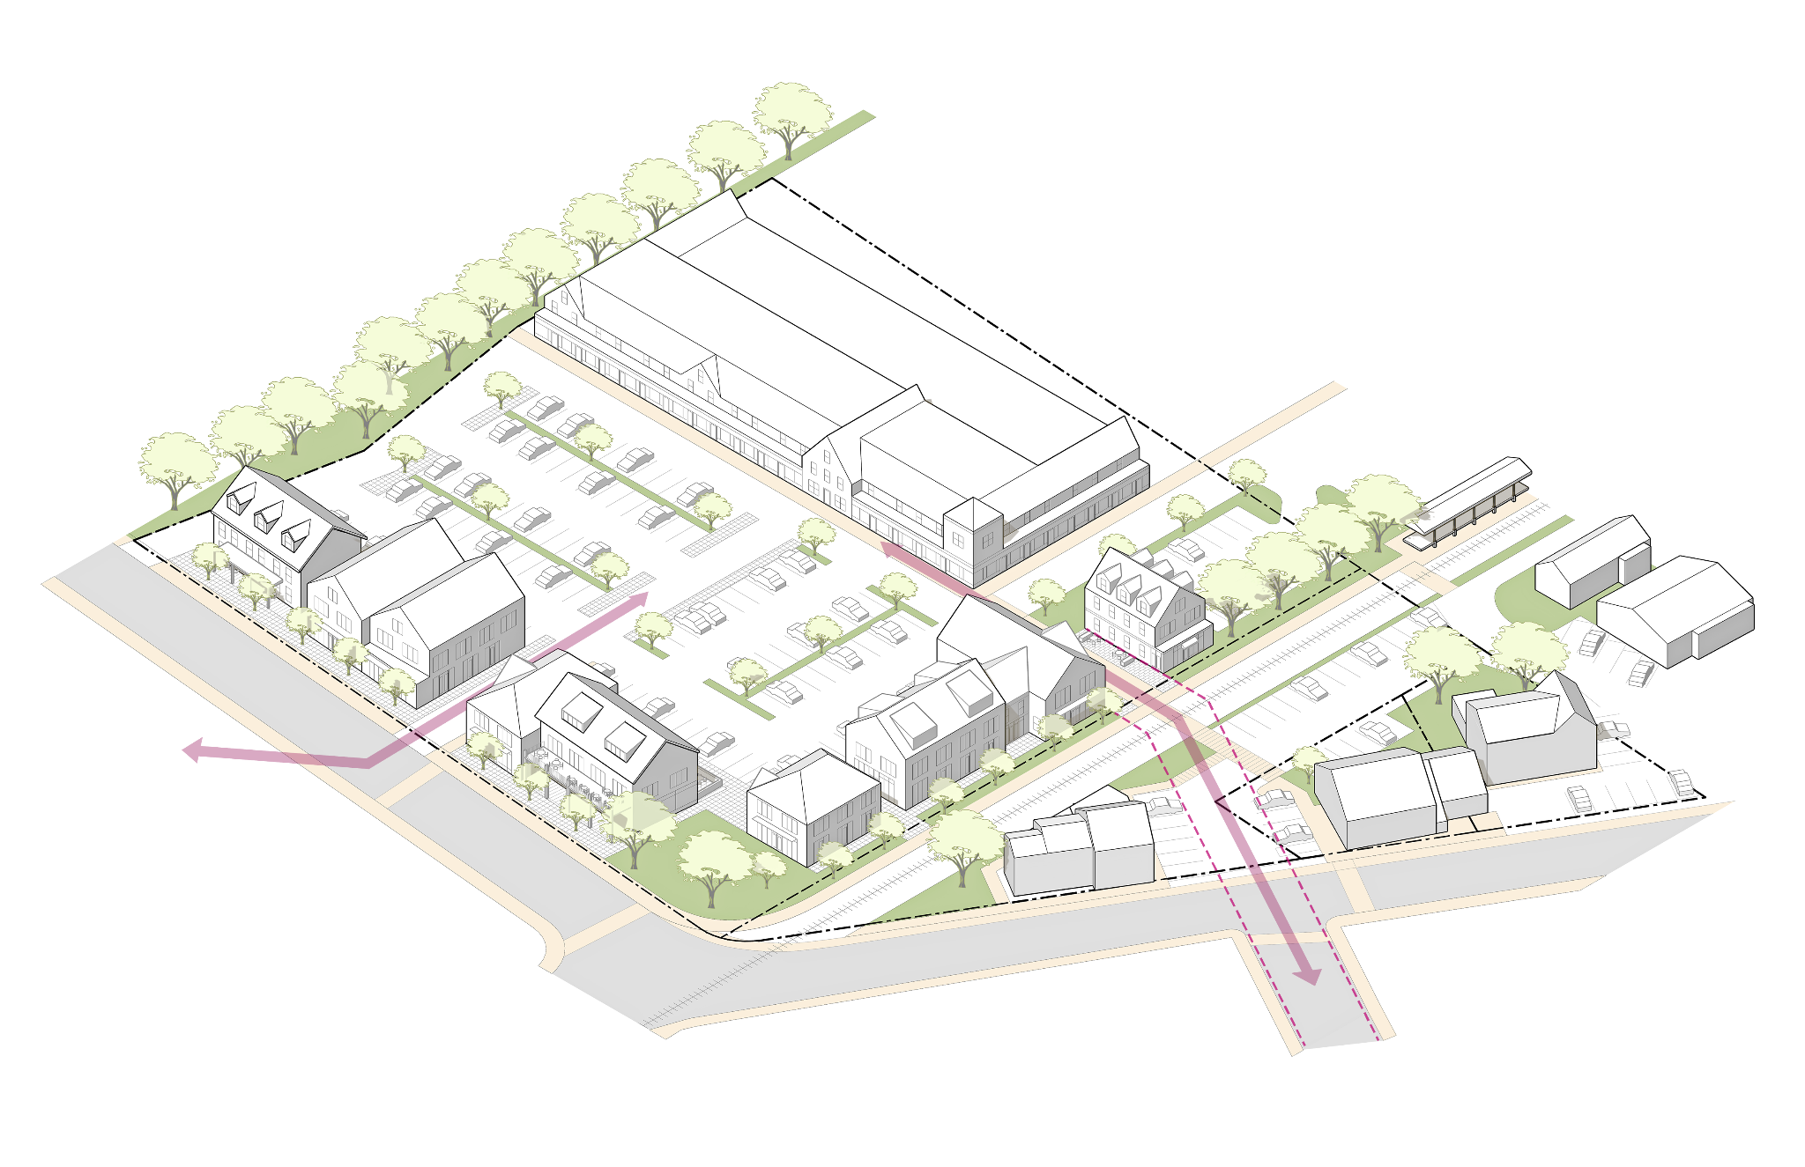

Figure 8. Depot Square Sub-District Vision Illustration

1. *Description.* The Depot Square Sub-district is characterized by two distinct conditions. On Railroad Avenue, buildings have small footprints and are up to 2.5 stories in height. East of the rail corridor, there is a large automobile-oriented shopping center. The area along Railroad Ave has the character of a small and historic town center; most buildings sit close together and near the sidewalk, while other buildings maintain some space between one another and include parking lots. The shopping center features one large, L-shaped, 1.5-story building with a large parking area between the building and the street and rail corridor. The sub-district is primarily commercial, with some mixed-use structures located near the edges of the sub-district. Most buildings west of the rail corridor were designed to accommodate commercial uses with form consistent with the historic residential buildings nearby.
2. *Purpose and Intent.*

Figure 9. Important Depot Square Visual and Pedestrian Connections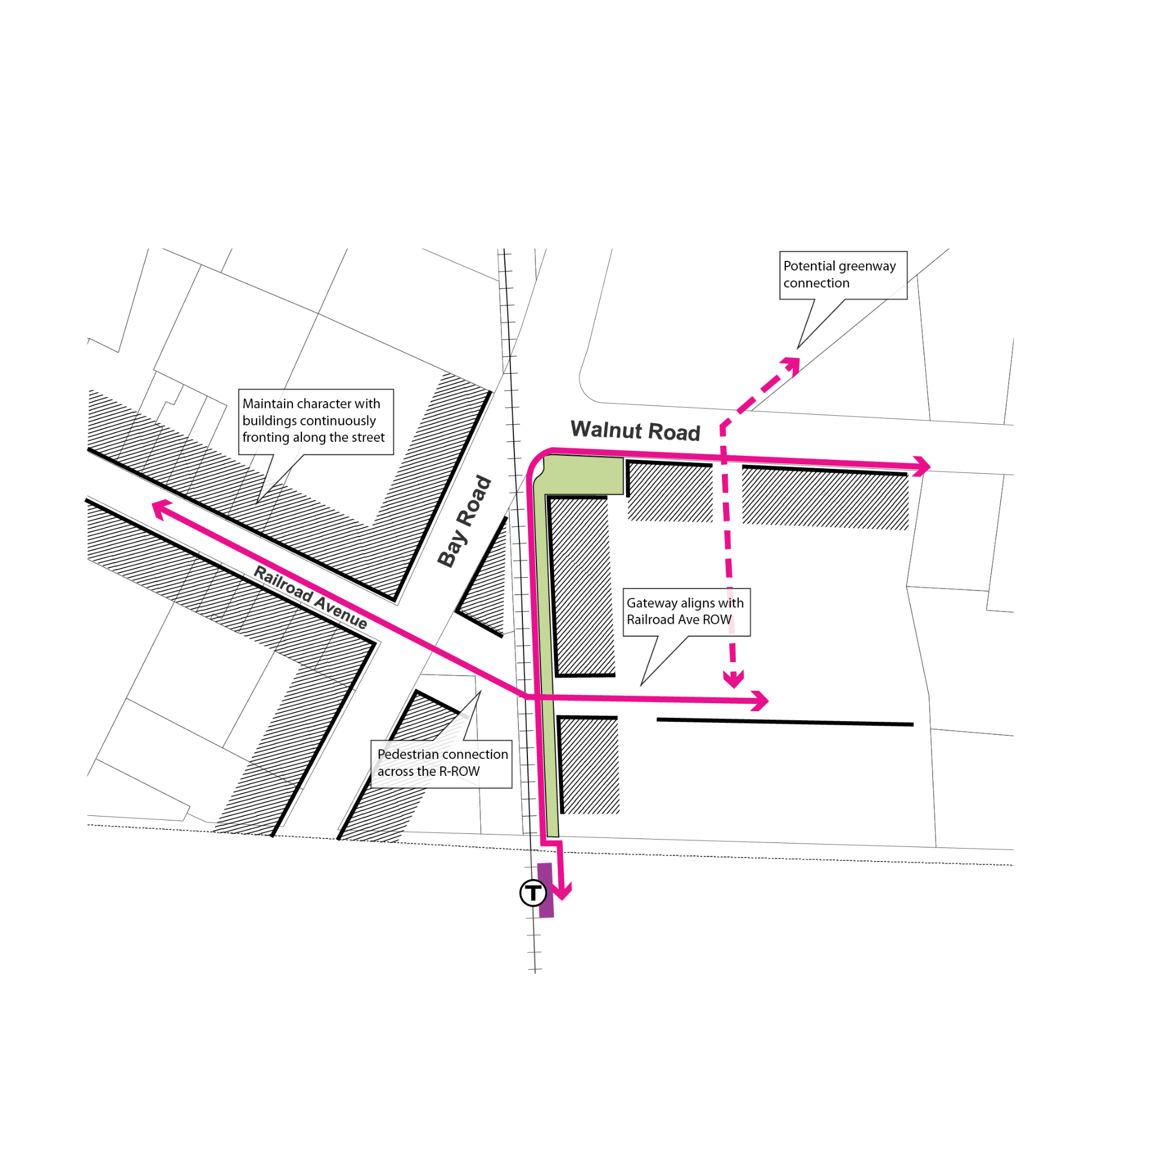

* 1. To foster a mixed-use and vibrant town center and preserve the existing small-scale commercial character along Railroad Avenue.
  2. To enhance a continuously built front along main public thoroughfare frontages in the sub-district.
  3. To extend the small-scale commercial character pattern on Railroad Avenue to future development in other larger parcels of the sub-district.
  4. To preserve and extend the visual and pedestrian corridor along Railroad Avenue across the MBTA tracks.
  5. To preserve existing open space/green space areas at critical intersections.
  6. To promote walkability and safety along all street frontages.

## 2*. Bay Road Civic.*

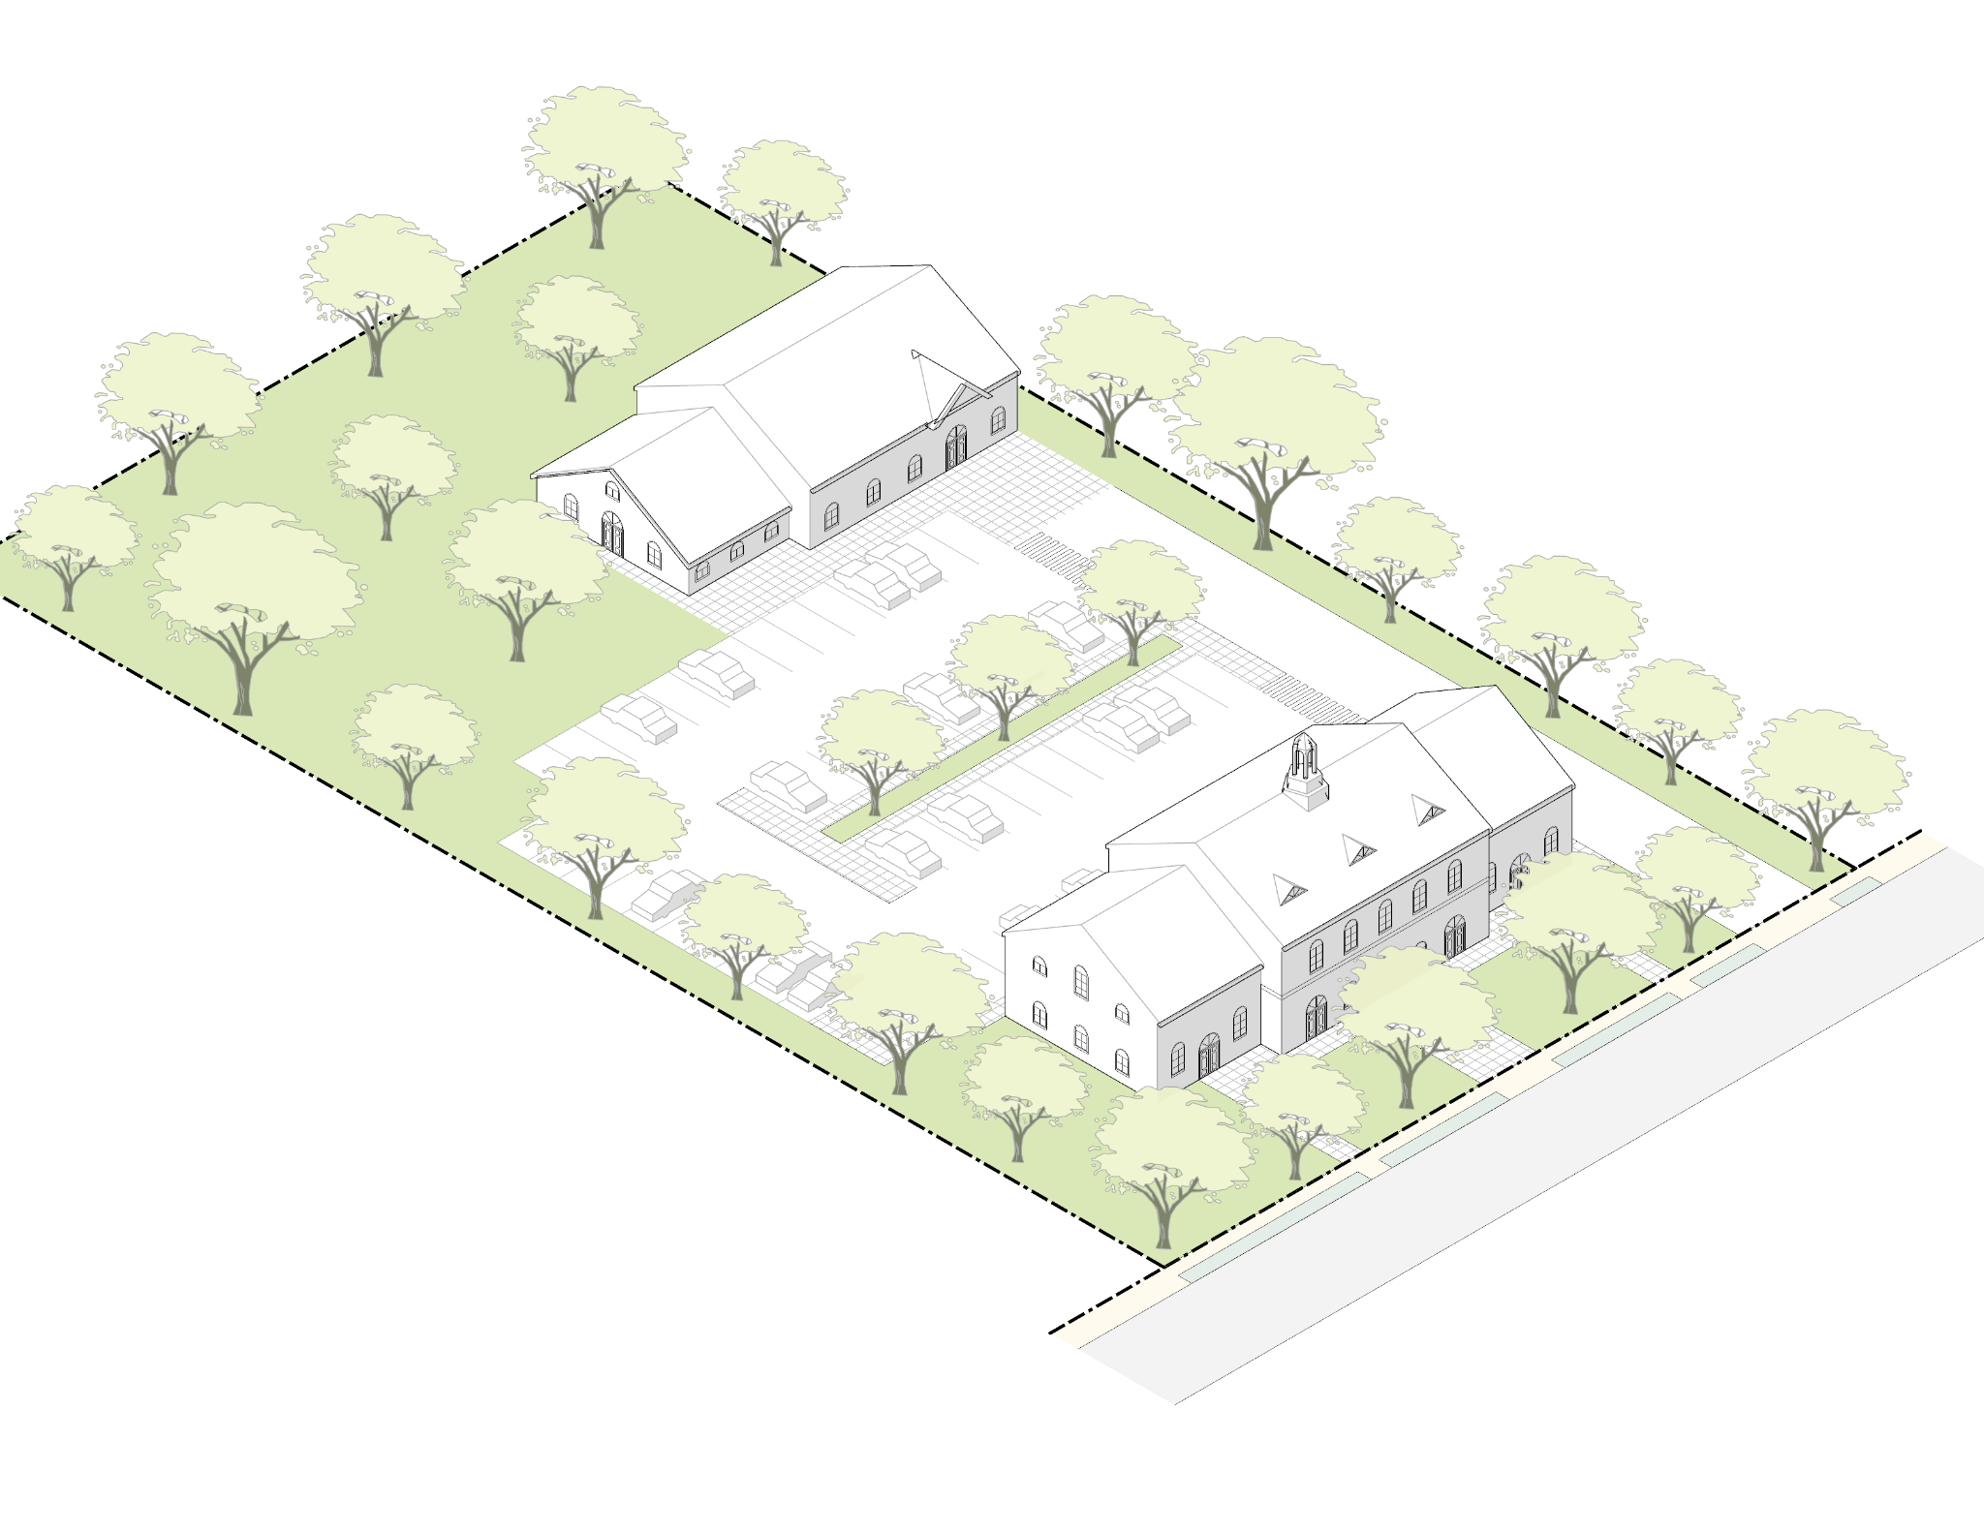

Figure 10. Bay Road Civic Sub-District Vision Illustration

1. *Description.* The Bay Road Civic Sub-district consists of two parcels owned by the Town and hosts municipal functions, including the Public Safety Complex, the Council on Aging, and the Building and Health Departments. The current arrangement of buildings and parking do not align with the traditional frontages of the Bay Road corridor. The site occupies an important “gateway” moment for the Downtown, where the alignment of Bay Road straightens out and the historic pattern of large structures set back behind generous lawns begins.
2. *Purpose and Intent.* The purpose of this sub-district is to guide the placement and scale of potential future buildings on this site that can improve and restore the consistency of Bay Road frontages. The regulations are crafted to ensure that the desirable patterns of Bay Road are enhanced while allowing the flexibility that may be required for additional municipal uses.

## 3. *Bay Road Mixed-Use.*

Figure 11. Bay Road Mixed-Use Sub-District Vision Illustration

1. *Description.* Most of the Bay Road Mixed-Use Sub-district matches the form of nearby residential areas where buildings have small footprints and a maximum height of two and a half stories. The eastern half of the sub-district contains a mix of residential, commercial, and civic uses, and is characterized by generous front yards and building types that are generally residential in form. The western side of Bay Road has a greater mix of building types and uses, and hence less consistent street edge and front yard conditions.
2. *Purpose and Intent.* The regulations for the Bay Road Mixed-Use Sub-district are intended to preserve and restore the historically scenic character of Bay Road, when the thoroughfare was tree-lined and more pedestrian-oriented in nature, while allowing a variety of uses, including residential and commercial. Several parcels on the east side of Bay Road abut an unused rail corridor and potential future recreational pathway. Consideration should be given to these important future connections in the planning of these deep lots where multiple frontages and access points may be possible.  
     
    Figure 12. Important Bay Road Mixed-Use Visual and Pedestrian Connections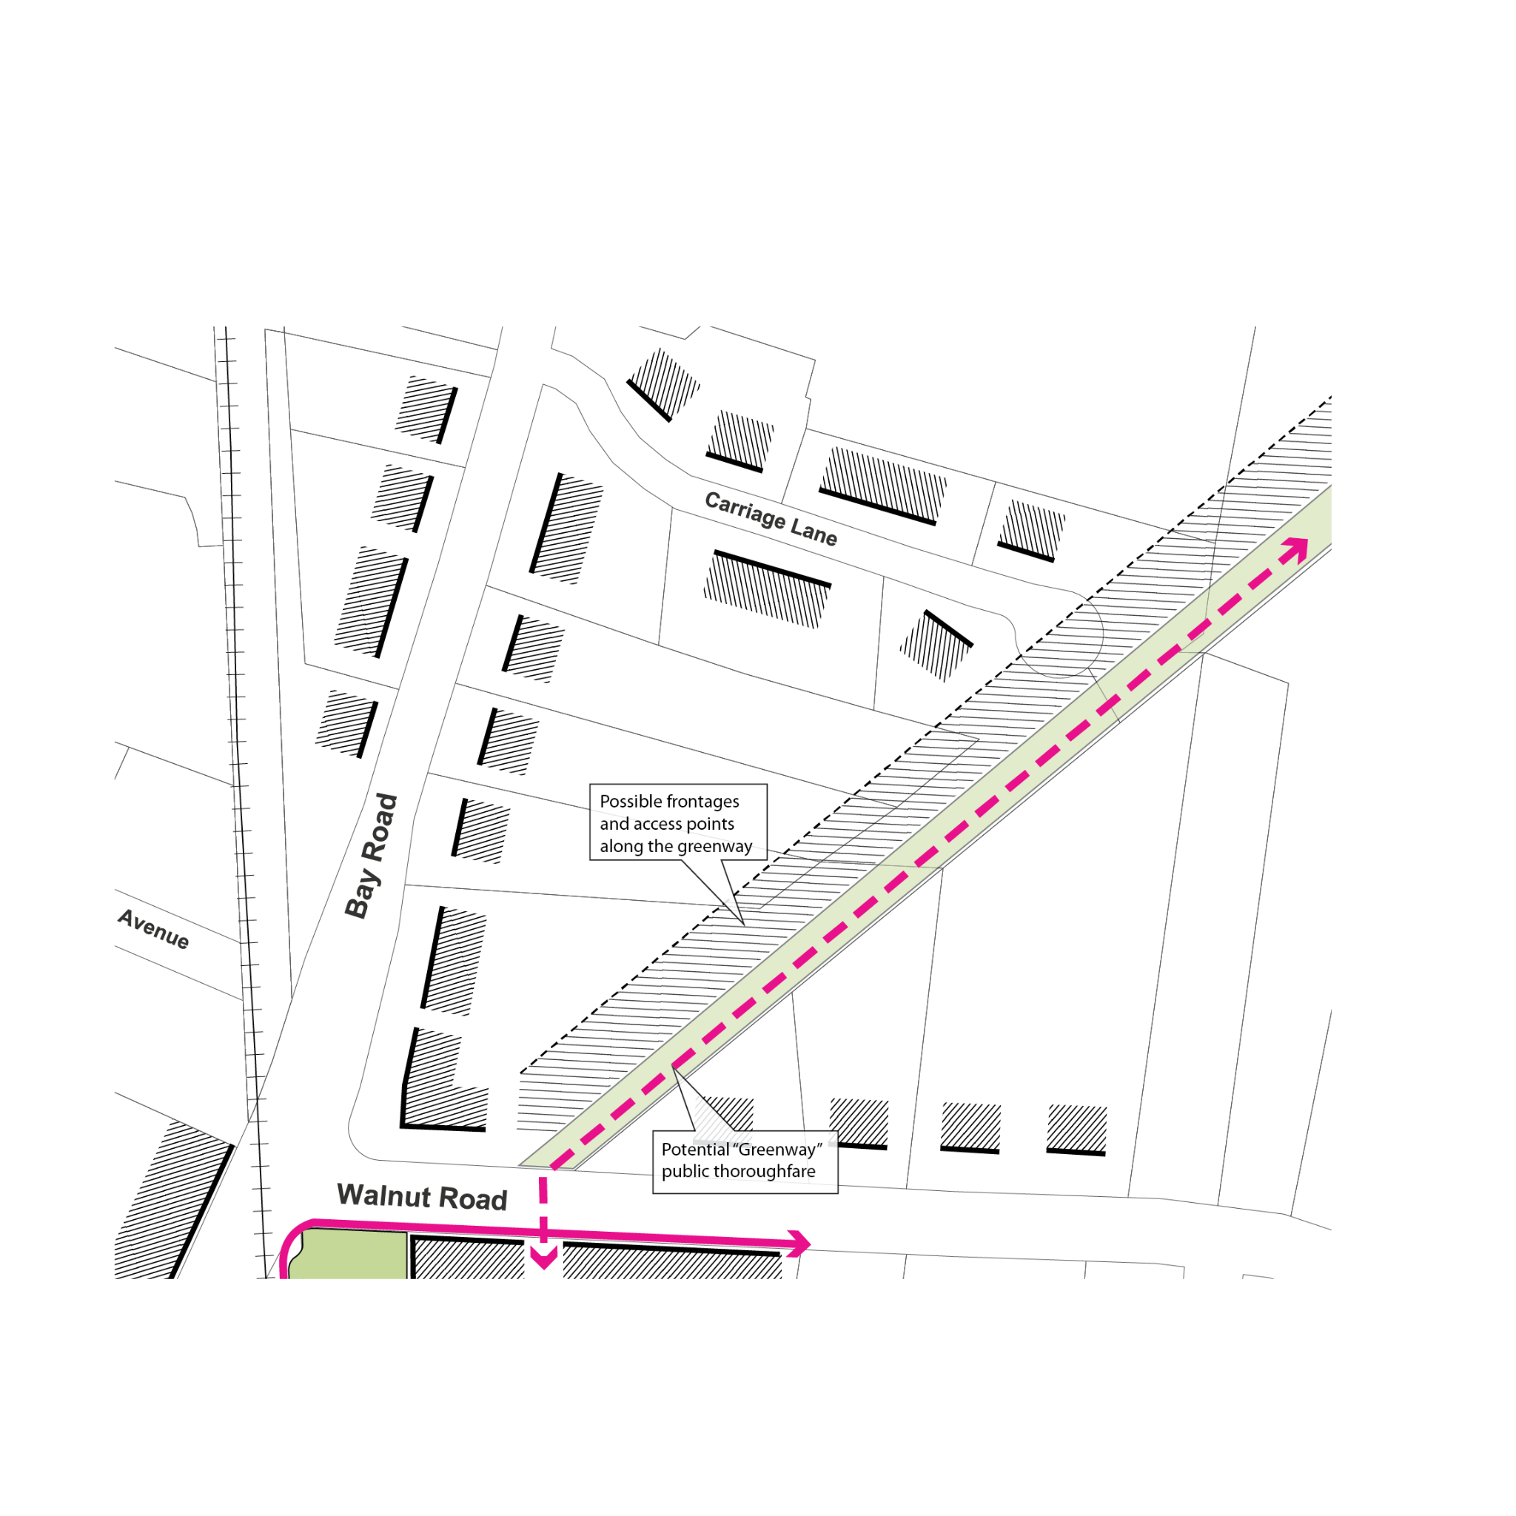

## 4. *Willow Street Mixed-Use.*

Figure 13. Willow Street Mixed-Use Sub-District Vision Illustration

1. *Description.* The Willow Street Mixed-Use Sub-district contains a variety of forms and uses. Portions of the sub-district have commercial and/or light industrial-use buildings with relatively large footprints, other portions have mixed-use buildings with moderately sized footprints, while other portions of the site are primarily residential with smaller footprints. The orientation of the rail corridor is such that rear yards are rarely consistent in depth. The objective of the code is to promote a more vibrant and walkable sub-district through the activation of mixed-use building frontages while respecting the scale and residential character of the adjacent Downtown Residential Sub-district.
2. *Purpose and Intent.* The objective of the code is to promote a more vibrant and walkable sub-district by activating mixed-use building frontages while respecting the scale and residential character of the adjacent Downtown Residential sub-district. Already mixed-use in character, the east side of Willow Street can accommodate more pedestrian-friendly ground floor uses and frontage conditions, supported by new residential uses. The By-law restricts the scale of buildings directly along Willow Street to match the abutting Downtown Residential Sub-district and allows for taller buildings toward the rear of the lot.

## 5. *Downtown Residential.*

Figure 14. Downtown Residential Sub-District Vision Illustration

1. *Description.* The Downtown Residential Sub-district is characterized by buildings that sit on small lots with small footprints and with an average height of approximately two and half stories. This sub-district is almost entirely residential with a very small selection of parcels with commercial or institutional uses.
2. *Purpose and Intent.* The regulations seek to preserve the existing scale and character of the neighborhood while permitting incremental infill development and adaptation. The dimensional standards reflect the current single-family patterns while allowing for additional units within those envelopes.

# 9.8.4. Dimensional Standards.

## 1. *Site Dimensional Requirements.*

Figure 15. Site Dimensional Requirements (see description of terms in Section 9.8.2)

**TABLE 1: TABLE OF TOWN CENTER SITE DIMENSIONAL STANDARDS**

*See Footnotes below for additional requirements and/or clarifying information.*

|  |  |  |  |  |  |  |
| --- | --- | --- | --- | --- | --- | --- |
|  | Lot Dimensions | Depot Square | Bay Road Mixed-Use | Willow Street Mixed-Use | Downtown Residential | Bay Road Civic |
|  | Lot Size (min) | 1,000 square-feet | 5,000 square-feet | 3,000 square-feet | 3,000 square-feet | 5,000 square-feet |
| **A** | Lot Width (min) | 20 feet | 40 feet | 40 feet | 30 feet | 40 feet |
|  | Coverage | Depot Square | Bay Road Mixed-Use | Willow Street Mixed-Use | Downtown Residential | Bay Road Civic |
|  | Open Space (min) | 0% | 40% | 40% | 40% | 40% |
|  | Building Yards Setbacks | Depot Square 2 | Bay Road Mixed-Use | Willow Street Mixed-Use | Downtown Residential | Bay Road Civic |
| **B** | Front Yard Setback on Streets (minimum / maximum) 1 | 0 / 10 feet | 20 / 35 feet | 10 / 20 feet | 10 /20 feet | 20 / 35 feet |
| **C** | Side Yard Setback (minimum) | 0 feet | 5 feet | 5 feet | 10 feet | 10 feet |
| **D** | Rear Yard Setback (minimum) | 0 feet | 15 feet | 15 feet | 15 feet | 10 feet |
|  | Parking Setbacks | Depot Square | Bay Road Mixed-Use | Willow Street Mixed-Use | Downtown Residential | Bay Road Civic |
| **E** | Front Setback (minimum) | 10 feet | Aligned with, or set back further than, Building Frontage | | | |
| **F** | Side Setback (minimum) | 0 feet | 5 feet | 5 feet | 5 feet | 5 feet |
| **G** | Rear Setback (minimum) | 0 feet | 5 feet | 5 feet | 5 feet | 5 feet |
|  | Parking Requirements | Depot Square | Bay Road Mixed-Use | Willow Street Mixed-Use | Downtown Residential | Bay Road Civic |
|  | Parking Spaces (minimum) | Per Section 6.1 or by Special Permit | | | | |

**Footnotes to Town Center Table of Site Dimensional Standards**

1. Includes frontage along the western edge of the rail corridor within the Depot Square sub-district. Porches less than 8 (eight) feet in depth and bay windows less than 3 (three) feet in depth may protrude into the Front Yard in all sub-districts except Depot Square.
2. Side and Rear Yards in the Depot Square sub-district that directly abut a different zoning district or sub-district shall conform to the minimum setbacks required in the abutting district or sub-district.

.

## 2. *Building Dimensional Standards.*

Figure 16. Building Dimensional Standards

**TABLE 2: TABLE OF TOWN CENTER DISTRICT BUILDING DIMENSIONAL STANDARDS**

*See Footnotes below for additional requirements and/or clarifying information.*

|  |  |  |  |  |  |  |
| --- | --- | --- | --- | --- | --- | --- |
|  | Massing | Depot Square 1 | Bay Road Mixed-Use | Willow Street Mixed-Use | Downtown Residential | Bay Road Civic |
| **A** | Building Footprint  (maximum per Building) | 5,000 square-feet | 3,000 square-feet | 5,000 square-feet | 3,000 square-feet | N/A |
| **B** | Facade Buildout (minimum) 2 | 60% | 35% | 35% | 35% | 35% |
| **C** | Height (maximum) | 35 feet / 2.5 stories | 35 feet / 2.5 stories | 35 feet / 2.5 stories for the first 60 feet from the front lot line, 45 feet / 3.5 stories elsewhere | 35 feet / 2.5 stories | 35 feet / 2.5 stories |
|  | Number of Stories Minimum | N/A | 2 | 2 | 2 | 2 |
| **D** | Ground Floor Height (minimum / maximum) | 13 / 15 feet | 13 / 15 feet | 13 / 15 feet | N/A | N/A |
|  | Floor Area Ratio (maximum) | N/A | 0.39, or up to 0.45 by Special Permit only | 0.42, or up to 0.45 by Special Permit only | 0.39, or up to 0.45 by Special Permit only | N/A |
| **E** | Facade Length without Offset (maximum) | 70 feet | 70 feet | 70 feet | 70 feet | 70 feet |
| **F** | Building Separation (minimum) | 10 feet | 10 feet | 10 feet | 20 feet | 0 feet |
|  | Roof | Depot Square | Bay Road Mixed-Use | Willow Street Mixed-Use | Downtown Residential | Bay Road Civic |
|  | Allowed Roof Type 3 | Gable, hip, gambrel, mansard, shed, flat | Gable, hip, gambrel, mansard, shed | Gable, hip, gambrel, mansard, shed | Gable, hip, gambrel, mansard, shed | Gable, hip, gambrel, mansard, shed, flat |
|  | Windows | Depot Square | Bay Road Mixed-Use | Willow Street Mixed-Use | Downtown Residential | Bay Road Civic |
|  | Ground Story Fenestration (minimum) | 50% | N/A | N/A | N/A | 20% |
|  | Doors | Depot Square | Bay Road Mixed-Use | Willow Street Mixed-Use | Downtown Residential | Bay Road Civic |
|  | Street Facing Entry Feature | Required | Required | Required | Required | Required |

**Footnotes to Table of Town Center Building Dimensional Standards:**

1. Depot Square Additional Dimensional Requirements. The following requirements and interpretations apply to the Depot Square sub-district only:
   1. New Structures are only permitted within 80 feet from a property line bounded by a public way, including the western edge of the rail corridor which shall be considered a Front Yard. This 80 foot measurement shall be measured perpendicular to the frontage. Structures extending beyond 80 feet from the front property line, and/or individual structures with a Building Footprint greater than 5,000 square-feet, shall be permitted only by Special Permit.
   2. Lots in the Depot Square sub-district with more than one frontage and a Lot area greater than 35,000 square-feet shall provide a minimum of 3,500 square-feet of open space at the intersection of the two frontages.
   3. Facade Buildout: On Lots where open space is required at an intersection, the length of the required open space along any frontage may be subtracted from each frontage length for the purpose of calculating minimum Facade Buildout. On lots greater than 45,000 square-feet and containing more than one frontage, Facade Buildout requirements shall apply only to the frontage where new structure(s) are proposed.
   4. Total Gross Floor Area of greater than 12,500 square-feet on a Lot is not permitted by right. Additional Gross Floor Area shall be permitted only through a Special Permit, granted by the appropriate SPGA applicable to the proposed uses.
2. For Lots with more than one frontage, the minimum Facade Buildout requirements shall apply to each frontage individually, and not cumulatively.

1. Roof forms may be combined, so long as minimum roof steepness is maintained.

# 9.8.5. Use Provisions.

1. The allowable uses and accessory uses in the Town Center District are contained in Section 3.0, Use Regulations. The following restrictions apply to the Town Center District sub-districts specified below only:  
   1. Use A6, a Garage with more than four motor vehicle spaces, is permitted in the Bay Road Mixed-Use, and Willow Street Mixed-Use sub-districts provided it is:   
      1. Accessory to a Multi-Family Dwelling or Mixed-Use Development, and;
      2. Located below grade or at grade beneath the primary Building massing and not within a stand-alone structure.
   2. Use D21, Mixed-Use Development, is allowed in the Depot Square sub-district provided that all of the following criteria are met:
      1. The ground floor area associated with the residential use shall be limited to entry areas, lobbies, mailrooms, and associated amenities and accessways serving residents, and vertical circulation elements such as stairs and elevators. All other ground floor uses shall be reserved for complimentary commercial uses;
      2. The residential ground floor uses occupy a minimum of 10% of the primary Building frontage, or 10 feet., whichever is greater; and
      3. The ground floor non-residential uses are a minimum of 20 feet deep.

# 9.8.6. Site Standards.

## 1. *Site Access.*

All development must provide vehicle, pedestrian, and bicycle access to and from a street.

1. *Pedestrian Access.*
   1. All development must provide pedestrian access connecting main entrances of Buildings, establishments or uses on a site that allows for public access, with all other public entrances with available access points including adjacent rights of way, all parking lots, and sidewalks.
   2. Pedestrian access must consist of an accessible, easily discernible walkway with a minimum width of five feet.
   3. Pedestrian access routes between Buildings must be physically separated from parking lots, except where required to cross a drive aisle; crossings must be perpendicular wherever practicable.
2. *Vehicle Access.*
   1. All parking spaces, parking lots, and Driveways must have vehicle access from a street.
   2. No parking spaces or parking lots shall be located within the front yard of principal structures. Parking of vehicles shall be allowed within driveway areas providing access to a principal structure, as long as the driveway is designed at a proper width for parking.
   3. No parking areas, parking lots or access drives shall be located within the minimum separation area between structures.
   4. Parking garage entries that face a public way must be set back 60 (sixty) feet from the property line(s) abutting the public way.

## 2. *Parking.*

Figure 17. Parking Standards

1. The quantity of off-street parking spaces shall be in accordance with the requirements of Section 6.1, Offstreet Parking and Loading Areas.
2. All driveways must comply with Section 6.2.2, Driveway Standards.
3. All parking spaces and structures must be located at or behind any required Parking Setbacks as specified for each sub-district of the Town Center District.
4. The maximum width of a curb cut and driveway for access to parking lots and structures is as follows:

One-lane: 12 feet

Two-lane: 24 feet

1. Each lot is limited to one curb cut per street frontage. Lots with more than 200 feet of frontage are allowed one additional curb cut every 200 feet.
2. The grade, cross slope, and clear width of the walkway of a sidewalk must be maintained between the driveway apron and the abutting driveway. The appearance of the walkway (i.e., scoring pattern or paving material) must indicate that, although a vehicle may cross, the area traversed by a vehicle remains part of the pedestrian sidewalk.
3. Shared or common driveways are encouraged where they reduce the interruption of curb cuts and allow for more landscape treatment. Shared driveways are subject to the requirements of Section 6.2.6, Common Driveway.
4. Parking Lots with ten or more parking spaces must have interior islands, median islands, and perimeter islands that conform with the following requirements:
   1. *Interior Islands.*
      * An interior landscape island must be provided every ten parking spaces and at the end of every parking row. Intervals may only be modified to preserve existing trees. Interior islands must be distributed evenly throughout the parking area.
      * An interior landscape island abutting a single row of parking spaces must be a minimum of 8 feet in width and 150 square-feet in area (measured inside the curb). The island must include one tree with a minimum caliper of 2.5 inches.
      * An interior landscape island abutting a double row of parking spaces must be a minimum of eight feet in width and 300 square-feet in area (measured inside the curb). This island must include 2 trees with a minimum caliper of 2.5 inches.
   2. *Median Islands.*
      * A median landscape island must be provided between every four rows of parking. Intervals may be modified to preserve existing trees.
      * A median landscape island must include a tree with minimum caliper of 2.5 inches spaced every 30 feet on average. Trees planted in an interior landscape island that overlap may be included in the count.
      * A median landscape island must be a minimum of 6 (six) feet-wide. A landscape median island with a pedestrian walkway must be a minimum of 12 (twelve) feet-wide (measured inside the curb).
   3. *Perimeter Islands.*
      * A perimeter landscape island is required on the outer edge of all parking lots when abutting the street or an internal access drive.
      * A perimeter landscape island must be a minimum of ten feet-wide not including any curbing.
      * Landscaping of perimeter islands must include evergreen shrubs planted three feet on center in a planting bed that is of a width suitable for the required plant spacing, but at least 36 inches wide.
      * A perimeter landscape island must include a tree with minimum caliper of 2.5 inches spaced every 30 feet on average.

## 3. *Screening.*

1. *Parking Lots.* Parking lots must be separated from the public right-of-way and abutting properties by a landscaped strip with a depth equal to the Parking Setbacks as specified in the Dimensional Requirements for each sub-district of the Town Center District. The landscaped strip must adhere to the following design standards:
   1. The landscape strip must run the full length of the parking lot perimeter along the right-of-way, excluding curb cuts and driveways.
   2. The landscape strip must be planted with shrubs, perennials, native grasses, and other planting types that provide screening from the public right-of-way.
   3. An optional low picket fence or pedestrian wall may be installed behind the landscape strip and set back up to 24 inches from the adjacent parking lot to accommodate for car overhang.
   4. The use of Low-Impact-Development (LID) stormwater management techniques such as rain gardens and bioswales is encouraged in landscape strips.
2. *Waste Receptacles.*
   1. Outdoor waste receptacles must be located to the side and rear of Buildings.
   2. Outdoor waste receptacles must be screened on three sides by an opaque wall or fence a minimum height of six feet.
   3. Access gates must be provided on the fourth side and must also be a minimum height of six feet.
3. *Roof-Mounted Equipment.* All outdoor mechanical, electrical or utility equipment (except for solar panels, wind turbines and antennas) must be screened on the roof edge by an opaque parapet wall or other type of screen that is at least a height six inches higher than the topmost point of the equipment being screened.
4. *Ground-Mounted Equipment.* 
   1. Ground-mounted mechanical, electrical or utility equipment must be located to the side or rear of Buildings.
   2. Ground-mounted mechanical, electrical or utility equipment visible from a public right-of-way must be fully screened by an opaque wall or fence or other type of screen that is at least a height 6 inches higher than the topmost point of the equipment being screened.
5. *Wall-Mounted Equipment.*
   1. Wall-mounted mechanical or electrical equipment must be located to the side or rear of Buildings.
   2. Wall-mounted mechanical, electrical or utility equipment visible from a public right-of-way must be fully screened by an opaque wall or fence or other type of screen that is at least a height 6 inches higher than the topmost point of the equipment being screened.

## 4. *Building Materials.*

1. *Applicability.* The Building material requirements set forth below apply to the exterior visible surfaces of Buildings and structures, including accessory structures, which are subject to Site Plan Review.
   1. Existing structures undergoing regular maintenance or enlargement must use materials similar in color, size and texture to the original structure's materials as to blend patch or repair work seamlessly with existing materials.
   2. Replacement of existing materials that are not permitted by this Section must be completed by permitted materials. This standard does not apply to small patches, rather it is intended for whole replacement, i.e. whole roof replacement or whole facade reconstruction.
   3. Exterior building materials must be those typically used in historic construction or be a composite or synthetic material that bears a strong resemblance to traditional building materials, including but not limited to brick, wood siding, engineered wood, or fiber cement artificial wood siding, asphalt shingle, tile roof shingle, copper roofing, stone masonry, and stucco.
   4. Concrete masonry units, pre-cast concrete panels, cinder block, vinyl siding, ribbed metal siding or roofs, EIFS is not allowed unless required due to the expansion of an existing Building to match the original structure.
   5. All windows and doorways shall be encased with wood or simulated wood trim; decorative trim is preferred. Aluminum windows shall be finished to match the proposed trim color of the Building.
   6. Deviation from the standards above will require approval from the Planning Board deeming that the finishes are of a design and quality that will elevate rather than detract from the appearance of the District or, in the case of multi-family housing, application of this Section would be prohibitive as determined by the Planning Board through Site Plan Review.

## 5. *Landscape Standards.*

1. *Native Trees.* Native deciduous shade trees must be spaced linearly and parallel to the public right-of-way, and planted at a minimum of 2.5 inches in tree caliper. The number of trees planted must be in accordance with the following:
   1. For lots with frontage of 100 feet or more, 1 native deciduous shade tree must be planted every 30 feet in the Front Yard unless at least three trees already exist in the Front Yard.
   2. For lots with a lot frontage of less than 100 feet and fronting Bay Road, a minimum of 2 trees must be planted in the Front Yard unless at least two trees already exist in the Front Yard.
2. *Permeable Surfaces.* Other than pathways to Building entrances or driveways, only permeable pavers or landscape / plantings are permitted within the front yard between Building frontage and the front lot line. Permeable pavers include brick, stone and/or cementitious materials, with joints that allow for the infiltration of water.

## 6. *Exterior Lighting.* To ensure that impacts of exterior lighting on adjacent properties are controlled, exterior lighting shall adhere to the following requirements:

1. A lighting plan must be submitted in conjunction with a required site plan.
2. No glare onto adjacent properties is permitted.
3. Excessive illumination is prohibited.
4. Non-overhead light sources, such as bollards and path lights, are encouraged.
5. The following light sources and fixtures are prohibited:
   1. Any exterior uplighting. Lighting fixtures for all areas of vehicular and/or pedestrian access must be full cut-off type fixtures or Illuminating Engineering Society of North America (IESNA) cut-off fixtures, or must be fully shielded/recessed fixtures where the lens is recessed or flush with the bottom surface.
   2. Low-pressure sodium and mercury vapor light sources
   3. Searchlights, laser source lights, or any similar high-intensity narrow-beam fixtures
   4. Flickering or flashing lights

# Administration.

1. *Site Plan Review.*Proposed development in Town Center District may be subject to Site Plan Review as required by Section 10.6, Site Plan Review. Multi-Family housing is allowed by-right in the Bay Road Mixed-Use, Willow Street Mixed-Use, and Downtown Residential sub-districts, subject to site plan review pursuant to Section 10.6, provided however that site plan review for Multi-Family uses cannot be denied. Applicants are encouraged to engage the Planning Board in a Pre-Application Conference.
2. *Special Permit.*Proposed uses in the Town Center District that are allowed by Special Permit shall be subject to review by the appropriate SPGA as indicated in Section 3.1, Table of Use Regulations.
3. *Site Plan Requirements and Design Review.*The Site Plan Review Regulations and Design Review provisions for Site Plan Review applications, authorized under Sections 10.6.7 and 10.6.9 of the Zoning By-law, if exercised by the Planning Board, may contain Site Plan Review Application requirements and Design Review Guidelines specific to projects proposed in the Town Center District. The Design Review Guidelines, if adopted by the Planning Board, shall identify the scale of projects which require Design Review. The Design Review Committee, if formed, shall be empowered to provide recommendations to the Planning Board concerning the site design and architecture of proposed developments.