APPENDIX A

ZONING BYLAW AND ZONING MAP AMENDMENTS

Unless specifically indicated below additions are underlined, deletions are ~~struck through~~, and explanatory and/or clarifying information for the reader that is not part of the proposed amendment itself and will not be included in the Zoning Bylaw is shown *italicized* and within borders.

## HAMILTON ZONING BY-LAW TABLE OF CONTENTS

*Insert the following to the Table of Contents under Section 9.0 Special District Regulations after 9.6:*

9.7 3A MULTI-FAMILY OVERLAY DISTRICT (3A-MFOD)

9.7.1 Purpose

9.7.2 Applicability

9.7.3 Permitted Uses

9.7.4 Dimensional Standards

9.7.5 Severability

9.8 TOWN CENTER DISTRICTS

9.8.1 Purpose and Intent

9.8.2 Interpretation

9.8.3 Town Center Sub-Districts

9.8.4 Dimensional Standards

9.8.5 Use Provisions

9.8.6 Site Standards

9.8.7 Administration

**2.1 CLASSES OF DISTRICTS.** The Town of Hamilton is hereby divided into the following districts:

Residence District R-1A

Residence District R-1B

Residence-Agricultural District RA

Business District B

Bay Road Mixed-Use TC-BRMU

Willow Street Mixed-Use TC-WSMU

Downtown Residential TC-DR

**2.2 ZONING MAP.** The Zoning Map dated December 28, 1964, filed with the Town Clerk, as amended by the Zoning Map - Conservancy District, dated February 1, 1971, and further amended May 7, 1974, May 14, 1979, May 13, 1985, November 14, 1999, ~~and~~ May 5, 2009, and July 14, 2025 (“Zoning Map”) is hereby made a part of this By-law.

*Maps depicting existing zoning and proposed zoning in the Town Center and the 3A-MFOD Overlay District presented under Articles I. Note that the underlying zoning district for the 3A Multi-Family Overlay District, which is R-1B, is not proposed to change.*

*Map of Existing Town Center Zoning*

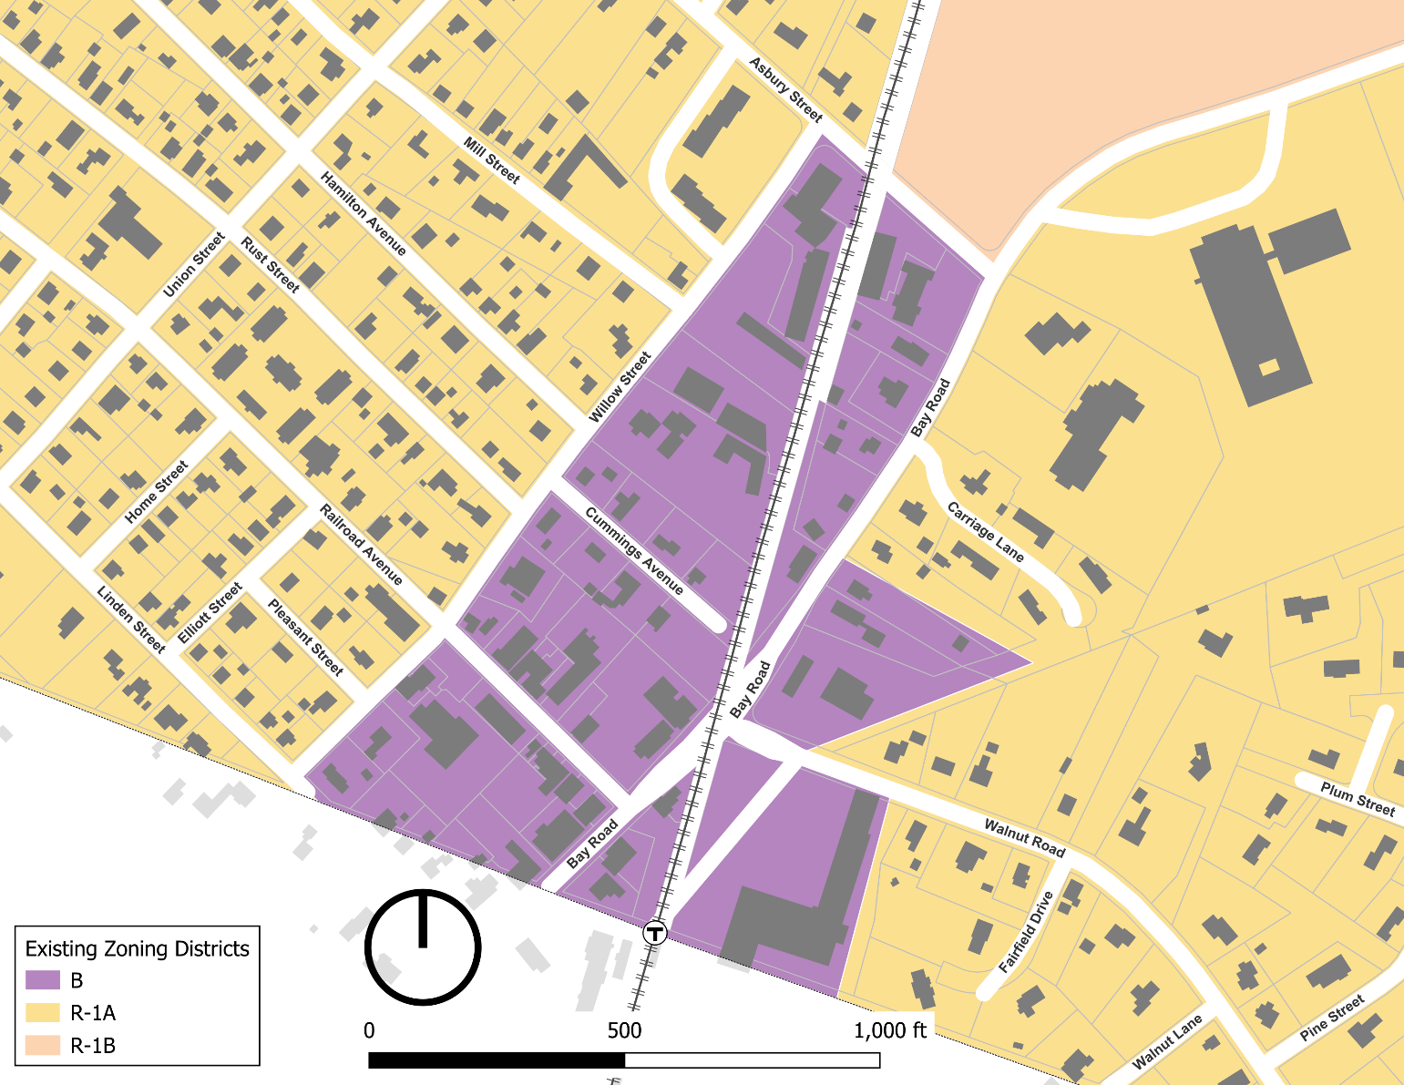

*Map of Proposed Town Center Zoning under Article I*

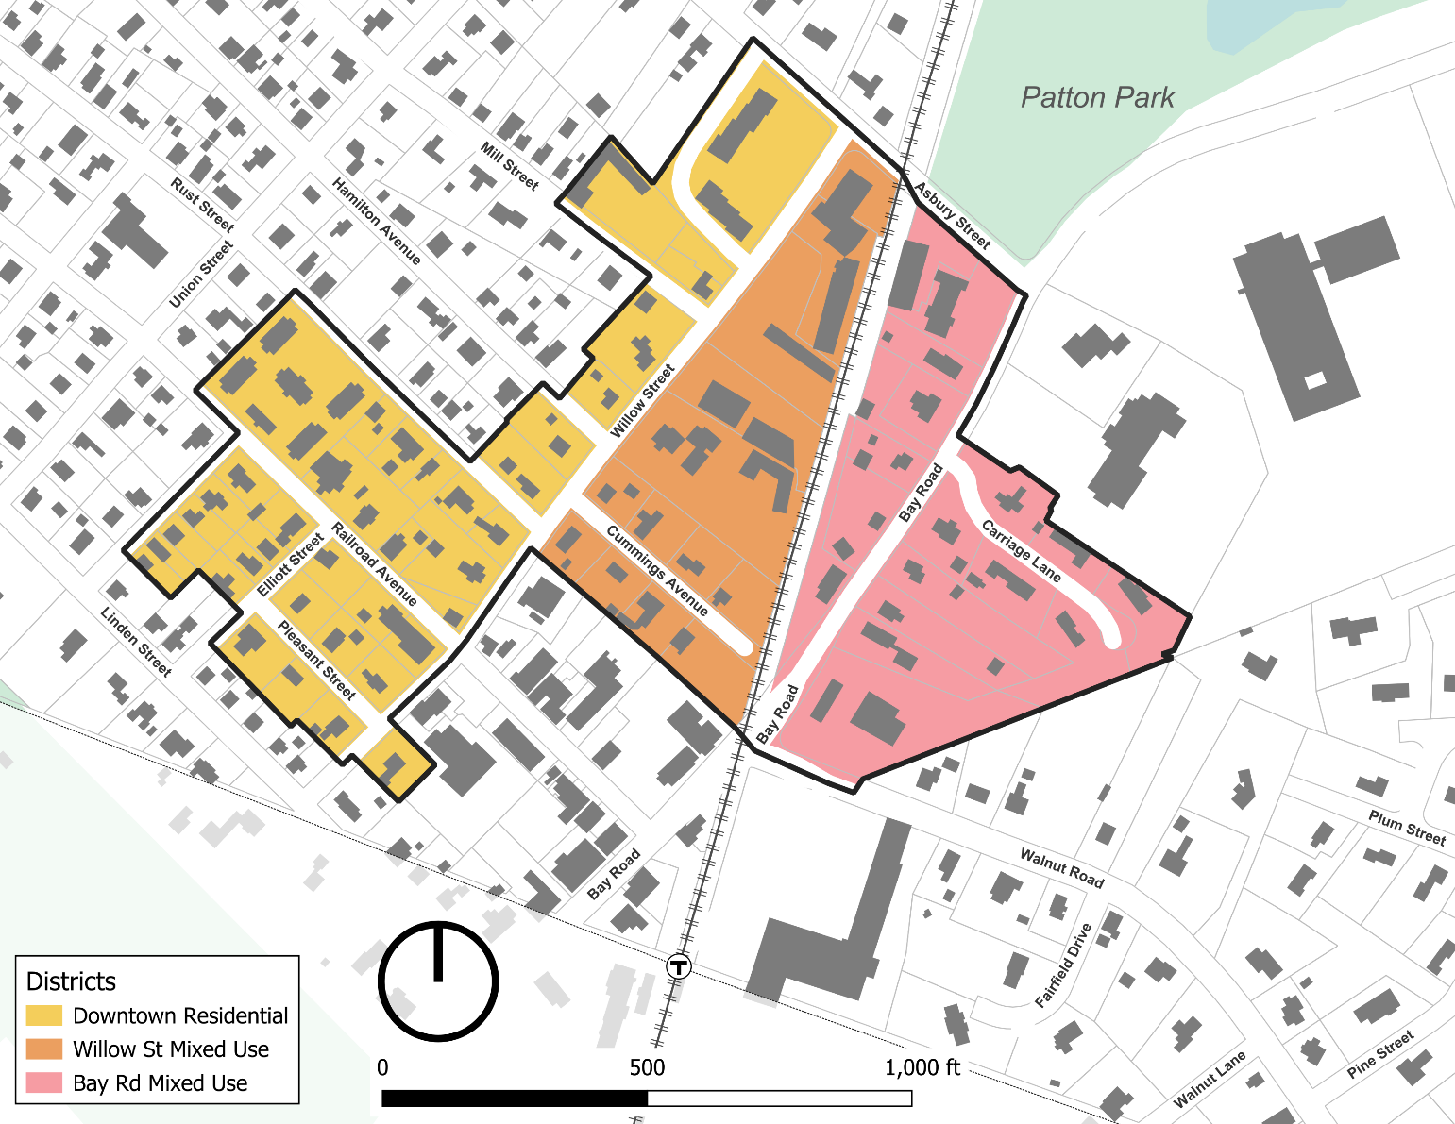

*Map of Proposed 3A-MFOD Overlay District (between Asbury Road and Highland Street) under Article I*

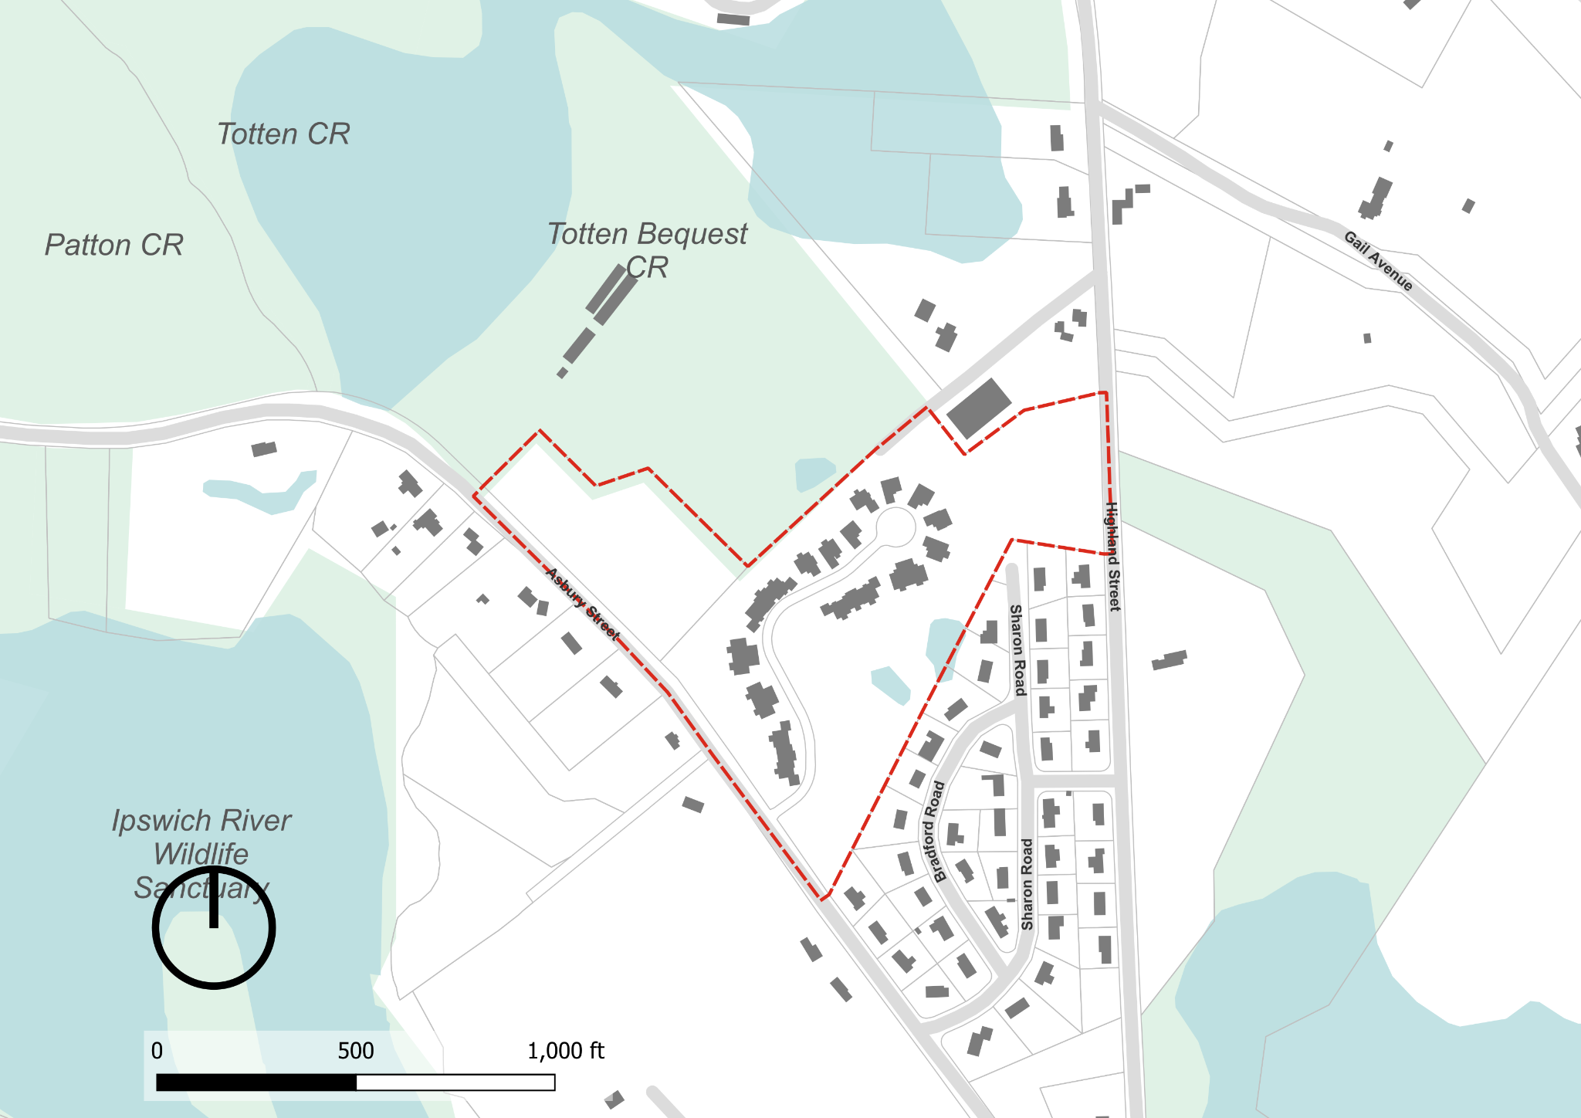

*Map of both Proposed Town Center Zoning and 3A-MFOD Overlay District under Article I*

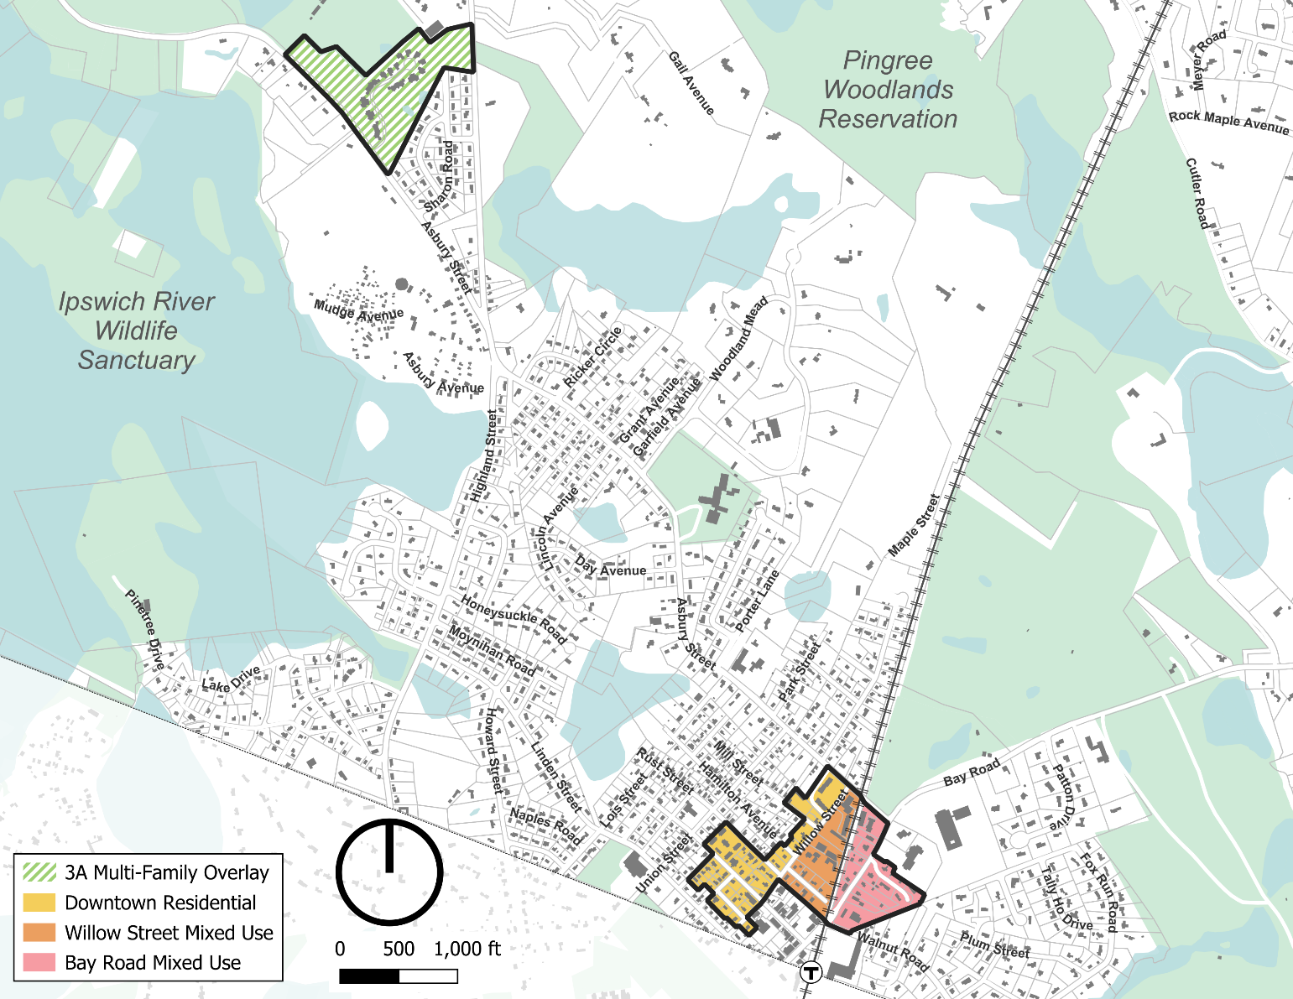

## **2.3 OVERLAY DISTRICTS.** The following Overlay Districts are also established, as set forth in Section 9.0, herein.

Groundwater Protection Overlay District GPOD

Flood Plain Overlay District FPOD

Estate Overlay District EOD

Willow Street Overlay District WSOD

Commercial Overlay District COD

3A Multi-Family Overlay District 3A-MFOD

**2.5 SPLIT LOTS.**

**2.5.2 By District Boundary.** Where a district boundary line between a residential and a business district divides any Lot existing at the time such line is adopted, the regulations for the less restricted portions of such lots shall extend no more than thirty (30) feet into the more restricted portion, provided the lot has lot frontage on a public way in the less restricted district or sub-district. For purposes of this section the Bay Road Mixed-Use and Willow Street Mixed-Use Sub-districts shall be business districts and the Downtown Residential District shall be a residential district.

## **3.1 PRINCIPAL USES.**

**TABLE OF USE REGULATIONS**

**Amend the Table of Use regulations to add columns for the new Bay Road Mixed-Use, Willow Street Mixed-Use and Downtown Residential sub-districts. Add a new use in Section A. Residential after 7 being Multi-Family Dwelling which use is allowed by right only in the new Bay Road Mixed-Use, Willow Street Mixed-Use and Downtown Residential sub-districts and which use is the only use allowed in those three districts.**

**3.2 ACCESSORY USES.**

**3.2.2 Accessory Uses and Structures in the Residence Districts and Downtown Residential Sub-district of the Town Center District.** The following provisions shall apply to Accessory Uses and Structures in the Residence Districts and Downtown Residential Sub-district:

**3.2.3 Accessory Uses in the Business, Willow Street Mixed-Use and Bay Road Mixed-Use Sub-districts of the Town Center District.** In the Business, Willow Street Mixed-Use and Bay Road Mixed-Use sub-districts, any use permitted as a Principal Use is also permitted as an Accessory Use provided such use is customarily incidental to the main or principal building or use of the land.

**4.1 GENERAL REGULATIONS.**

**4.1.2 Table of Dimensional Regulations.** The Table of Dimensional Regulations is hereby declared to be a part of this By-law.

**TABLE OF DIMENSIONAL REGULATIONS7**

|  |  |  |  |  |
| --- | --- | --- | --- | --- |
|  | R-1A | R-1B | RA | B |
| Minimum Lot Area per Dwelling Unit (sq. ft.) | 20,000 | 40,000 | 80,000 | ZBA1 |
| Minimum Lot Frontage (ft.) | 125 | 175 | 175 | ZBA2 |
| Minimum Lot width and depth (ft.) (for Dwellings, see also Sections 4.2.2, 4.2.6 and 4.3) | 100 at building | 100 at building | 100 at building | ZBA3 |
| Maximum Building Height (ft.) | 35 | 35 | 35 | 35 |
| Maximum number of Stories | 3 | 3 | 3 | 3 |
| Maximum Building coverage of Lot (%) | 25 | 25 | 25 | 754 |
| Minimum Front Yard (ft.)  (See also Section 4.2.4) | 25/50~~5~~2 | 25/50~~5~~2 | 25/50~~5~~2 | 25/505 |
| Minimum Side Yard and Rear Yard (ft.) | 15 | 15 | 15 | ZBA6 |

1. For each Dwelling Unit, minimum lot area is twenty thousand (20,000) square feet or as determined by the SPGA. For other uses, to be determined during site plan review.

2. For a Building that contains a Dwelling Unit, 125 feet. For all other uses, to be determined during site plan review.

3. To be determined during site plan review.

4. Or as determined during site plan review.

5. Twenty-five (25) feet from the Street line, or fifty (50) feet from the Street center line, whichever is greater.

6. For a Dwelling Unit, 15 feet. For all other uses, to be determined during site plan review.

7.Dimensional Requirements for the Town Center Sub-Districts are found in Section 9.8 of the Zoning By-law.

## **6.3 SIGNS.**

**6.3.2 Residence Districts and Downtown Residential Sub-district.**

**6.3.3 Business District, Bay Road Mixed-Use and Willow Street Mixed-Use Sub-districts of the Town Center District.**

**6.3.4 Standards**

8. A sign in the Business District, Bay Road Mixed-Use and Willow Street Mixed-Use sub-districts of the Town Center District shall not exceed a total area of six square feet.

## **8.3 INCLUSIONARY HOUSING**

**8.3.3 Mandatory Provision of Affordable Housing Units.** In any development subject to this Section, the tenth dwelling unit and every seventh unit thereafter shall be an Affordable Housing Unit, except in the 3A-MFOD, Bay Road Mixed-Use, Willow Street Mixed-Use, and Downtown Residential sub-districts, where the tenth dwelling unit and every tenth unit thereafter shall be an Affordable Housing Unit. Nothing in this Section shall preclude a developer from providing more Affordable Housing Units than are required hereunder. In the 3A-MFOD, and the Bay Road Mixed-Use, Willow Street Mixed-Use, and Downtown Residential Sub-districts, Affordable Housing Units in Multi-Family Housing developments shall not be required to make up more than 10% of the total units and the cap on the income of families or individuals who are eligible to occupy Affordable Housing Units shall not be less than 80% of Area Median Income (AMI) as determined by the US Department of Housing and Urban Development (HUD).

## **9.1 GROUNDWATER PROTECTION OVERLAY DISTRICT (GPOD)**

**9.1.4 Dimensional Requirements.** Regardless of the minimum Lot size of the underlying zone, there shall be a minimum lot area of eighty thousand (80,000) square feet per dwelling unit in the GPOD; provided however, proposed development in the 3A-MFOD advanced under the provisions of the overlay district, and not under the provisions of the underlying district, is exempt from the minimum lot area per dwelling.

**9.1.9 Uses and Activities Requiring a Special Permit.** The following uses and activities are permitted only upon the issuance of Special Permit by the Zoning Board of Appeals under such conditions as it may require, provided however that proposed development in the 3A-MFOD advanced under the provisions of the overlay district, and not under the provisions of the underlying district, is exempt from the Special Permit Requirement.

## **11.0 DEFINITIONS**

**Floor Area Ratio (FAR):**  In the Town Center Sub-districts, the ratio of the total Gross Floor Area of all buildings on a lot to the total lot area. For the purposes of calculating FAR, basements, cellars, attics, garages and interior parking spaces shall be excluded from the GFA. Half-stories that meet the criteria listed in 9.8.2.2.2 (j), Half Story, shall be counted as one half of the GFA of the floor below.

**Dwelling, Multi-Family or Multi-Family housing:** A building with ~~containing~~ ~~five~~ three or more residential dwelling units, or two or more buildings on the same lot with more than one residential dwelling unit in each building.

*Insert an entirely new Section 9.8 Town Center District as follows:*

9.8 TOWN CENTER DISTRICT.

*1. Introduction.* The Town Center District consists of three sub-districts: Bay Road Mixed-Use, Willow Street Mixed-Use and Downtown Residential, all located in the Town Center area of Hamilton. Collectively, these sub-districts shall be referred to as the Town Center District, however each sub-district contains its own use, dimensional, and associated regulations as stipulated under this Section. This Section consists of seven sub-sections that follow this introduction:

1. *Purpose and Intent.* This Section introduces the purpose and intent of the zoning generally, how and where it is to be applied, and how the regulations of this Section relate to other Sections of the By-law.
2. *Interpretation*. This Section provides definitions and explanations of the terms and metrics that are used to regulate building scale, form and placement. Many of the terms are unique to this Section.
3. *Town Center Sub-districts*. This Section describes the purpose and intent of each sub-district, as well as any relevant planning considerations.
4. *Dimensional Standards*.This Section includes district-wide tables with dimensions for lots and Buildings.
5. *Use Provisions*. This Section offers additional conditions and clarifications to the general use table.
6. *Site Standards*. This section provides standards for site design elements including vehicular and pedestrian access, parking, screening, building materials, landscaping, and lighting. It also establishes appropriate landscape treatments and contextually appropriate building materials.
7. *Administration*. This Section outlines the permitting path for proposed development, including whether Site Plan Review or a Special Permit is required.

# 9.8.1. Purpose and Intent.

1. *Purpose.*The purpose of this Section of the Hamilton Zoning By-law is to regulate the use of land, Buildings, and structures in the Town in a way that preserves the historic village character of Downtown Hamilton, and to provide standards for multi-family housing development that are both in accordance with G.L. c. 40A, § 3A and the Regulations issued by the Executive Office of Housing and Livable Communities (HLC) set forth at 760 CMR 72.00 and consistent with the Town’s existing character.

2. *Intent.*This Section is intended to ensure development in Hamilton’s Downtown contributes to the realization of the [Hamilton Town Center Vision Plan](https://docs.google.com/presentation/d/1QyuEc1qKCFhwlbIDQigC12AALwFk7PO9_jCP7LiXnaA/edit?usp=sharing) developed over the course of a townwide visioning process conducted throughout 2024 and 2025. Specifically, this Section intends to:

1. Ensure that new development is compatible with the historic and village character of Downtown Hamilton.
2. Preserve and enhance the historic commercial corridor along Railroad Avenue and Depot Square.
3. Promote activity in the Downtown, support commercial uses and promote increased walkability.
4. Provide a variety of housing types that cater to the diverse and changing needs of Hamilton’s residents.
5. In conjunction with Section 9.7, 3A Multi-Family Overlay District, comply with G.L. c. 40A, § 3A and the Section 3A Compliance Regulations of the Executive Office of Housing and Livable Communities (HLC) (760 CMR.72.00).

3. *Applicability.*

1. *Territorial Application.* This Section is applicable to all real property, structures, and uses located in the Bay Road Mixed-Use, Downtown Mixed-Use and Downtown Residential sub-districts as these sub-districts are depicted on the official Town of Hamilton Official Zoning Map dated July 14, 2025.
2. *Conflicting Provisions.* 
   1. If any condition or requirement imposed by this Section contains an actual, implied or apparent conflict with another provision of this Section, the more restrictive condition or requirement controls.
   2. If any condition or requirement imposed by this Section contains an actual, implied or apparent conflict with any condition or requirement of any other provision of the Town of Hamilton's Zoning By-law, the provisions of this Section control.
3. *Text and Graphics.* Illustrations, photographs and graphics are included in this Section to illustrate the intent and requirement of the text. In the case of a conflict between the text of this Section and any illustrations, the text governs.
4. *Existing Applications and Permits.* The applicability of this Section with respect to existing and proposed uses and structures is governed by Section 1.4.1, Applicability/Nonconformities, Section 1.4.2, Commencement of Construction or Operation, Section 5.1, and Section 9.8.1.4 *Nonconformities*.
5. *Severability.* If any provision of Section 9.8 is found to be invalid by a court of competent jurisdiction, the remainder of Section 9.8 shall not be affected and shall remain in full force. The invalidity of any provision of Section 9.8 shall not affect the validity of the remainder of Hamilton’s Zoning By-law. If any metric set forth in the Regulations issued by the HLC at 760 CMR 72.00 is amended, this Section may be amended to utilize the revised metrics set forth in the amended Regulations.

# 9.8.2 Interpretation

1. *Site Dimensional Standards and Measurements.*

1. *Yards.* See Section 11, Definitions. Each yard measurement is made perpendicular to the property line and begins at the property line. Measurements are made to the nearest portion of the Building, excluding open porches less than eight feet deep and bay windows less than 3 ft. deep.
2. *Lot Frontage.* See Section 11, Definitions. For lots bounded by more than one street, all frontages shall conform to the dimensional standards applicable to the front.
3. *Lot Size.* The area of a Lot, measured as the land within the parcel lines.
4. *Open Space.* Refers to land within a lot not covered by any structures or area dedicated to vehicular use including parking spaces and drive aisles.
5. *Parking Setbacks.*All parking spaces must be located behind the Parking Setback lines or as otherwise indicated. Each setback measurement is made perpendicular to the property line and begins at the property line.
6. *Number of Buildings.* Multiple Buildings are permitted on each lot, subject to the dimensional requirements listed in Section 9.8.4. Where thereis more thanone Building, Floor Area Ratio limitations shall apply to all Buildings cumulatively, and maximum Building Footprint limitations shall be applied on a per Building basis.
7. *Street Facing Entry Feature.* Refers to a Building entry that is directly accessible and visible from a street. Entry doors are not required to face the street so long as they are accessed through a porch, patio, plaza, canopy or other element facilitating direct visual and physical access from the street.

2. *Building Dimensional Standards and Measurements.*

1. *Depth.* Refers to the measurement of a Building, yard, or setback measured perpendicular to a front lot line, excluding open porches less than eight feet deep and bay windows less than three feet deep.
2. *Facade Buildout.* The ratio of the facade width within the minimum and maximum Front Yard dimensions to the lot width, calculated by dividing the cumulative facade width by the lot width. Facade Buildout is intended to ensure that new development addresses the street in a pedestrian-friendly manner and that frontage conditions are compatible with existing patterns.

Figure 1. Facade Buildout

1. *Facade Length without Offset.* The maximum allowable length of any Building facade, front, side or rear, without a change in plane of five feet or greater, extending from the ground plane to the Roof. The purpose of offset requirements is to limit long, undifferentiated facades and to ensure that larger Buildings are broken down into smaller elements that are more reflective of the existing context.

Figure 2. Facade Length without Offset

1. *Building Footprint.* The area of land occupied by a Building, defined by the outer edge of its foundation and exterior walls inclusive of covered parking and other enclosed spaces. Cantilevered elements that do not touch the ground, such as bay windows, do not contribute to the calculation of footprint area provided they do not protrude more than three feet from the face of the Building. Unenclosed porches less than eight feet deep do not contribute to the calculation of the Building Footprint.

Figure 3. Building Footprint

1. *Building Separation.* The distance between Buildings on a lot, measured from the nearest primary face of each Building at its closest point, excluding bay windows less than three feet deep and porches less than eight feet deep.

Figure 4. Building Separation

1. *Height.* See Section 11, Definitions. In the Town Center District, for Buildings on lots fronting more than one public way, height shall be measured from all frontages.
2. *Roof Type.* Roof forms include gable, hip, gambrel, mansard, shed, and flat, and are permitted as detailed in Section 9.8.4.2. Gable, hipped and shed roofs shall have a minimum slope of 9:12.

|  |  |
| --- | --- |
| A drawing of a house  AI-generated content may be incorrect.  Gable Roof | A drawing of a roof pitch  AI-generated content may be incorrect.  Hipped Roof |
| A drawing of a house  AI-generated content may be incorrect.  Shed Roof | A white box with a roof  AI-generated content may be incorrect.  Gambrel Roof |
| A white box with a lid  AI-generated content may be incorrect.  Mansard Roof | A white box with a black outline  AI-generated content may be incorrect.  Flat Roof |

Figure 5. Roof Type

1. *Width.* Measurement of the length of a Building parallel to a front Lot line.
2. *Fenestration.* The percentage area of glazing at the ground level, measured between two feet and 10 feet above the finished floor of the ground story. Where fenestration requirements apply, ground story windows should be display windows that may or may not have muntins and/or mullions, decorative stiles and or a combination of display windows and transoms supported by appropriate kickplates. The windows may be segmented with trim, piers or wall plane. Where required, minimum ground floor fenestration is intended to ensure that ground floor uses can activate the public realm.

Figure 6. Ground Story Fenestration

1. *Half story.* The occupiable portion of a Building between the uppermost floor and a pitched roof supported by a bottom plate no greater than three feet above the floor level, and containing dormers whose aggregate length is less than 50% of the length of the roof measured horizontally. Where a story is being counted as a half story, dormers shall be located a minimum of three feet from the edge of the primary roof. The uppermost level of gambrel, mansard and flat roofs may not be considered a half story and shall be considered a full story.

Figure 7. Half StoryA diagram of a house

AI-generated content may be incorrect.

# 9.8.3. Town Center Sub-Districts.

## 1*. (reserved)*

## 2*. (reserved)*

## 3. *Bay Road Mixed-Use.*

Figure 11. Bay Road Mixed-Use Sub-District Vision Illustration

1. *Description.* Most of the Bay Road Mixed-Use Sub-district matches the form of nearby residential areas where buildings have small footprints and a maximum height of two and a half stories. The eastern half of the sub-district contains a mix of residential, commercial, and civic uses, and is characterized by generous front yards and building types that are generally residential in form. The western side of Bay Road has a greater mix of building types and uses, and hence less consistent street edge and front yard conditions.
2. *Purpose and Intent.* The regulations for the Bay Road Mixed-Use Sub-district are intended to preserve and restore the historically scenic character of Bay Road, when the thoroughfare was tree-lined and more pedestrian-oriented in nature, while allowing a variety of uses, including residential and commercial. Several parcels on the east side of Bay Road abut an unused rail corridor and potential future recreational pathway. Consideration should be given to these important future connections in the planning of these deep lots where multiple frontages and access points may be possible.  
     
    Figure 12. Important Bay Road Mixed-Use Visual and Pedestrian Connections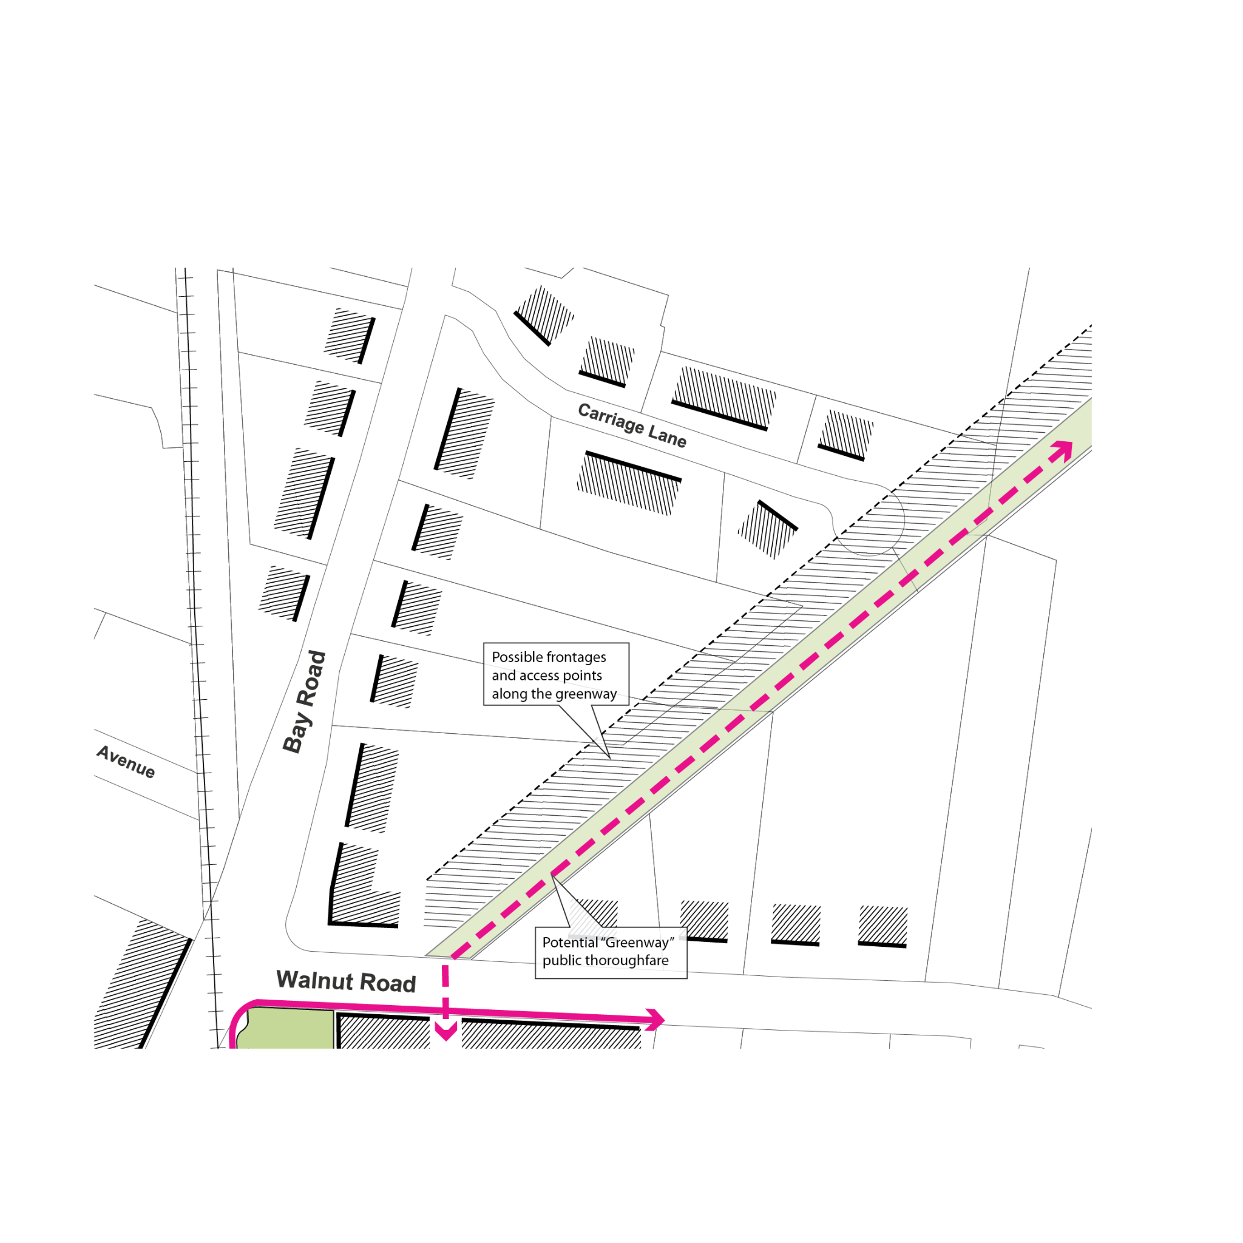

## 4. *Willow Street Mixed-Use.*

Figure 13. Willow Street Mixed-Use Sub-District Vision Illustration

1. *Description.* The Willow Street Mixed-Use Sub-district contains a variety of forms and uses. Portions of the sub-district have commercial and/or light industrial-use buildings with relatively large footprints, other portions have mixed-use buildings with moderately sized footprints, while other portions of the site are primarily residential with smaller footprints. The orientation of the rail corridor is such that rear yards are rarely consistent in depth. The objective of the code is to promote a more vibrant and walkable sub-district through the activation of mixed-use building frontages while respecting the scale and residential character of the adjacent Downtown Residential Sub-district.
2. *Purpose and Intent.* The objective of the code is to promote a more vibrant and walkable sub-district by activating mixed-use building frontages while respecting the scale and residential character of the adjacent Downtown Residential Sub-district. Already mixed-use in character, the east side of Willow Street can accommodate more pedestrian-friendly ground floor uses and frontage conditions, supported by new residential uses. The By-law restricts the scale of buildings directly along Willow Street to match the abutting Downtown Residential Sub-district and allows for taller buildings toward the rear of the lot.

## 5. *Downtown Residential.*

Figure 14. Downtown Residential Sub-District Vision Illustration

1. *Description.* The Downtown Residential Sub-district is characterized by buildings that sit on small lots with small footprints and with an average height of approximately two and half stories. This sub-district is almost entirely residential with a very small selection of parcels with commercial or institutional uses.
2. *Purpose and Intent.* The regulations seek to preserve the existing scale and character of the neighborhood while permitting incremental infill development and adaptation. The dimensional standards reflect the current single-family patterns while allowing for additional units within those envelopes.

# 9.8.4. Dimensional Standards.

## 1. *Site Dimensional Requirements.*

Figure 15. Site Dimensional Requirements (see description of terms in Section 9.8.2)

**TABLE 1: TABLE OF TOWN CENTER DISTRICT SITE DIMENSIONAL STANDARDS**

|  |  |  |  |  |  |
| --- | --- | --- | --- | --- | --- |
|  | Lot Dimensions | Bay Road Mixed-Use | Willow Street Mixed-Use | Downtown Residential | |
|  | Lot Size (min) | 5,000 square-feet | 3,000 square-feet | 3,000 square-feet | |
| **A** | Lot Width (min) | 40 feet | 40 feet | 30 feet | |
|  | Coverage | Bay Road Mixed-Use | Willow Street Mixed-Use | Downtown Residential | |
|  | Open Space (min) | 40% | 40% | 40% | |
|  | Building Yards Setbacks | Bay Road Mixed-Use | Willow Street Mixed-Use | Downtown Residential | |
| **B** | Front Yard Setback on Streets (minimum / maximum) 1 | 20 / 35 feet | 10 / 20 feet | 10 /20 feet | |
| **C** | Side Yard Setback (minimum) | 5 feet | 5 feet | 10 feet | |
| **D** | Rear Yard Setback (minimum) | 15 feet | 15 feet | 15 feet | |
|  | Parking Setbacks | Bay Road Mixed-Use | Willow Street Mixed-Use | Downtown Residential | |
| **E** | Front Setback (minimum) | Aligned with, or set back further than, Building Frontage | | |
| **F** | Side Setback (minimum) | 5 feet | 5 feet | 5 feet | |
| **G** | Rear Setback (minimum) | 5 feet | 5 feet | 5 feet | |
|  | Parking Requirements | Bay Road Mixed-Use | Willow Street Mixed-Use | Downtown Residential | |
|  | Parking Spaces (minimum) | Per Section 6.1 or by Special Permit | | |

.

## 2. *Building Dimensional Standards.*

Figure 16. Building Dimensional Standards

**TABLE 2: TABLE OF TOWN CENTER DISTRICT BUILDING DIMENSIONAL STANDARDS**

*See Footnotes to Table for additional requirements and/or clarifying information.*

|  |  |  |  |  |  |
| --- | --- | --- | --- | --- | --- |
|  | Lot Dimensions | Bay Road Mixed-Use | Willow Street Mixed-Use | Downtown Residential | |
|  | Lot Size (min) | 5,000 square-feet | 3,000 square-feet | 3,000 square-feet | |
| **A** | Lot Width (min) | 40 feet | 40 feet | 30 feet | |
|  | Coverage | Bay Road Mixed-Use | Willow Street Mixed-Use | Downtown Residential | |
|  | Open Space (min) | 40% | 40% | 40% | |
|  | Building Yards Setbacks | Bay Road Mixed-Use | Willow Street Mixed-Use | Downtown Residential | |
| **B** | Front Yard Setback on Streets (minimum / maximum) 1 | 20 / 35 feet | 10 / 20 feet | 10 /20 feet | |
| **C** | Side Yard Setback (minimum) | 5 feet | 5 feet | 10 feet | |
| **D** | Rear Yard Setback (minimum) | 15 feet | 15 feet | 15 feet | |
|  | Parking Setbacks | Bay Road Mixed-Use | Willow Street Mixed-Use | Downtown Residential | |
| **E** | Front Setback (minimum) | Aligned with, or set back further than, Building Frontage | | |
| **F** | Side Setback (minimum) | 5 feet | 5 feet | 5 feet | |
| **G** | Rear Setback (minimum) | 5 feet | 5 feet | 5 feet | |
|  | Parking Requirements | Bay Road Mixed-Use | Willow Street Mixed-Use | Downtown Residential | |
|  | Parking Spaces (minimum) | Per Section 6.1 or by Special Permit | | |

**Footnotes to Table of Building Dimensional Standards:**

1. (reserved)
2. For Lots with more than one frontage, the minimum Facade Buildout requirements shall apply to each frontage individually, and not cumulatively.

1. Roof forms may be combined, so long as minimum roof steepness is maintained.

# 9.8.5. Use Provisions.

1. The allowable uses and accessory uses in the Town Center District are contained in Section 3.0, Use Regulations. The following clarifications and exceptions are made with respect to the Town Center District sub-districts only:  
   1. Use A6, a Garage with more than 4 motor vehicle spaces, is permitted in the Bay Road Mixed-Use, and Willow Street Mixed-Use sub-districts provided it is:   
      1. Accessory to a Multi-Family Dwelling and;
      2. Located below grade or at grade beneath the primary Building massing and not within a stand-alone structure.

# 9.8.6. Site Standards.

## 1. *Site Access.*

All development must provide vehicle, pedestrian, and bicycle access to and from a street.

1. *Pedestrian Access.*
   1. All development must provide pedestrian access connecting main entrances of Buildings, establishments or uses on a site that allows for public access, with all other public entrances with available access points including adjacent rights of way, all parking lots, and sidewalks.
   2. Pedestrian access must consist of an accessible, easily discernible walkway with a minimum width of five feet.
   3. Pedestrian access routes between Buildings must be physically separated from parking lots, except where required to cross a drive aisle; crossings must be perpendicular wherever practicable.
2. *Vehicle Access.*
   1. All parking spaces, parking lots, and Driveways must have vehicle access from a street.
   2. No parking spaces or parking lots shall be located within the front yard of principal structures. Parking of vehicles shall be allowed within driveway areas providing access to a principal structure, as long as the driveway is designed at a proper width for parking.
   3. No parking areas, parking lots or access drives shall be located within the minimum separation area between structures.
   4. Parking garage entries that face a public way must be set back 60 feet from the property line(s) abutting the public way.

## 2. *Parking.*

Figure 17. Parking Standards

1. The quantity of off-street parking spaces shall be in accordance with the requirements of Section 6.1, Offstreet Parking and Loading Areas.
2. All driveways must comply with Section 6.2.2, Driveway Standards.
3. All parking spaces and structures must be located at or behind any required Parking Setbacks as specified for each sub-district of the Town Center District.
4. The maximum width of a curb cut and driveway for access to parking lots and structures is as follows:

One-lane: 12 feet

Two-lane: 24 feet

1. Each lot is limited to one curb cut per street frontage. Lots with more than 200 feet of frontage are allowed one additional curb cut every 200 feet.
2. The grade, cross slope, and clear width of the walkway of a sidewalk must be maintained between the driveway apron and the abutting driveway. The appearance of the walkway (i.e., scoring pattern or paving material) must indicate that, although a vehicle may cross, the area traversed by a vehicle remains part of the pedestrian sidewalk.
3. Shared driveways are encouraged where they reduce the interruption of curb cuts and allow for more landscape treatment. Permits shall be issued subject to the requirements of 6.2.6 Common Driveway.
4. Parking Lots with 10 or more parking spaces must have interior islands, median islands, and perimeter islands that conform with the following requirements:
   1. *Interior Islands.*
      * An interior landscape island must be provided every 10 parking spaces and at the end of every parking row. Intervals may only be modified to preserve existing trees. Interior islands must be distributed evenly throughout the parking area.
      * An interior landscape island abutting a single row of parking spaces must be a minimum of eight feet in width and 150 square-feet in area (measured inside the curb). The island must include one tree with a minimum caliper of 2.5 inches.
      * An interior landscape island abutting a double row of parking spaces must be a minimum of eight feet in width and 300 square-feet in area (measured inside the curb). This island must include two trees with a minimum caliper of 2.5 inches.
   2. *Median Islands.*
      * A median landscape island must be provided between every four rows of parking. Intervals may be modified to preserve existing trees.
      * A median landscape island must include a tree with a minimum caliper of 2.5 inches spaced every 30 feet on average. Trees planted in an interior landscape island that overlap may be included in the count.
      * A median landscape island must be a minimum of six feet-wide. A landscape median island with a pedestrian walkway must be a minimum of 12 feet wide (measured inside the curb).
   3. *Perimeter Islands.*
      * A perimeter landscape island is required on the outer edge of all parking lots when abutting the street or an internal access drive.
      * A perimeter landscape island must be a minimum of 10 feet-wide not including any curbing.
      * Landscaping of perimeter islands must include evergreen shrubs planted three feet on center in a planting bed that is of a width suitable for the required plant spacing, but at least 36 inches wide.
      * A perimeter landscape island must include a tree with minimum caliper of 2.5 inches spaced every 30 feet on average.

## 3. *Screening.*

1. *Parking Lots.* Parking lots must be separated from the public right-of-way and abutting properties by a landscaped strip with a depth equal to the Parking Setbacks as specified in the Dimensional Requirements for each sub-district of the Town Center District. The landscaped strip must adhere to the following design standards:
   1. The landscape strip must run the full length of the parking lot perimeter along the right-of-way, excluding curb cuts and driveways.
   2. The landscape strip must be planted with shrubs, perennials, native grasses, and other planting types that provide screening from the public right-of-way.
   3. An optional low picket fence or pedestrian wall may be installed behind the landscape strip and set back up to 24 inches from the adjacent parking lot to accommodate for car overhang.
   4. The use of Low-Impact-Development (LID) stormwater management techniques such as rain gardens and bioswales is encouraged in landscape strips.
2. *Waste Receptacles.*
   1. Outdoor waste receptacles must be located to the side and rear of Buildings.
   2. Outdoor waste receptacles must be screened on three sides by an opaque wall or fence a minimum height of six feet.
   3. Access gates must be provided on the fourth side and must also be a minimum height of six feet.
3. *Roof-Mounted Equipment.* All outdoor mechanical, electrical or utility equipment (except for solar panels, wind turbines and antennas) must be screened on the roof edge by an opaque parapet wall or other type of screen that is at least a height six inches higher than the topmost point of the equipment being screened.
4. *Ground-Mounted Equipment.* 
   1. Ground-mounted mechanical, electrical or utility equipment must be located to the side or rear of Buildings.
   2. Ground-mounted mechanical, electrical or utility equipment visible from a public right-of-way must be fully screened by an opaque wall or fence or other type of screen that is at least a height six inches higher than the topmost point of the equipment being screened.
5. *Wall-Mounted Equipment.*
   1. Wall-mounted mechanical or electrical equipment must be located to the side or rear of Buildings.
   2. Wall-mounted mechanical, electrical or utility equipment visible from a public right-of-way must be fully screened by an opaque wall or fence or other type of screen that is at least a height six inches higher than the topmost point of the equipment being screened.

## 4. *Building Materials.*

1. *Applicability.* The Building material requirements set forth below apply to the exterior visible surfaces of Buildings and structures, including accessory structures, which are subject to Site Plan Review.
   1. Existing structures undergoing regular maintenance or enlargement must use materials similar in color, size and texture to the original structure's materials as to blend patch or repair work seamlessly with existing materials.
   2. Replacement of existing materials that are not permitted by this Section must be completed by permitted materials. This standard does not apply to small patches, rather it is intended for whole replacement, i.e. whole roof replacement or whole facade reconstruction.
   3. Exterior building materials must be those typically used in historic construction or be a composite or synthetic material that bears a strong resemblance to traditional building materials, including but not limited to brick, wood siding, engineered wood, or fiber cement artificial wood siding, asphalt shingle, tile roof shingle, copper roofing, stone masonry, and stucco.
   4. Concrete masonry units, pre-cast concrete panels, cinder block, vinyl siding, ribbed metal siding or roofs, EIFS is not allowed unless required due to the expansion of an existing Building to match the original structure.
   5. All windows and doorways shall be encased with wood or simulated wood trim; decorative trim is preferred. Aluminum windows shall be finished to match the proposed trim color of the Building.
   6. Deviation from the standards above will require approval from the Planning Board deeming that the finishes are of a design and quality that will elevate rather than detract from the appearance of the District or, in the case of multi-family housing, application of this Section would be prohibitive as determined by the Planning Board through site plan review.

## 5. *Landscape Standards.*

1. *Native Trees.* Native deciduous shade trees must be spaced linearly and parallel to the public right-of-way, and planted at a minimum of 2.5 inches in tree caliper. The number of trees planted must be in accordance with the following:
   1. For lots with frontage of 100 feet or more, 1 native deciduous shade tree must be planted every 30 feet in the Front Yard unless at least three trees already exist in the Front Yard.
   2. For lots with a lot frontage of less than 100 feet and fronting Bay Road, a minimum of two trees must be planted in the Front Yard unless at least two trees already exist in the Front Yard.
2. *Permeable Surfaces.* Other than pathways to Building entrances or driveways, only permeable pavers or landscape / plantings are permitted within the front yard between Building frontage and the front lot line. Permeable pavers include brick, stone and/or cementitious materials, with joints that allow for the infiltration of water.

## 6. *Exterior Lighting.* To ensure that impacts of exterior lighting on adjacent properties are controlled, exterior lighting shall adhere to the following requirements:

1. A lighting plan must be submitted in conjunction with a required site plan.
2. No glare onto adjacent properties is permitted.
3. Excessive illumination is prohibited.
4. Non-overhead light sources, such as bollards and path lights, are encouraged.
5. The following light sources and fixtures are prohibited:
   1. Any exterior uplighting. Lighting fixtures for all areas of vehicular and/or pedestrian access must be full cut-off type fixtures or Illuminating Engineering Society of North America (IESNA) cut-off fixtures, or must be fully shielded/recessed fixtures where the lens is recessed or flush with the bottom surface.
   2. Low-pressure sodium and mercury vapor light sources
   3. Searchlights, laser source lights, or any similar high-intensity narrow-beam fixtures
   4. Flickering or flashing lights

# Administration.

1. *Site Plan Review.*Proposed development in Town Center District may be subject to Site Plan Review as required by Section 10.6, Site Plan Review. Multi-Family housing is allowed by-right in the Bay Road Mixed-Use, Willow Street Mixed-Use, and Downtown Residential Sub-districts, subject to site plan review pursuant to Section 10.6, provided however that site plan review for Multi-Family uses cannot be denied. Applicants are encouraged to engage the Planning Board in a Pre-Application Conference.
2. *(reserved).*
3. *Site Plan Requirements and Design Review.*The Site Plan Review Regulations and Design Review provisions for Site Plan Review applications, authorized under Sections 10.6.7 and 10.6.9 of the Zoning By-law, if exercised by the Planning Board may contain Site Plan Review Application requirements and Design Review Guidelines specific to projects proposed in the Town Center District. The Design Review Guidelines, if adopted by the Planning Board, shall identify the scale of projects which require Design Review. The Design Review Committee, if formed, shall be empowered to provide recommendations to the Planning Board concerning the site design and architecture of proposed developments.

*Amend the Zoning Bylaw to add an entirely new Section 9.7 3A Multi-Family Overlay District (3A-MFOD) as follows:*

# 9.7 3A MULTI-FAMILY OVERLAY DISTRICT (3A-MFOD).

**9.7.1 Purpose.** The purpose of the 3A Multi-Family Overlay District (3A-MFOD) is to allow Multi-Family housing development as of right in accordance with G.L. c. 40A, § 3A and the Regulations issued by the Executive Office of Housing and Livable Communities (HLC), as may be amended from time to time. This overlay district, in combination with the Downtown Residential, Willow Street Mixed-Use, and Bay Road Mixed-Use sub-districts of the Town Center District, as described in Section 9.8, together comprise the Town-wide compliance with the requirements of G.L. c. 40A, § 3A. In addition, Section 9.7 is intended to:

1. Encourage the production of a variety of housing sizes and typologies to provide equal access to new housing throughout the community for people with a variety of needs and income levels.
2. Increase the municipal tax base through private investment in new residential developments.
3. Develop affordable housing in support of the Town’s inclusionary housing goals as outlined in Section 8.3.

**9.7**.**2 Applicability.** The 3A-MFOD shall be superimposed over underlying existing zoning district(s). The 3A-MFOD shall not replace any underlying zoning district(s). The regulations for use, dimension, and all other underlying provisions of the Zoning By-law(s) governing the respective underlying zoning district(s) shall remain in full force, except for uses and dimensions allowed as of right in the 3A-MFOD. Uses that are not identified in Section 9.7.3 are governed by the requirements of the underlying zoning district(s).

The 3A-MFOD covers one continuous area surrounding Asbury Street as shown on the 3A-MFOD boundary map, which can be found in the official Town of Hamilton Official Zoning Map dated July 14, 2025.

If the applicant elects to proceed under the zoning provisions of the underlying district, the Zoning By-laws applicable in the underlying district shall control and the provisions of the 3A-MFOD shall not apply. If the applicant elects to proceed under the zoning provisions of the 3A-MFOD, they may develop Multi-Family housing as of right within the district in accordance with the provisions of the 3A-MFOD overlay district. When a building permit is issued for any project approved in accordance with this Section 9.7, the provisions of the underlying district(s) shall no longer be applicable to the land shown on the site plan which was submitted pursuant to Section 10 for such Project.

**9.7**.**3 Permitted Uses.** Multi-Family housing is allowed by-right for all parcels within the 3A-MFOD, subject to site plan review pursuant to Section 10.6, provided however that site plan review for Multi-Family cannot be denied.

**9.7**.**4 Dimensional Standards.** The table of dimensions below determines the dimensional requirements for land within the 3A-MFOD.

**TABLE OF DIMENSIONAL STANDARDS:   
3A MULTI-FAMILY OVERLAY DISTRICT**

*See Footnotes to Table of Dimensional Standards for clarifying information.*

|  |  |
| --- | --- |
| Minimum Lot Size (feet) | 80,000 |
| Minimum Lot Frontage (feet) | 175 |
| Minimum Lot width and depth (feet) (for Dwellings, see also Sections 4.2.2, 4.2.6 and 4.3) | 100 at Building |
| Maximum Building Height (feet) | 35 |
| Maximum Number of Stories | 3.0 |
| Maximum Building Coverage of Lot (%) | 20 |
| Minimum Front Yard (feet) (See also Section 4.2.4) | 25/501 |
| Minimum Side Yard and Rear Yard (feet) | 15 |
| Maximum Floor Area Ratio (FAR) | 0.45 |
| Maximum Building Footprint (feet) | 8,0002 |

**Footnotes to Table of Dimensional Standards:**

1. Twenty-five (25) feet from the Street line, or fifty (50) feet from the Street center line, whichever is greater
2. As defined in Section 9.8.2. Applies to any single Building. Multiple Buildings on one lot are permitted.

**9.7**.**5 Design and Building Standards.**

1. *Roof Form.* All Buildings shall have pitched roofs, or the appearance of pitched roofs, with a steepness no less than 9:12 and not greater than 14:12.
2. *Permitted Building Materials.* Building materials must comply with the requirements of Section 9.8.6.4 of the Zoning By-law.

**9.7**.**6 Severability.** If any provision of Section 9.7 is found to be invalid by a court of competent jurisdiction, the remainder of Section 9.7 shall not be affected but shall remain in full force. The invalidity of any provision of Section 9.7 shall not affect the validity of the remainder of Hamilton’s Zoning By-law.