APPENDIX B

ZONING BYLAW AND ZONING MAP AMENDMENTS

Unless specifically indicated below, additions are underlined, deletions are ~~struck through~~, and explanatory and/or clarifying information for the reader that is not part of the proposed amendment itself and will not be included in the Zoning Bylaw is shown *italicized* and within borders.

**2.1 CLASSES OF DISTRICTS.** The Town of Hamilton is hereby divided into the following districts:

Residence District R-1A

Residence District R-1B

Residence-Agricultural District RA

~~Business District B~~

Depot Square TC-DS

Bay Road Mixed-Use TC-BRMU

Willow Street Mixed-Use TC-WSMU

Downtown Residential TC-DR

Bay Road Civic TC-BRC

**2.2 ZONING MAP.** The Zoning Map dated December 28, 1964, filed with the Town Clerk, as amended by the Zoning Map - Conservancy District, dated February 1, 1971, and further amended May 7, 1974, May 14, 1979, May 13, 1985, November 14, 1999, ~~and~~ May 5, 2009, and July 14, 2025 (“Zoning Map”) is hereby made a part of this By-law.

*Maps depicting existing zoning and proposed zoning in the Town Center presented under Article II*

*Map of Existing Town Center Zoning*

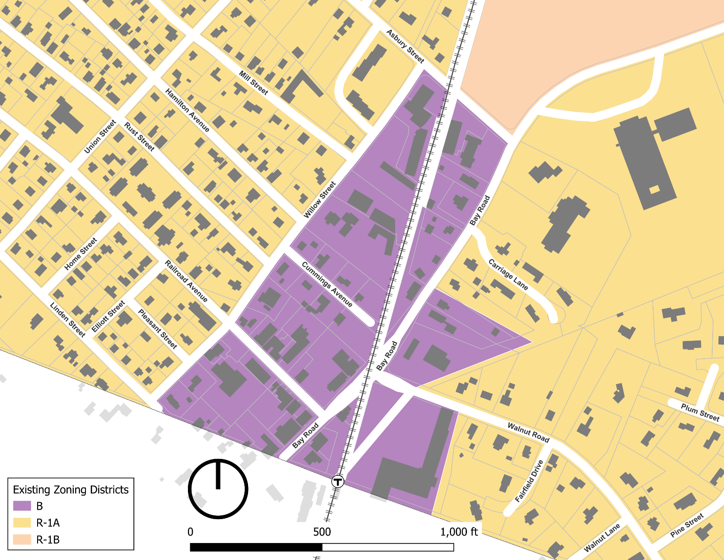

*Map of proposed Town Center zoning under Article II. Note that Depot Square and Bay Road Civic are proposed new Town Center Sub-districts, while the area shaded in yellow on Linden Street spanning the Wenham town boundary is proposed to change from the Business District to the R-1A District*

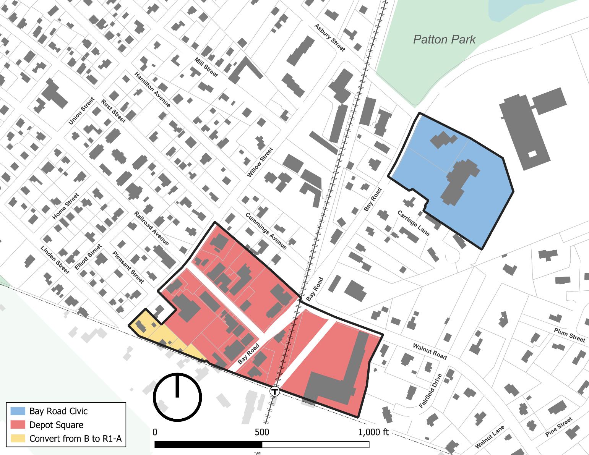

## **2.3 OVERLAY DISTRICTS.** The following Overlay Districts are also established, as set forth in Section 9.0, herein.

Groundwater Protection Overlay District GPOD

Flood Plain Overlay District FPOD

Estate Overlay District EOD

~~Willow Street Overlay District WSOD~~

Commercial Overlay District COD

3A Multi-Family Overlay District 3A-MFOD

**2.5 SPLIT LOTS.**

**2.5.2 By District Boundary.** Where a district boundary line between ~~a residential and a business district~~ an R-1A or R-1B District or the Downtown Residential sub-district and any other sub-district of the Town Center District divides any Lot existing at the time such line is adopted, the regulations for the less restricted portions of such lots shall extend no more than thirty (30) feet into the more restricted portion, provided the lot has lot frontage on a public way in the less restricted district or sub-district. ~~For purposes of this section the Bay Road Mixed-Use and Willow Street Mixed-Use Sub-districts shall be business districts and the Downtown Residential District shall be a residential district.~~

## **3.1 PRINCIPAL USES**

**TABLE OF USE REGULATIONS**

*Given the extensive changes to the Table of Use Regulations, the following changes are described but not shown by underlined and strikethrough text, except for a new use added to the table which is shown in underline and additional language being added to D.21 that is shown as underlined.*

*Delete the last Column “B” Business District from the existing Table*

*Indicate in the Table that use A8 (Multi-family Dwelling) and new use A9 (Two-family dwelling) are not allowed (“N”) in the R-1A, R-1B and RA districts.*

*Add 2 additional columns to include Depot Square and Bay Road Civic sub-districts and designate uses allowed and prohibited in the Depot Square, Bay Road Civic, Bay Road Mixed-Use, Willow Street Mixed-Use, Downtown Residential districts as follows:*

|  |  |  |  |  |  |
| --- | --- | --- | --- | --- | --- |
| 1. **Residential** | Depot Square | Bay Road Mixed-Use | Willow Street Mixed-Use | Downtown Residential | Bay Road Civic |
| **1.** One Single Family Dwelling | N | Y | Y | Y | N |
| **2.** Conversion of a Single Family Dwelling existing at the time of the adoption of the ordinance (1954) into a Two Family Dwelling (see Section 3.5) | Y | Y | Y | Y | N |
| **3.** Open Space and Farmland Preservation Development (see Section 8.1) | N | N | N | N | N |
| **4.** Senior Housing (see Section 8.2) | N | N | N | N | N |
| **5.** Long Term Care Facility | PB | PB | PB | PB | PB |
| **6.** Garage with more than 4 motor vehicle spaces subject to the requirements of Section 9.8.5 in the Town Center District | PB | Y | Y | PB | PB |
| **7.** Two or more dwelling units, second floor and above when part of a mixed-use building or development | Y | Y | Y | N | N |
| **8**. Multi-Family Dwelling | N | Y | Y | Y | N |
| **9**. Two-Family Dwelling | N | Y | Y | Y | N |
| 1. **Community Facilities** | Depot Square | Bay Road Mixed-Use | Willow Street Mixed-Use | Downtown Residential | Bay Road Civic |
| **1.** Use of land or  Structures for religious  purposes | Y | Y | Y | Y | N |
| **2.** Museums, libraries and parks, playgrounds, conservation areas, water supply areas and other land owned and operated for the public enjoyment or service by a public or semi-public agency | Y | Y | Y | Y | Y |
| **3.** Use of land or Structures for educational purposes on land owned or leased by the Commonwealth of Massachusetts or any of its agencies, subdivisions or bodies politic or by a religious sect or denomination, or by a nonprofit educational corporation | Y | Y | Y | Y | Y |
| **4.** Hospital, Medical Clinic, cemetery, and camps of educational and charitable institutions | PB | PB | PB | N | N |
| **5.** Community or private club, not conducted for profit | PB | PB | PB | N | PB |
| **6.** Nonprofit civic or fraternal building | N | N | N | N | N |
| **7.** Child Care Center or School Aged Child Care Program | Y | Y | Y | Y | Y |
| **8.** Commercial Recreation, Outdoors | N | N | N | N | SB |
| **9.** Temporary use for amusements and recreation | SB | SB | SB | N | SB |
| **10.** Municipal Buildings or facilities | Y | PB | PB | PB | Y |
| **11.** Essential Services | Y | N | N | N | Y |
| 1. **Agricultural** | Depot Square | Bay Road Mixed-Use | Willow Street Mixed-Use | Downtown Residential | Bay Road Civic |
| **1.** On parcels five (5) acres or more, or two (2) Qualified Acres or more: agriculture, horticulture and floriculture | N | N | N | N | N |
| **2.** Gardens; riding stables; growing and storing of fruits, berries, vegetables, hay, fodder and ensilage; woodlots; forestry; and greenhouses | N | N | N | N | N |
| **3.** The raising or keeping of poultry, horses, or cows for other than the use of the occupants of the residence | N | N | N | N | N |
| 1. **Commercial** | Depot Square | Bay Road Mixed-Use | Willow Street Mixed-Use | Downtown Residential | Bay Road Civic |
| **1.** Adult Entertainment Uses | PB | N | N | N | N |
| **2.** Motor Vehicle and/or Boat Sales and/or Leasing Shop | PB | N | N | N | N |
| **3.** Business or Professional Office; bank; financial institution | Y | Y | Y | N | Y |
| **4.** Communication Towers and Telecommunication Antenna Facilities (see Section 7.2) | PB | PB | PB | PB | PB |
| **5.** Kennel | N | N | N | N | N |
| **6.** Funeral homes | PB | N | N | N | N |
| **7.** Garage with more than four automobile/truck spaces | N | N | N | N | N |
| **8.** Motor Vehicle Light Service Station | N | N | N | N | N |
| **9.** Manufacturing of products sold on the premises at retail, where no more than five operators are employed in such manufacture | PB | N | N | N | N |
| **10.** Rail or bus station or terminal | PB | N | N | N | N |
| **11.** Motor Vehicle Repair Shop | N | N | N | N | N |
| **12.** General Service Establishment | Y | N | N | N | N |
| **13.** Personal Service Establishment | Y | Y | Y | N | Y |
| **14.** Restaurant | Y | Y | Y | N | Y |
| **15.** Restaurant, Fast Food | PB | N | N | N | N |
| **16.** Retail Store | Y | Y | Y | N | Y |
| **17.** Veterinary Facility or Clinic | PB | PB | PB | N | PB |
| **18.** Wind Energy Facility in COD, subject to site plan approval (see Section 7.3) | N | N | N | N | N |
| **19.** Wind Energy Facility (not in COD) (see Section 7.3) | PB | PB | PB | PB | PB |
| **20.** Communications Tower and Telecommunication Antenna Facilities (see Section 7.2) | Y | Y | Y | Y | Y |
| **21.** Mixed-Use Development, subject to ~~Site Plan Review~~ Section 9.8.5 in the Town Center District if applicable | Y | Y | Y | N | Y |
| **22.** Drive-In or Drive-Through Establishment | N | N | N | N | N |
| **23.** For Profit Educational Facility | PB | PB | PB | N | PB |
| **24.** Marijuana Establishment | N | N | N | N | N |
| 1. **Accessory** | Depot Square | Bay Road Mixed-Use | Willow Street Mixed-Use | Downtown Residential | Bay Road Civic |
| **1.** Up to three boarders in a Single Family Dwelling | N | Y | Y | Y | N |
| **2.** Accessory Dwelling Unit (see Section 3.6 and definition) | Y | Y | Y | Y | N |
| **3.** Large Accessory Dwelling Unit (see Section 11.0) | PB | PB | PB | PB | PB |
| **4.** Customary home occupation conducted in a Dwelling or Building accessory thereto by a person residing on the premises (see Section 3.3) | Y | Y | Y | Y | N |
| **5.** Accessory Uses or Building on the same Lot with and customarily incidental to a permitted main use on the same premises | Y | Y | Y | Y | Y |
| **6.** Uses, whether or not on the same parcel as activities permitted as a matter of right, which are both: (a) accessory to activities permitted as a matter of right, and (b) necessary in connection with scientific research or scientific development or related production (see Section 3.2.1.2) | PB | PB | PB | PB | PB |
| **7.** Parking area or garage for use of employees, customers or visitors | Y | Y | Y | N | Y |
| **8.** Level Two Electric Charging Station | Y | Y | Y | Y | Y |
| **9.** Large Family Child Care Home | PB | PB | ZBA | PB | PB |
| **10.** Small Family Child Care Home | Y | Y | Y | Y | Y |
| **11.** Adult Social Day Care | PB | PB | PB | PB | PB |
| **12.** Marijuana Establishment | N | N | N | N | N |

**3.2 ACCESSORY USES.**

**3.2.2 Accessory Uses and Structures in the ~~Residence Districts~~ R1-A, R-1B, RA Districts and Downtown Residential Sub-district of the Town Center District.** The following provisions shall apply to Accessory Uses and Structures in the ~~Residence~~ R1-A, R1-B, RA Districts and Downtown Residential Sub-district:

**3.2.3 Accessory Uses in the ~~Business,~~ Depot Square, Willow Street Mixed-Use, ~~and~~ Bay Road Mixed-Use and Bay Road Civic sub-districts of the Town Center District.** In the ~~Business~~ Depot Square, Willow Street Mixed-Use, ~~and~~ Bay Road Mixed-Use and Bay Road Civic sub-districts any use permitted as a Principal Use is also permitted as an Accessory Use provided such use is customarily incidental to the main or principal building or use of the land.

**4.1 GENERAL REGULATIONS.**

**4.1.2 Table of Dimensional Regulations.** The Table of Dimensional Regulations is hereby declared to be a part of this By-law.

**TABLE OF DIMENSIONAL REGULATIONS1 ~~7~~**

|  |  |  |  |  |
| --- | --- | --- | --- | --- |
|  | R-1A | R-1B | RA | ~~B~~ |
| Minimum Lot Area per Dwelling Unit (sq. ft.) | 20,000 | 40,000 | 80,000 | ~~ZBA~~~~1~~ |
| Minimum Lot Frontage (ft.) | 125 | 175 | 175 | ~~ZBA~~~~2~~ |
| Minimum Lot width and depth (ft.) (for Dwellings, see also Sections 4.2.2, 4.2.6 and 4.3) | 100 at building | 100 at building | 100 at building | ~~ZBA~~~~3~~ |
| Maximum Building Height (ft.) | 35 | 35 | 35 | ~~35~~ |
| Maximum number of Stories | 3 | 3 | 3 | ~~3~~ |
| Maximum Building coverage of Lot (%) | 25 | 25 | 25 | ~~75~~~~4~~ |
| Minimum Front Yard (ft.)  (See also Section 4.2.4) | 25/50~~5~~2 | 25/50~~5~~2 | 25/50~~5~~2 | ~~25/50~~~~5~~ |
| Minimum Side Yard and Rear Yard (ft.) | 15 | 15 | 15 | ~~ZBA6~~ |

1. Renumbered from #7 Dimensional Requirements for the Town Center Sub-District are found in Section 9.8 of the Zoning By-law.
2. Renumbered from #5 Twenty-five (25) feet from the Street line, or fifty (50) feet from the Street center line, whichever is greater.

~~1. For each Dwelling Unit, minimum lot area is twenty thousand (20,000) square feet or as determined by the SPGA. For other uses, to be determined during site plan review.~~

~~2. For a Building that contains a Dwelling Unit, 125 feet. For all other uses, to be determined during site plan review.~~

~~3. To be determined during site plan review.~~

~~4. Or as determined during site plan review.~~

~~5.~~ *Text moved to #2*.

~~6. For a Dwelling Unit, 15 feet. For all other uses, to be determined during site plan review.~~

~~7.~~ *Text moved to #1*.

## **SECTION 5.0 NONCONFORMING USES AND STRUCTURES**

5.1 APPLICABILITY. This By-law shall not apply to Structures or uses lawfully in existence or lawfully begun, or to a Building or special permit issued before the first publication of notice of the public hearing required by G.L. c. 40A, s. 5 at which this By-law, or any relevant part thereof, was adopted. Such prior, lawfully existing nonconforming uses and Structures may continue, provided that no modification of the use or Structure is accomplished, unless authorized herein~~under~~. This Section, with the exception of Subsection 5.1, shall not apply to Structures or uses in the Town Center Districts which are regulated under Section 9.8.1.4 of the By-law.

## **6.1 OFF-STREET PARKING AND LOADING AREAS.**

**6.1.3 No Reduction.** Required off-street parking and loading spaces shall not hereafter be reduced, unless approved by the Planning Board pursuant to Section 6.1.6, nor any loading space counted as or substituted for a parking space.

**6.1.6 Shared Parking**. ~~No part of an off-street parking or loading space required for any Building or use shall be included as a part of an off-street parking area required for another Building or use unless a determination is made by the Board of Appeals to the effect that the period of usage of such structure or uses will not be simultaneous.~~ In the Town Center District, shared parking may be permitted by the Planning Board for a mix of uses on a single site or between sites during the Site Plan Review process, if the applicant can demonstrate that shared spaces will adequately meet parking demands because uses have varying peak parking demands, will reduce excess parking, and if the Planning Board determines shared parking will serve as a benefit to the Town Center. The minimum number of parking spaces for a Mixed-Use Development or between sites where shared parking is proposed shall be determined by a study prepared by the applicant following the procedures of the Urban Land Institute Shared Parking Report, ITE Shared Parking Guidelines, or other professionally accepted procedures.

**6.1.9 Site Plan.** Parking areas and loading areas ~~in the Business District~~ shall be shown on a site plan, as provided in Section 10.6.

## **6.3 SIGNS.**

**6.3.2 ~~Residence Districts~~ R-1A, R-1B and RA Districts, and Downtown Residential Sub-District.**

**6.3.3 ~~Business District,~~ Depot Square, Bay Road Civic, Bay Road Mixed-Use and Willow Street Mixed-Use Sub-districts of the Town Center District.**

**6.3.4 Standards**

8. A sign in the ~~Business District~~ Depot Square, Bay Road Civic, Bay Road Mixed-Use and Willow Street Mixed-Use sub-districts of the Town Center District shall not exceed a total area of (6) square feet.

## **8.2 SENIOR HOUSING.**

**8.2.2 Eligible Locations.** A Special Permit may be granted for Senior Housing on any lot(s) in the R-1A, R-1B, or R-A.~~, or B~~,

**8.2.7 Permitted Uses.** A Senior Housing development may include the following uses:

~~13. In the Business District a mixture of residential and business uses.~~

**8.2.9 Base Senior Housing Density.** The Base Density per Developable Acre for a Senior Housing Special Permit shall be: ~~four (4) Dwelling units in the Business District;~~ three (3) Dwelling units in the R-1A~~R1-A~~ District, two (2) Dwelling units in the R-1B~~R1-B~~ District, and one (1) Dwelling unit in the RA District.

|  |  |  |  |  |  |  |  |  |  |  |
| --- | --- | --- | --- | --- | --- | --- | --- | --- | --- | --- |
|  | A | B | C | D | E | F | G | H | I | J |
|  | Zoning District | Base Senior Housing Density (BSHD) per Dev. Acre | Incentives to Increase Base Senior Housing Density for: | | | | | Subtotal of Base Senior Housing Density Incentives (C+D+E+F+G) | Incremental Density per Developable Acre Rewardable by PB for Trails, Fields, Environmental, energy, water conservation, building green, & other public benefits | Maximum Density per Dev. Acre |
| Mix of Smaller Units (50% units under 1300 sq. ft.) | On or Off Site Construction of Inclusionary Housing Obligation (Affordable Housing) | Smart Growth, per Comm. of Mass. Criteria (PB Rules & Regs) | Additional 25% of Property as Open Space | Voluntary Cap on Appreciation of Units |
| ~~1~~ | ~~B~~ | ~~4~~ | ~~25%~~ | ~~25%~~ | ~~25%~~ | ~~N/A~~ | ~~25%~~ | ~~100%~~ | ~~1.0~~ | ~~6.00~~ |
| 1 | R-1A | 3 | 25% | 25% | 25% | 25% | 25% | 125% | 1.0 | 4.00 |
| 2 | R-1B | 2 | 25% | 25% | 25% | 25% | 25% | 125% | 1.0 | 4.00 |
| 3 | RA | 1 | 25% | 25% | 25% | 50% | 25% | 150% | 2.0 | 4.00 |

**NOTES ON HOW TO READ THE MATRIX:**

Column I: Encourages other initiatives which provide a public benefit to the Town such as, but not limited to, preservation and enhancement of trails; creation of playing fields; environmental, energy, water conservation, green building design, and other public benefits. For one (1) or a combination of these initiatives, an applicant may earn one (1) additional Dwelling Unit per Developable Acre in the ~~Business,~~ R-1A ~~R1-A~~, and R-1B ~~R1-B~~ Districts, and up to two (2) additional Dwelling Units per Developable Acre in the RA District.

**8.2.11 Minimum Distance between Projects.**

In order to mitigate the impact of multiple developments on surrounding neighborhoods, a proposed project must be located at least the distance established in the Minimum Distance Between Projects Table below from any other existing or approved Senior Housing project, any existing or approved project including multi‑unit residential buildings under G.L. c. 40B, or any existing or approved project including Multi-Family residential buildings under any other provision or By-law. Excluded from this calculation and this Section are any existing multi-unit Multi-Family projects approved prior to January 1, 2003, Multi-Family Dwellings or Mixed-Use Developments in the Town Center District, and ~~apartments under Sections~~ ~~3.4, 3.6, or 3.7~~ Accessory Dwelling Units or Large Accessory Dwelling Units.

~~4. Senior Housing proposals in the Business District shall be exempt from the provisions of this Section and developments wholly within the Business District shall not be considered as existing or approved projects for purposes of establishing required project separation in any other district.~~

**8.2.13 General Requirements.** The following requirements shall apply.

3. Location of Wastewater Treatment. All wastewater shall be treated and discharged on-site. Off-site wastewater treatment is not allowed. ~~An exception to this is for parcels located in the Business District, where wastewater treatment may be located off-site.~~

**8.2.15 Dimensional Standards.** The following dimensional and other standards shall supersede all dimensional standards in the underlying zoning district and shall be applied to any Senior Housing development:

**TABLE OF DIMENSIONAL REQUIREMENTS**

|  |  |  |  |  |  |  |  |  |  |
| --- | --- | --- | --- | --- | --- | --- | --- | --- | --- |
|  | A | B | C | D | E | F | G | H | I |
|  | Zoning District | Under- lying Zoning District Require-ment (s.f.) | Minimum Parcel Size (sq.ft.) to be eligible for develop-ment | Minimum Parcel Frontage Required (feet) to be eligible for develop-ment | Front Setback (feet) from perimeter property line | Side & Rear Setbacks (feet) from perimeter property line | Vegetated Buffer (feet) around perimeter of parcel | Minimum Open Space Required of total acreage | Maximum Lot Coverage of entire parcel |
| ~~1~~ | ~~Bus. District~~ |  | ~~none~~ | ~~site specific~~ | ~~0~~ | ~~01~~ | ~~01~~ | ~~0~~ | ~~site specific~~ |
| 2 | R-1A | 20,000 | 80,000 | 125 | 25 | 252 | 20 | 0 | 25% |
| 3 | R-1B | 40,000 | 80,000 | 175 | 25 | 252 | 20 | 15% | 25% |
| 4 | RA | 80,000 | 80,000 | 175 | 50 | 252 | 20 | 25% | 25% |

## **9.5** **~~WILLOW STREET OVERLAY~~ Reserved *(Willow Street Overlay District deleted in July 2025)***

10.6 SITE PLAN REVIEW

**10.6.4. Projects Requiring Approval.** No Building Permit shall be applied for or issued for any

construction or alteration subject to this Section, as specified below, until a site plan has been

approved by the Planning Board as set forth herein. Except as exempted in the Bylaw, Site Plan

Review shall be required for the following construction, alterations, and uses:

* + - 1. Any new construction or changes to an existing structure for the purpose of altering, expanding, or converting to either a business, office, industrial, Mixed-Use Development, or a M~~m~~ulti-F~~f~~amily Housing ~~residential~~ use, in any district;
      2. Parking lots over five (5) spaces serving any of the above-listed types of buildings, schools, hospitals, nursing homes, long term care facility, life care facilities, children’s camps, campgrounds, churches, Multi-Family Housing, ~~multi-family structures for more than two (2) families,~~ Mixed-Use Development, government buildings and structures, farm stands, and buildings in commercial, and/or office use;
      3. Any industrial and scientific research use under Section 3.2 of the Zoning Bylaw;
      4. Stables providing boarding and/or services for more than six (6) horses other than those owned by the resident(s) of the Lot on which the stable is located;
      5. Greenhouses for commercial production of plants or produce;
      6. Alterations which increase the commercial, industrial, institutional, or multi-family floor area within an existing building, and/or which change the number of separately leasable or saleable spaces within an existing building; and
      7. Wind Energy Facilities in the Commercial Overlay District.
      8. A change of use of a site or structure from one permitted use category to another or from a nonconforming use to a permitted use category.

10.6.6 Exemptions from Site Plan Review. The following activities shall not require site plan review or abbreviated site plan review:

Interior ~~A~~alterations unless the alterations increase the floor area within the building devoted to any of the uses listed in Section 10.6.4 and/or change the number of separately leasable or saleable spaces within the Building. Examples of exempt interior alterations are: paneling, shelving, partitions other than those creating new commercial units, counters, flooring and general interior decoration;

Repairs, repainting, residing with a like material, reroofing, and window replacement unless the activity also increases floor area or creates or increases a nonconformity;

Replacement of parts of a partially damaged conforming building that would normally require site plan review with generally identical portions provided the repairs and/or replacements are conforming with the By-law. Total replacement of such a destroyed building shall require site plan review;

Demolition of a Building or Structure;

Change of tenant of commercial or mixed-use building, provided that a change of the use category is not proposed and/or that no new construction triggering site plan review is proposed~~unless there is also new construction triggering Site Plan Review~~;

Customary home occupations;

Townhouse or Multifamily housing developed under Sections 8.1 (OSFPD) or 8.2 (Senior Housing)

Uses permitted by special permit within the Commercial Overlay District; and

Entries B.1, B.3, and B.7 in the Table of Uses shall require site plan review under Section 10.7.

## **11.0 DEFINITIONS**

**~~Dwelling,~~** ~~Three-family: A building containing three dwelling units, each of which has direct access to the outside or to a common hall that leads to the outside.~~

**~~Dwelling,~~** ~~Four-family: A building containing four dwelling units, each of which has direct access to the outside or to a common hall that leads to the outside.~~

**Mixed-Use Development:** ~~Two or more uses on a single parcel as a part of a single development plan~~. A complementary combination of permitted residential uses and commercial land uses, occupying the same site or building as part of a single development plan.

**Substantial Improvement:** Any repair, reconstruction, rehabilitation, or improvement of a non-conforming structure, the cost of which equals or exceeds 50 percent of the assessed value of the structure before the start of construction of the improvement. Assessed value shall mean the most recent value assigned to the structure as calculated by the Hamilton Tax Assessor. This definition shall not apply in the Floodplain Overlay District.

# 9.8 TOWN CENTER DISTRICT.

*1. Introduction.* The Town Center District consists of ~~three~~ five sub-districts: Depot Square, Bay Road Mixed-Use, Willow Street Mixed-Use, ~~and~~ Downtown Residential, and Bay Road Civic, all located in the Town Center area of Hamilton. Collectively, these sub-districts shall be referred to as the Town Center District, however each sub-district contains its own use, dimensional, and associated regulations as stipulated under this section. This Section consists of seven sub-sections that follow this introduction:

3. *Applicability.*

1. *Territorial Application.* This Section is applicable to all real property, structures, and uses located in the Depot Square, Bay Road Mixed-Use, Downtown Mixed-Use, ~~and~~ Downtown Residential, and Bay Road Civic sub-districts as these sub-districts are depicted on the official Town of Hamilton Official Zoning Map dated July 14, 2025.

4. *Nonconformities.*

1. *Purpose & Intent.* The purpose of this Subsection is to regulate and limit the continued existence of uses and structures established prior to the effective date of this By-law (or any amendment subsequent thereto) that do not conform to this By-law such that all buildings, structures or land, in whole or in part, will be used or occupied in conformance with this Section.

Many nonconformities may continue, but the provisions of this Section are designed to curtail substantial investment in nonconformities and, when appropriate, to bring about their eventual elimination and/or lessen their impact upon surrounding conforming uses to preserve the integrity of the Town Center Districts in accordance with the intent of this By-law.

1. *Nonconforming Uses***.** A nonconforming use may continue only in accordance with Section 5.1 of the By-law and the provisions of this Subsection.
   1. *Repair and Maintenance.* Normal repair and maintenance may be performed to allow the continuation of nonconforming use.
   2. *Reconstruction after Catastrophe or Demolition.*
      1. If a nonconforming use is within a nonconforming structure that is voluntarily demolished, the nonconforming use shall not be reestablished.
      2. A nonconforming use in a nonconforming structure may be re-established in case of damage, to an extent equal to or less than 50 percent of the assessed value of the property on which the nonconforming structure is located, provided that the nonconforming use is not expanded and that reconstruction commences within two years of the event in which the damage occurred.
      3. A nonconforming use in a nonconforming structure which is damaged, to an extent greater than 50 percent of the assessed value of the property, shall not be re-established unless the use is re-established in a fully conforming structure, the use is not extended or altered, and unless reconstruction commences within two years of the event in which the damage occurred.
   3. *Modification.*
      1. A nonconforming use may change to a permitted use as stipulated under the Table of Use Regulations (Section 3.0 of the Zoning By-law), however Site Plan Review shall be required by the Planning Board.
      2. A nonconforming use shall not otherwise be modified or expanded unless a Special Permit is granted by the Planning Board upon a finding that such change, extension or alteration shall not be substantially more detrimental than the existing nonconforming use to the neighborhood.
   4. *Abandonment or Discontinuance*. If a nonconforming use is abandoned or discontinued for two years or more, the use shall not be permitted to re-establish.
2. *Nonconforming Structures.* A nonconforming structure may continue only in accordance with Section 5.1 of the By-law and the provisions of this Subsection.
3. *Repair and Maintenance.* Normal repair and maintenance may be performed to allow the continuation of a nonconforming structure.
4. *Reconstruction after Catastrophe or Demolition.*
   1. If a nonconforming structure is voluntarily demolished or abandoned, any replacement structure must be conforming to the By-law.
   2. If a nonconforming structure is damaged to an extent greater than 50 percent of its assessed value for tax purposes, it may be rebuilt only in conformance with the standards of this ordinance.
   3. If a nonconforming structure is damaged to an extent equal to or less than 50 percent of its assessed value for tax purposes, then the structure may be rebuilt in accordance with the following standards:

A building permit for reconstruction must be secured no later than two years from the date of destruction.

A nonconforming structure shall not be rebuilt in a manner which increases its nonconformity.

(iii) *Modifications/Alterations of Single family and Two-family Dwellings only:*

* + - * 1. Nonconforming Single family or Two-family Dwellings may be modified, altered, extended, or reconstructed by right provided that the proposed change does not increase the nonconforming nature of the structure.
        2. Nonconforming Single family and Two-family Dwellings shall not be modified, altered, extended, or reconstructed if the proposed change would increase the nonconforming nature of the structure or create a new nonconformity unless a Special Permit is granted by the Planning Board upon a finding that such modification, alteration, extension or reconstruction shall not be substantially more detrimental than the existing nonconforming structure to the neighborhood.

(iv) *Modifications/Alterations of all other structures.*

* + - * 1. A primary or accessory nonconforming structure shall not be enlarged or altered in a way which increases its nonconformity or creates a new nonconformity.
        2. Modifications to a nonconforming structure which constitute a Substantial Improvement shall not be permitted unless the structure is made conforming with the requirements of the By-law or, if non-conformities remain, by issuance of Special Permit by the Planning Board upon a finding that such modification, alteration or extension shall not be substantially more detrimental than the existing nonconforming structure to the neighborhood.

1. Should a nonconforming structure be moved for any distance on the lot upon which it is located, it shall be moved to make the structure conforming to setbacks.
2. *Nonconforming Site Characteristics.* Nonconforming site characteristics governed under Section 9.8.6 Site Standards, including parking, driveways, landscaping, lighting, and screening, shall not be altered such that they are made more non-conforming with the standards and requirements of this By-law.
3. *Nonconforming Signs.* *Nonconforming Signs.* Nonconforming signs in the Town Center District may continue only in accordance with the provisions of this Subsection.
   1. *Repair and Maintenance.* Minor repairs and maintenance of a nonconforming sign, which are necessary to keep such sign in sound condition, are permitted so long as the nonconformity is not increased.
   2. *Modification.* 
      1. No sign may be enlarged or altered in such a way that increases the extent of nonconformity or causes a previously conforming sign to become nonconforming.
      2. A nonconforming sign may not be moved or replaced except to bring the sign into complete conformity with this By-law.
   3. *Damage or Destruction.* Any nonconforming sign which is partially damaged or destroyed by any means, beyond 50 percent of its value, shall not be restored, but shall be removed or reconstructed in conformance with the provisions of this section.
   4. *Discontinuance.*
      1. Any nonconforming sign, the use or copy of which is discontinued or removed for a period of two years or more, regardless of any intent to resume or not to abandon such sign, shall not thereafter be re-established. Abandonment or obsolescence of a nonconforming sign shall terminate immediately the right to maintain such sign.
      2. If a nonconforming sign remains blank for a continuous period of two years, that sign shall be deemed discontinued and shall, within 180 days after such discontinuance, be altered to comply with this By-law or be removed. For purposes of this By-law, a sign shall be “blank” if:
         1. The advertising message it displays becomes illegible in whole or substantial part; or
         2. It does not contain an advertising or identification message. For such purposes, signage offering a building or site for sale or lease shall not be deemed to be an advertising or identification message.
   5. *Change of Principal Use*. Any nonconforming sign shall be removed or brought into compliance with this By-law immediately upon a change in the principal use of the site.

*Amend Section 9.8.3 to delete (reserved) and add 1. Depot Square and 2. Bay Road Civic as follows:*

# 9.8.3. Town Center Sub-Districts.

## 1*. ~~(reserved)~~ Depot Square.*

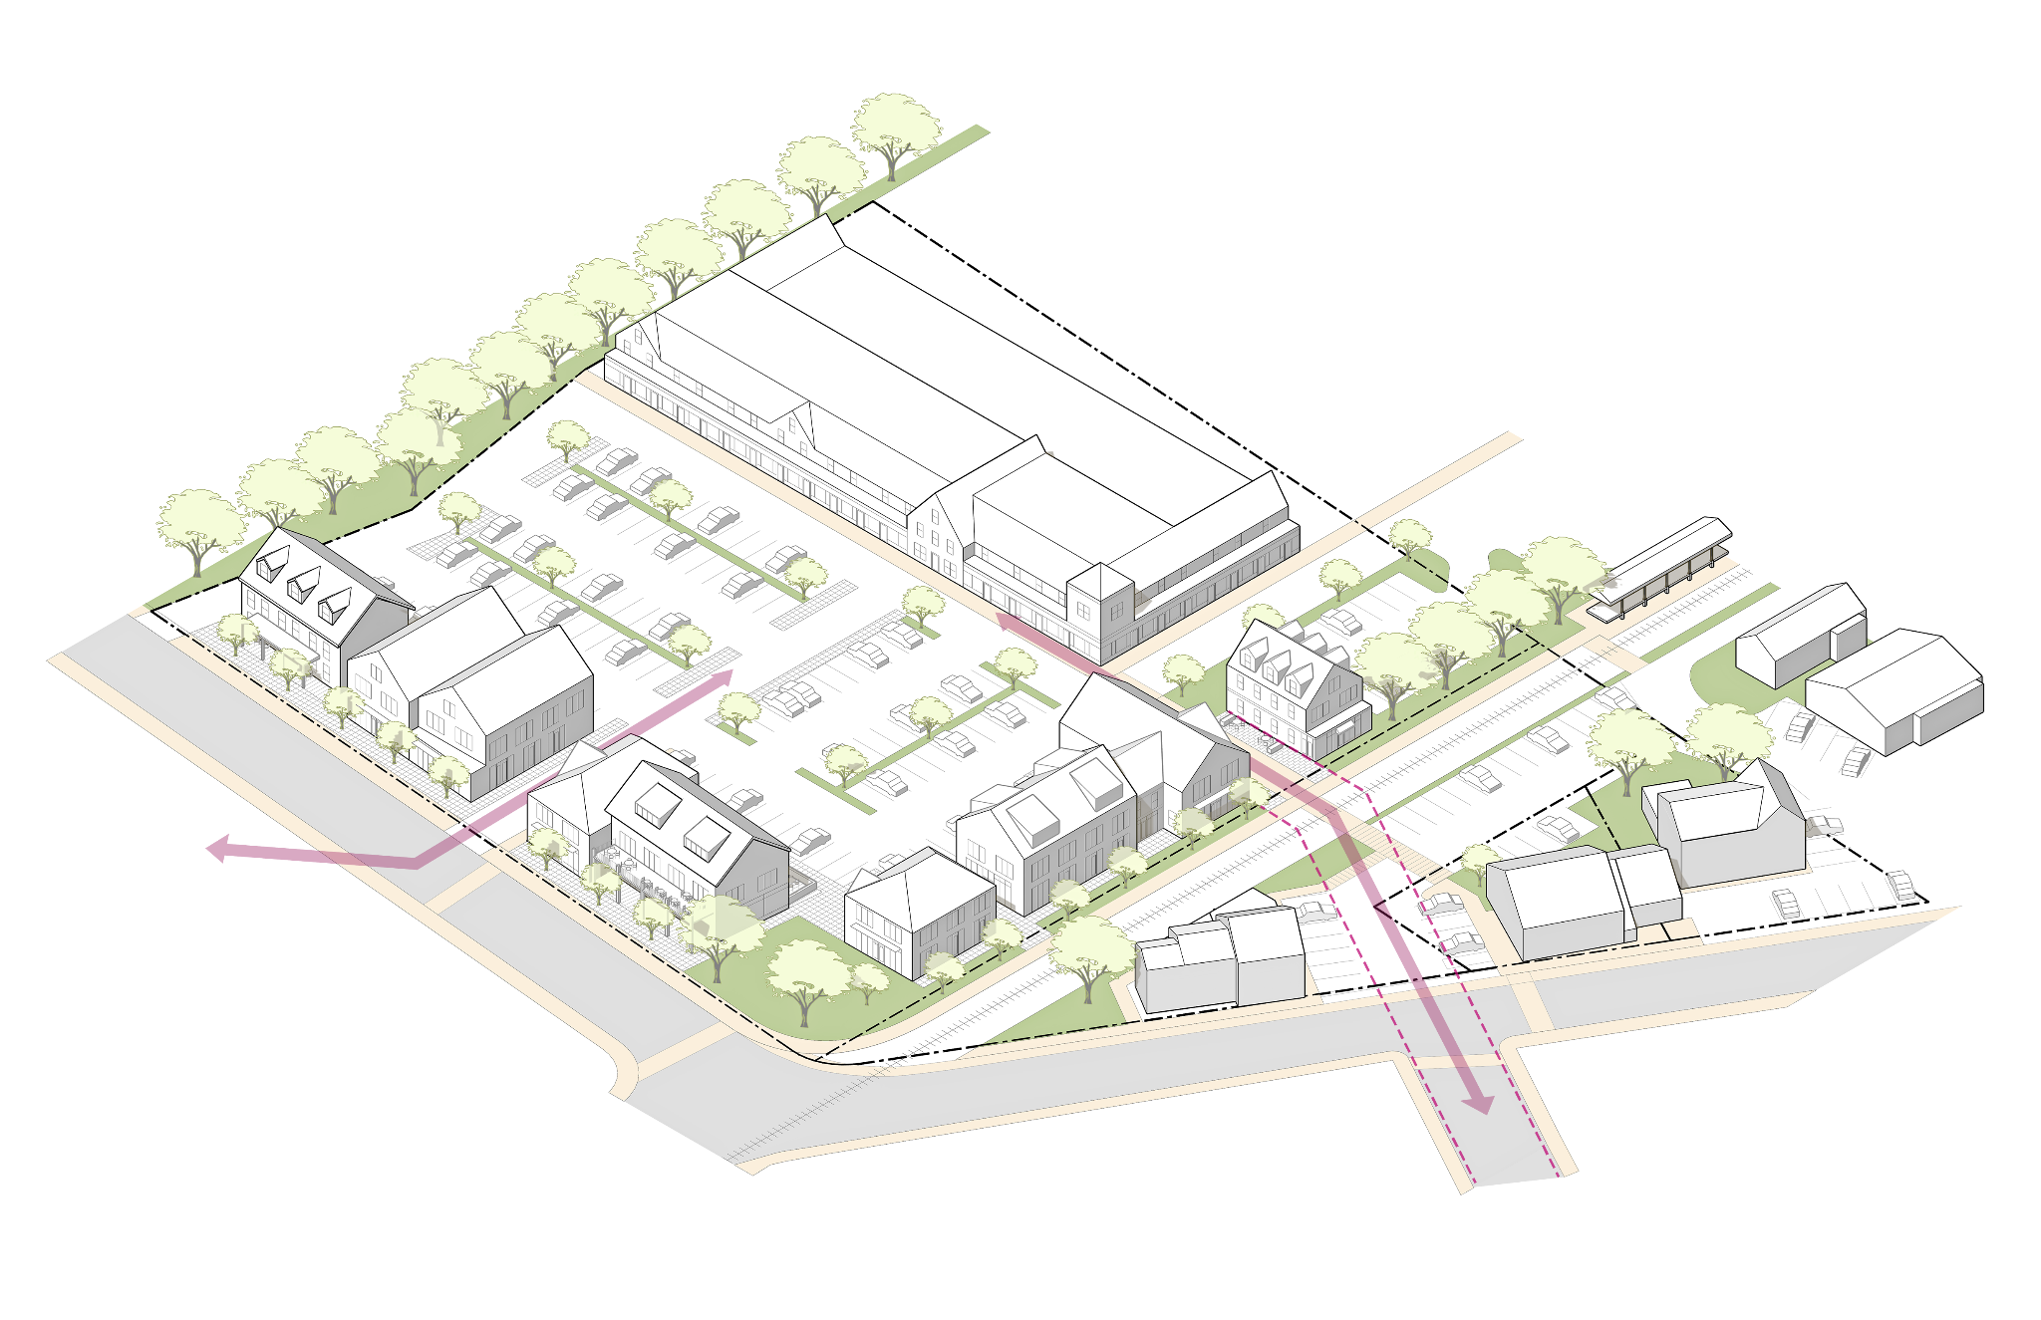

Figure 8. Depot Square Sub-District Vision Illustration

1. *Description.* The Depot Square Sub-district is characterized by two distinct conditions. On Railroad Avenue, buildings have small footprints and are up to 2.5 stories in height. East of the rail corridor, there is a large automobile-oriented shopping center. The area along Railroad Ave has the character of a small and historic town center; most buildings sit close together and near the sidewalk, while other buildings maintain some space between one another and include parking lots. The shopping center features one large, L-shaped, 1.5-story building with a large parking area between the building and the street and rail corridor. The Sub-district is primarily commercial, with some mixed-use structures near the edges of the sub-district. Most buildings west of the rail corridor were designed to accommodate commercial uses with forms consistent with the historic residential buildings nearby.
2. *Purpose and Intent.*

Figure 9. Important Depot Square Visual and Pedestrian Connections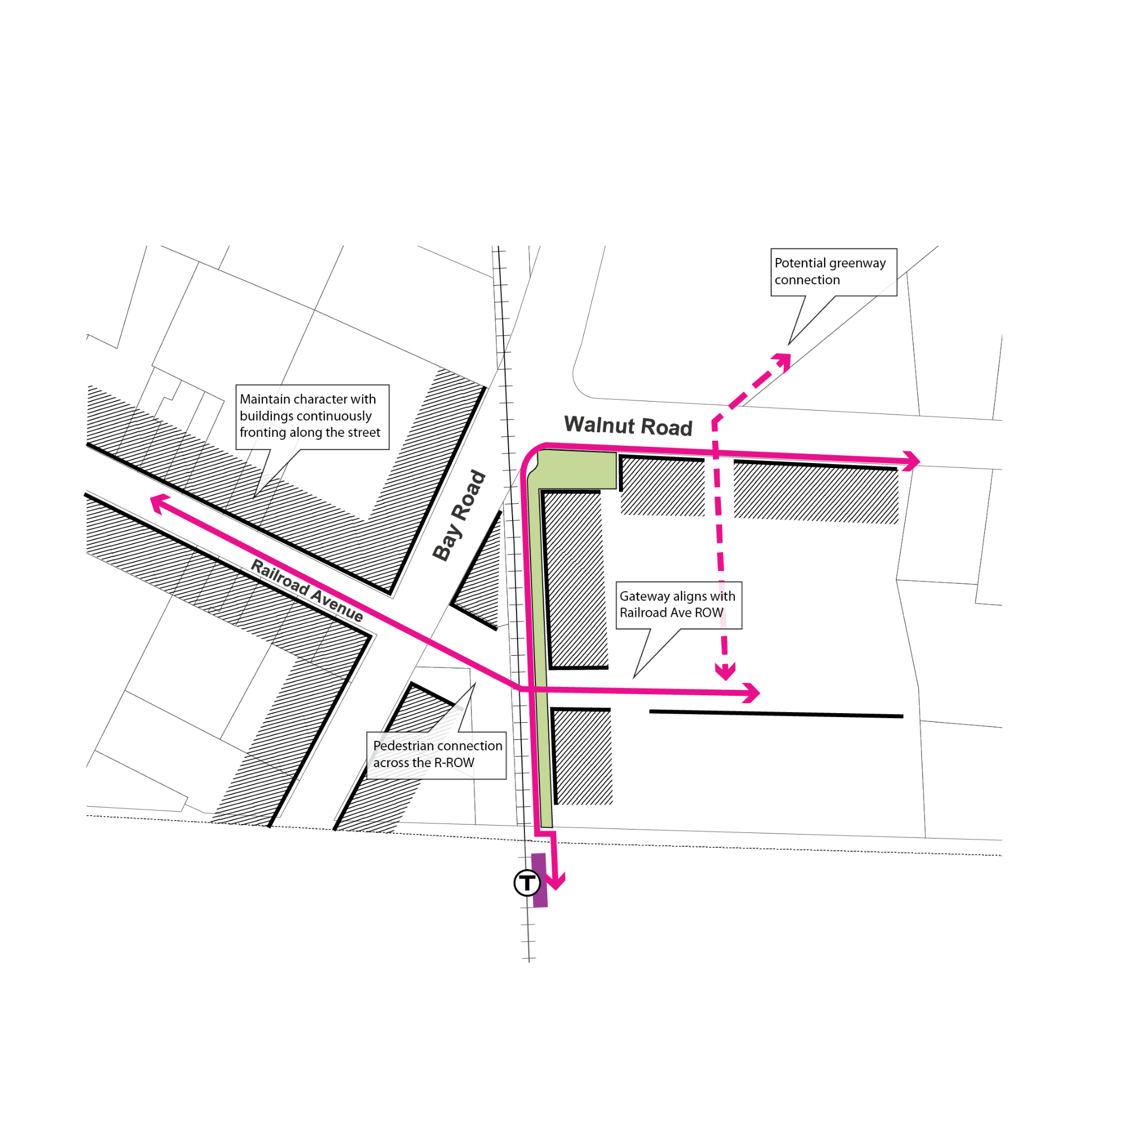

* 1. To foster a mixed-use and vibrant town center and preserve the existing small-scale commercial character along Railroad Avenue.
  2. To enhance a continuously built front along main public thoroughfare frontages in the sub-district.
  3. To extend the small-scale commercial character pattern on Railroad Avenue to future development in other larger parcels of the sub-district.
  4. To preserve and extend the visual and pedestrian corridor along Railroad Avenue across the MBTA tracks.
  5. To preserve existing open space/green space areas at critical intersections.
  6. To promote walkability and safety along all street frontages.

## 2*. ~~(reserved)~~ Bay Road Civic.*

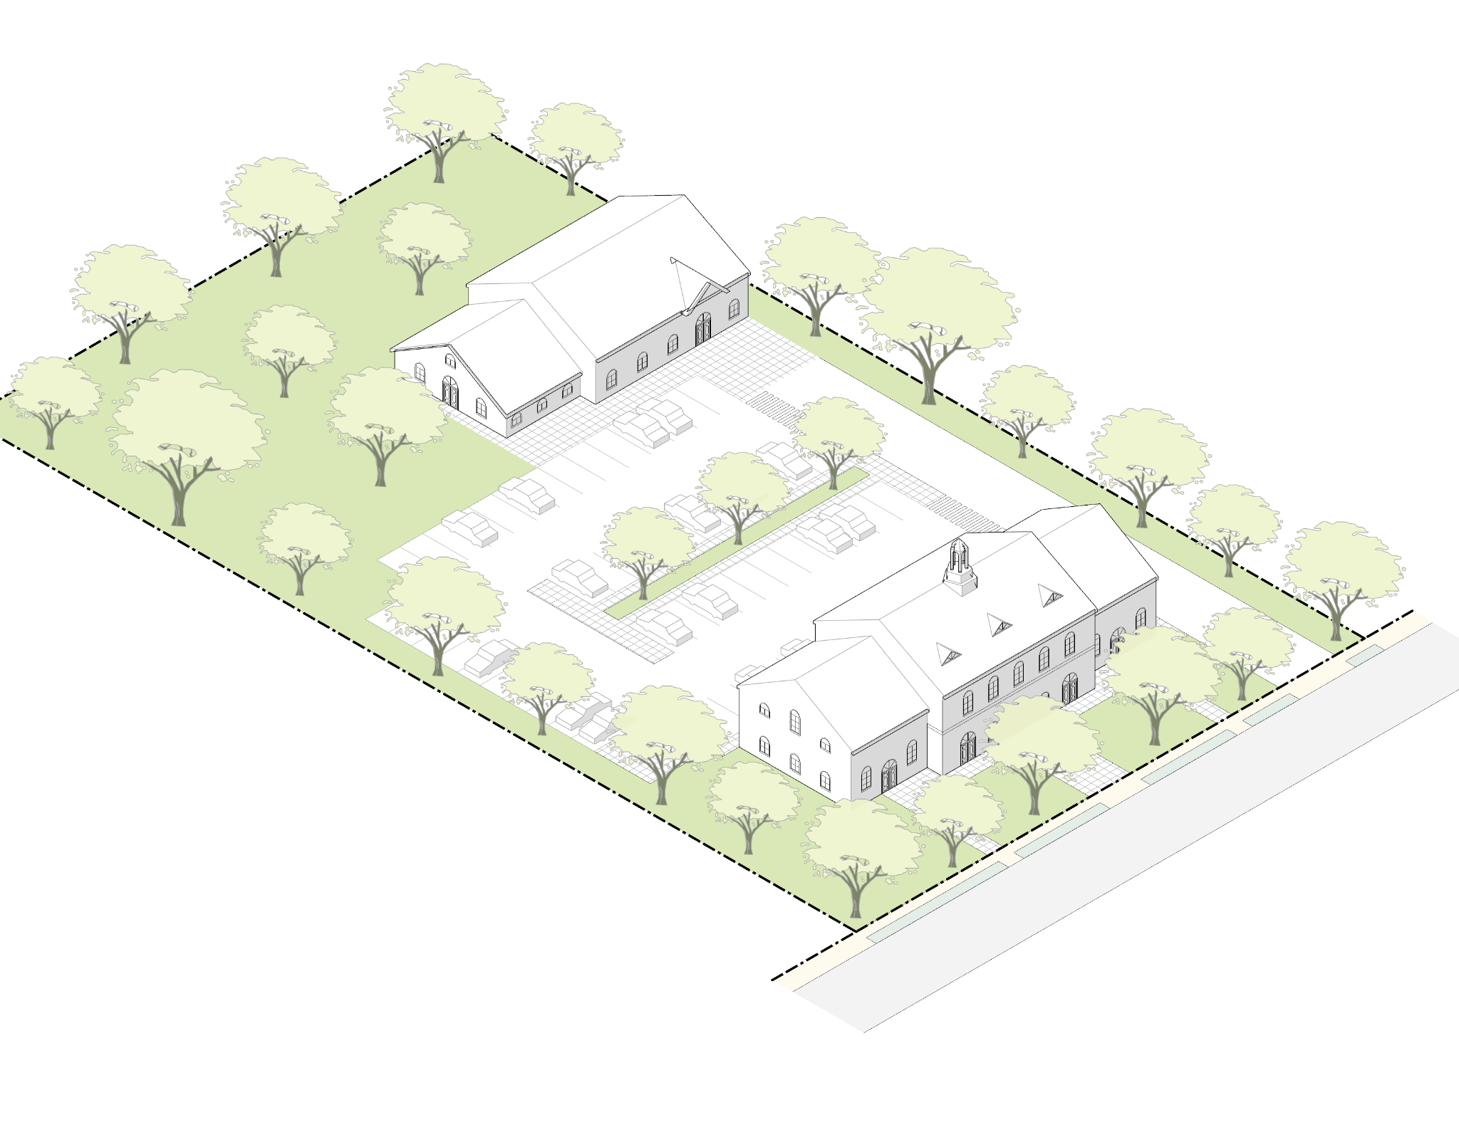

Figure 10. Bay Road Civic Sub-District Vision Illustration

1. *Description.* The Bay Road Civic Sub-district consists of two parcels owned by the Town accommodating municipal functions, including the Public Safety Complex, the Council on Aging, and the Building and Health Departments. The current arrangement of buildings and parking do not align with the traditional frontages of the Bay Road corridor. The site occupies an important “gateway” moment for the Downtown, where the alignment of Bay Road straightens out and the historic pattern of large structures set back behind generous lawns begins.
2. *Purpose and Intent.* The purpose of this Sub-district is to guide the placement and scale of potential future buildings on this site that can improve and restore the consistency of Bay Road frontages. The regulations are crafted to ensure that the desirable patterns of Bay Road are enhanced while allowing the flexibility that may be required for additional municipal uses.

# 9.8.4. Dimensional Standards.

*Amend the Table of Dimensional Standards: Town Center District to add columns for the Depot Square and Bay Road Civic districts so the table reads as follows and to add the underlined language referencing and containing footnotes related to the Depot Square sub-district.*

**TABLE 1: TABLE OF TOWN CENTER DISTRICT SITE DIMENSIONAL STANDARDS**

*See Footnotes to Table for additional requirements and/or clarifying information.*

|  |  |  |  |  |  |  |
| --- | --- | --- | --- | --- | --- | --- |
|  | Lot Dimensions | Depot Square | Bay Road Mixed-Use | Willow Street Mixed-Use | Downtown Residential | Bay Road Civic |
|  | Lot Size (min) | 1,000 square-feet | 5,000 square-feet | 3,000 square-feet | 3,000 square-feet | 5,000 square-feet |
| **A** | Lot Width (min) | 20 feet | 40 feet | 40 feet | 30 feet | 40 feet |
|  | Coverage | Depot Square | Bay Road Mixed-Use | Willow Street Mixed-Use | Downtown Residential | Bay Road Civic |
|  | Open Space (min) | 0% | 40% | 40% | 40% | 40% |
|  | Building Yards Setbacks | Depot Square 2 | Bay Road Mixed-Use | Willow Street Mixed-Use | Downtown Residential | Bay Road Civic |
| **B** | Front Yard Setback on Streets (minimum / maximum) 1 | 0 / 10 feet | 20 / 35 feet | 10 / 20 feet | 10 /20 feet | 20 / 35 feet |
| **C** | Side Yard Setback (minimum) | 0 feet | 5 feet | 5 feet | 10 feet | 10 feet |
| **D** | Rear Yard Setback (minimum) | 0 feet | 15 feet | 15 feet | 15 feet | 10 feet |
|  | Parking Setbacks | Depot Square | Bay Road Mixed-Use | Willow Street Mixed-Use | Downtown Residential | Bay Road Civic |
| **E** | Front Setback (minimum) | 10 feet | Aligned with, or set back further than, Building Frontage | | | |
| **F** | Side Setback (minimum) | 0 feet | 5 feet | 5 feet | 5 feet | 5 feet |
| **G** | Rear Setback (minimum) | 0 feet | 5 feet | 5 feet | 5 feet | 5 feet |
|  | Parking Requirements | Depot Square | Bay Road Mixed-Use | Willow Street Mixed-Use | Downtown Residential | Bay Road Civic |
|  | Parking Spaces (minimum) | Per Section 6.1 or by Special Permit | | | | |

**Footnotes to Table of Site Dimensional Standards:**

1. Includes frontage along the western edge of the rail corridor within the Depot Square sub-district. Porches less than eight feet in depth and bay windows less than three feet in depth may protrude into the Front Yard in all sub-districts except Depot Square.
2. Side and Rear Yards in the Depot Square sub-district that directly abut a different zoning district or sub-district shall conform to the minimum setbacks required in the abutting district or sub-district.

.

## 2. *Building Dimensional Standards.*

*Amend the Table of Building Dimensional Standards: Town Center District to add columns for the Depot Square and Bay Road Civic districts so the table reads as follows and in footnote 1, delete “reserved” and add the underlined language.*

**TABLE 2: TABLE OF TOWN CENTER DISTRICT BUILDING DIMENSIONAL STANDARDS**

*See Footnotes to Table for additional requirements and/or clarifying information.*

|  |  |  |  |  |  |  |
| --- | --- | --- | --- | --- | --- | --- |
|  | Massing | Depot Square 1 | Bay Road Mixed-Use | Willow Street Mixed-Use | Downtown Residential | Bay Road Civic |
| **A** | Building Footprint  (maximum per Building) | 5,000 square-feet | 3,000 square-feet | 5,000 square-feet | 3,000 square-feet | N/A |
| **B** | Facade Buildout (minimum) 2 | 60% | 35% | 35% | 35% | 35% |
| **C** | Height (maximum) | 35 feet / 2.5 stories | 35 feet / 2.5 stories | 35 feet / 2.5 stories for the first 60 feet from the front lot line, 45 feet / 3.5 stories elsewhere | 35 feet / 2.5 stories | 35 feet / 2.5 stories |
|  | Number of Stories Minimum | N/A | 2 | 2 | 2 | 2 |
| **D** | Ground Floor Height (minimum / maximum) | 13 / 15 feet | 13 / 15 feet | 13 / 15 feet | N/A | N/A |
|  | Floor Area Ratio (maximum) | N/A | 0.39, or up to 0.45 by Special Permit only | 0.42, or up to 0.45 by Special Permit only | 0.39, or up to 0.45 by Special Permit only | N/A |
| **E** | Facade Length without Offset (maximum) | 70 feet | 70 feet | 70 feet | 70 feet | 70 feet |
| **F** | Building Separation (minimum) | 10 feet | 10 feet | 10 feet | 20 feet | 0 feet |
|  | Roof | Depot Square | Bay Road Mixed-Use | Willow Street Mixed-Use | Downtown Residential | Bay Road Civic |
|  | Allowed Roof Type 3 | Gable, hip, gambrel, mansard, shed, flat | Gable, hip, gambrel, mansard, shed | Gable, hip, gambrel, mansard, shed | Gable, hip, gambrel, mansard, shed | Gable, hip, gambrel, mansard, shed, flat |
|  | Windows | Depot Square | Bay Road Mixed-Use | Willow Street Mixed-Use | Downtown Residential | Bay Road Civic |
|  | Ground Story Fenestration (minimum) | 50% | N/A | N/A | N/A | 20% |
|  | Doors | Depot Square | Bay Road Mixed-Use | Willow Street Mixed-Use | Downtown Residential | Bay Road Civic |
|  | Street Facing Entry Feature | Required | Required | Required | Required | Required |

**Footnotes to Table of Building Dimensional Standards:**

1. ~~(reserved)~~ Depot Square Additional Dimensional Requirements. The following requirements and interpretations apply to the Depot Square sub-district only:
   1. New Structures are only permitted within 80 feet from a property line bounded by a public way, including the western edge of the rail corridor which shall be considered a Front Yard. This 80 foot measurement shall be measured perpendicular to the frontage. Structures extending beyond 80 feet from the front property line, and/or individual structures with a Building Footprint greater than 5,000 square-feet, shall be permitted only by Special Permit.
   2. Lots in the Depot Square sub-district with more than one frontage and a Lot area greater than 35,000 square-feet shall provide a minimum of 3,500 square-feet of open space at the intersection of the two frontages.
   3. Facade Buildout: On Lots where open space is required at an intersection, the length of the required open space along any frontage may be subtracted from each frontage length for the purpose of calculating minimum Facade Buildout. On lots greater than 45,000 square-feet and containing more than one frontage, Facade Buildout requirements shall apply only to the frontage where new structure(s) are proposed.
   4. Total Gross Floor Area of greater than 12,500 square-feet on a Lot is not permitted by right. Additional Gross Floor Area shall be permitted only through a Special Permit, granted by the appropriate SPGA applicable to the proposed uses.
2. For Lots with more than one frontage, the minimum Facade Buildout requirements shall apply to each frontage individually, and not cumulatively.

1. Roof forms may be combined, so long as minimum roof steepness is maintained.

# 9.8.5. Use Provisions.

1. The allowable uses and accessory uses in the Town Center District are contained in Section 3.0, Use Regulations. The following clarifications and exceptions are made with respect to the Town Center District sub-districts only:  
   1. Use A6, a Garage with more than 4 motor vehicle spaces, is permitted in the Bay Road Mixed-Use, and Willow Street Mixed-Use sub-districts provided it is:   
      1. Accessory to a Multi-Family Dwelling or Mixed-Use Development, and;
      2. Located below grade or at grade beneath the primary Building massing and not within a stand-alone structure.
   2. Use D21, Mixed-Use Development, is allowed in the Depot Square sub-district, provided that all of the following criteria are met:
      1. The ground floor area associated with the residential use are limited to entry areas, lobbies, mailrooms, amenities, and vertical circulation elements such as stairs and elevators,
      2. The residential ground floor uses occupy a minimum of 10% of the primary Building frontage, or 10 feet., whichever is greater, and
      3. The ground floor non-residential uses are a minimum of 20 feet deep.

# Administration.

1. *Site Plan Review.*Proposed development in Town Center District may be subject to Site Plan Review as required by Section 10.6, Site Plan Review. Multi-Family housing is allowed by-right in the Bay Road Mixed-Use, Willow Street Mixed-Use, and Downtown Residential Sub-districts, subject to site plan review pursuant to Section 10.6, provided however that site plan review for Multi-Family uses cannot be denied. Applicants are encouraged to engage the Planning Board in a Pre-Application Conference.
2. *Special Permit.*Proposed uses in the Town Center District that are allowed by Special Permit shall be subject to review by the appropriate SPGA as indicated in Section 3.1, Table of Use Regulations.
3. *Site Plan Requirements and Design Review.*The Site Plan Review Regulations and Design Review provisions for Site Plan Review applications, authorized under Sections 10.6.7 and 10.6.9 of the Zoning By-law, if exercised by the Planning Board, may contain Site Plan Review Application requirements and Design Review Guidelines specific to projects proposed in the Town Center District. The Design Review Guidelines, if adopted by the Planning Board, shall identify the scale of projects which require Design Review. The Design Review Committee, if formed, shall be empowered to provide recommendations to the Planning Board concerning the site design and architecture of proposed developments.