
June 30, 2025

Essex County Trail Association
162 Main Street, Suite 5
Wenham MA, 01984

Dear Essex County Trail Association,

I am writing to ask for your assistance in gaining permission from the Hamilton Conservation Office for the breaching of a beaver dam and the installation of a “Pond Leveler” flow control device that will help correct flooding issue on one of our trails at Appleton Farms in Hamilton/Ipswich.

The beaver dam in question (42.643112, -70.854093) has been built on top of an old causeway that was most recently used as a recreational trail. There is a 3’ diameter culvert running under the causeway that has been plugged, and the beavers have continued to build on top of the old causeway. We would like to breach this dam and install a “pond leveler” (information sheet attached) flow control device that would maintain the water at a low enough level to allow foot traffic to resume on this trail. If possible, we will try to install the flow control device through the old culvert.

Once the water is lowered, we would like to work with hand tools to stabilize the surface of the causeway enough for safe foot traffic as I’m assuming that all the sticks and mud that have been deposited on the trail by the beavers will make for an unstable walking surface.

The stream in question is the town line between Ipswich and Hamilton, I have also reached out to Mary Lester in the Ipswich conservation office about working with them on the Ipswich side of things.

Thank you for your consideration,
J.J. Desmond

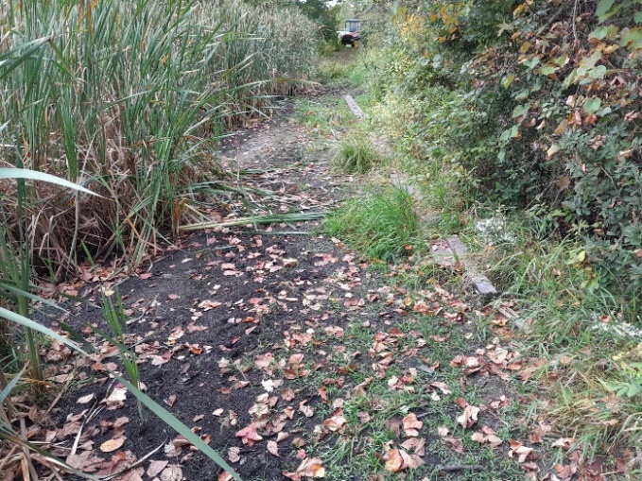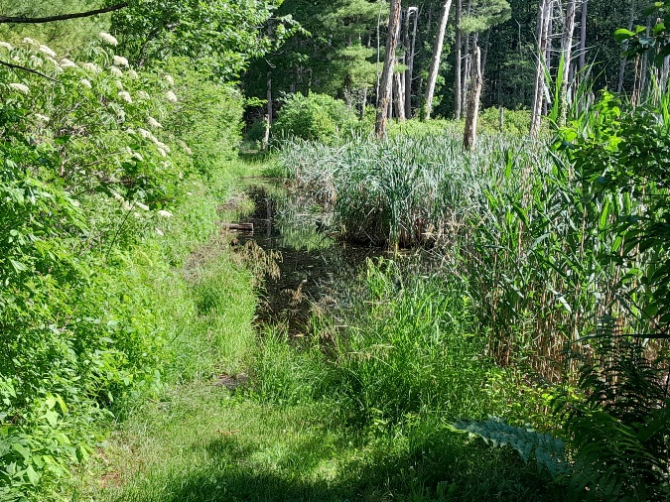
Before After (taken from opposite direction)

